Unit 3 Lesson 3 Cumulative Practice Problems
- Draw a tape diagram to match each equation.
  - $5(x+1)=20$
  - $5x+1=20$
- Select all the equations that match the tape diagram.
- 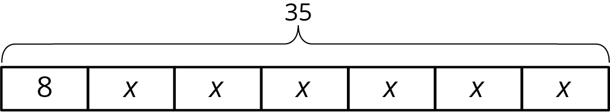
  - $35=8+x+x+x+x+x+x$
  - $35=8+6x$
  - $6+8x=35$
  - $6x+8=35$
  - $6x+8x=35x$
  - $35−8=6x$
- Point $B$ has coordinates $(\text{-}2,\text{-}5)$. After a translation 4 units down, a reflection across the $y$-axis, and a translation 6 units up, what are the coordinates of the image?
- (From Unit 1, Lesson 5.)
- Figure 2 is a scaled copy of Figure 1.
- 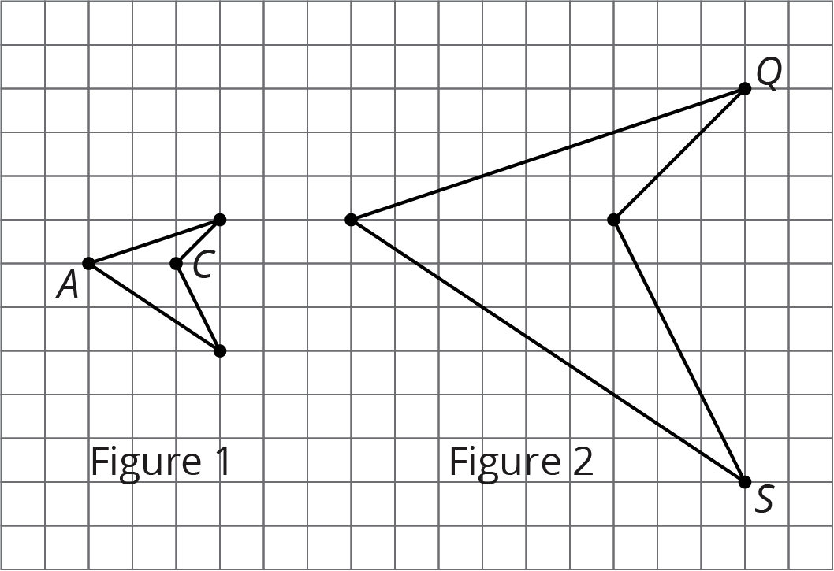
  - Identify the points in Figure 2 that correspond to the points $A$ and $C$ in Figure 1. Label them $P$ and $R$. What is the distance between $P$ and $R$?
  - Identify the points in Figure 1 that correspond to the points $Q$ and $S$ in Figure 2. Label them $B$ and $D$. What is the distance between $B$ and $D$?
  - What is the scale factor that takes Figure 1 to Figure 2?
  - $G$ and $H$ are two points on Figure 1, but they are not shown. The distance between $G$ and $H$ is 1. What is the distance between the corresponding points on Figure 2?
- (From Unit 2, Lesson 3.)
© CC BY Open Up Resources. Adaptations CC BY IM.

