Unit 1 Lesson 9: Composing Figures

1 Angles of an Isosceles Triangle (Warm up)

Student Task Statement
Here is a triangle.
- Reflect triangle $ABC$ over line $AB$. Label the image of $C$ as $C^{′}$.
- Rotate triangle $ABC^{′}$ around $A$ so that $C^{′}$ matches up with $B$.
- What can you say about the measures of angles $B$ and $C$?
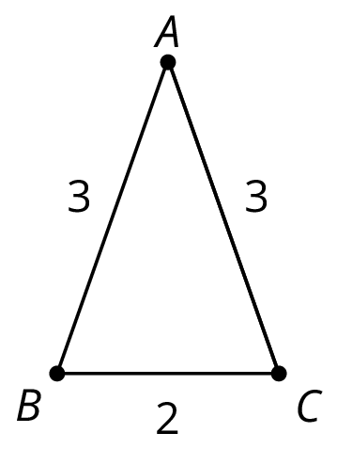

2 Triangle Plus One

Student Task Statement
Here is triangle $ABC$.
- Draw midpoint $M$ of side $AC$.
- Rotate triangle $ABC$ 180 degrees using center $M$ to form triangle $CDA$. Draw and label this triangle.
- What kind of quadrilateral is $ABCD$? Explain how you know.
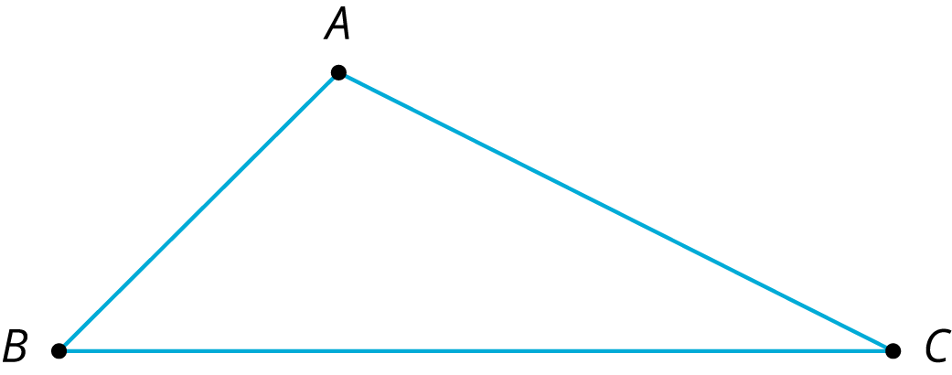

3 Triangle Plus Two

Student Task Statement
The picture shows 3 triangles. Triangle 2 and Triangle 3 are images of Triangle 1 under rigid transformations.
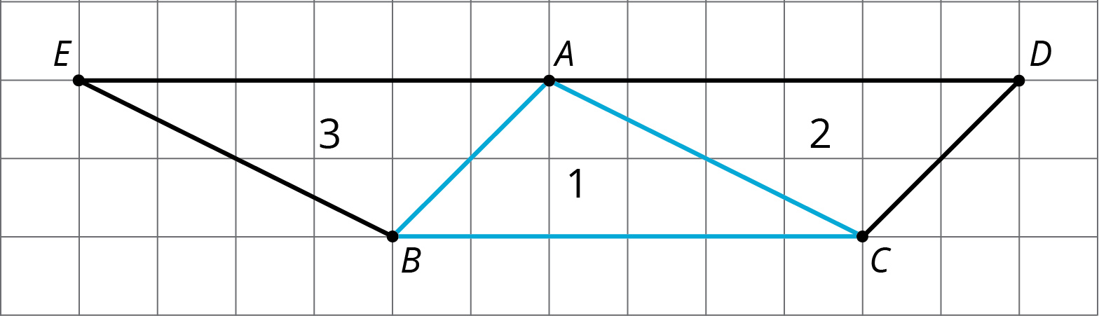
- Describe a rigid transformation that takes Triangle 1 to Triangle 2. What points in Triangle 2 correspond to points $A$, $B$, and $C$ in the original triangle?
- Describe a rigid transformation that takes Triangle 1 to Triangle 3. What points in Triangle 3 correspond to points $A$, $B$, and $C$ in the original triangle?
- Find two pairs of line segments in the diagram that are the same length, and explain how you know they are the same length.
- Find two pairs of angles in the diagram that have the same measure, and explain how you know they have the same measure.

4 Triangle ONE Plus (Optional)

Student Task Statement
Here is isosceles triangle $ONE$. Its sides $ON$ and $OE$ have equal lengths. Angle $O$ is 30 degrees. The length of $ON$ is 5 units.
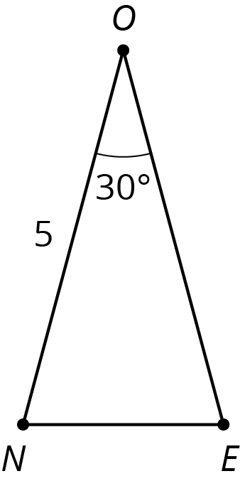
- Reflect triangle $ONE$ across segment $ON$. Label the new vertex $M$.
- What is the measure of angle $MON$?
- What is the measure of angle $MOE$?
- Reflect triangle $MON$ across segment $OM$. Label the point that corresponds to $N$ as $T$.
- How long is $\overline{OT}$? How do you know?
- What is the measure of angle $TOE$?
- If you continue to reflect each new triangle this way to make a pattern, what will the pattern look like?

Images for Activity Synthesis
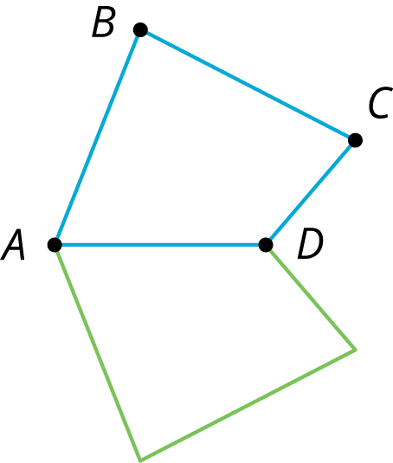
© CC BY Open Up Resources. Adaptations CC BY IM.

