Unit 1 Lesson 10: Represent Data Using Picture Graphs and Bar Graphs

WU Which One Doesn’t Belong: Data (Warm up)

Student Task Statement
Which one doesn’t belong?
A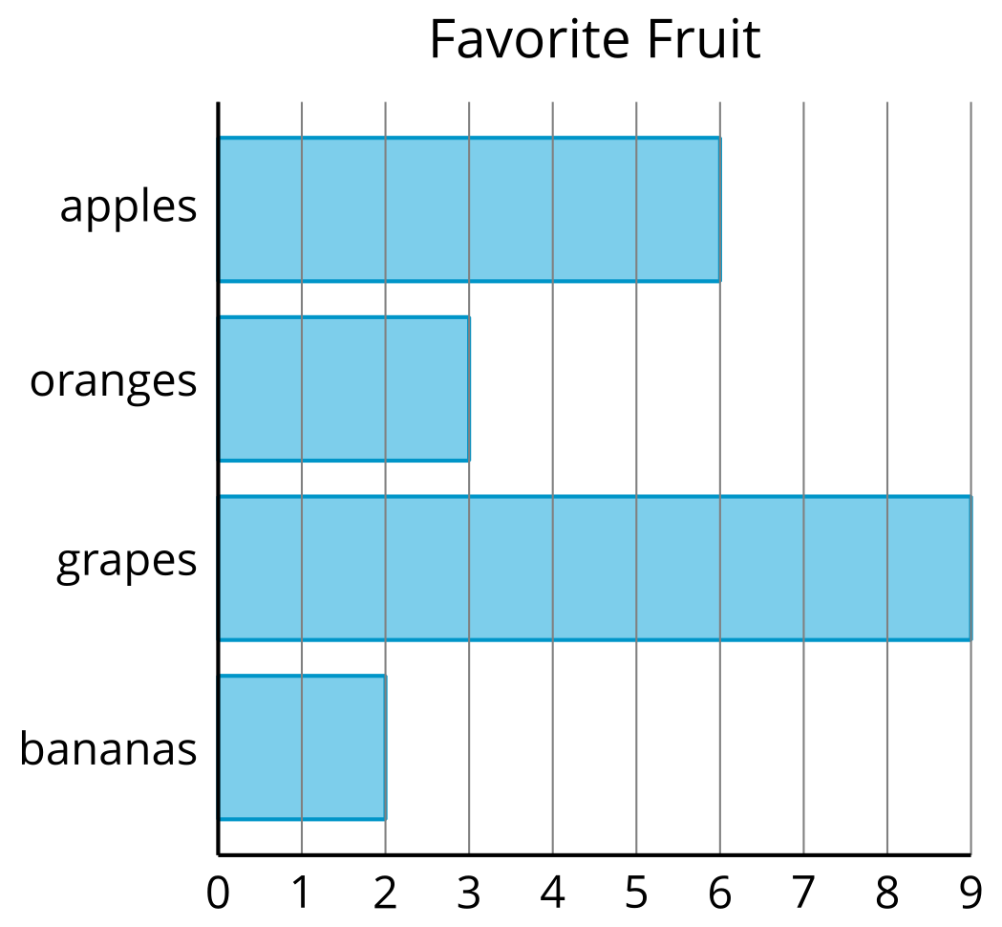
B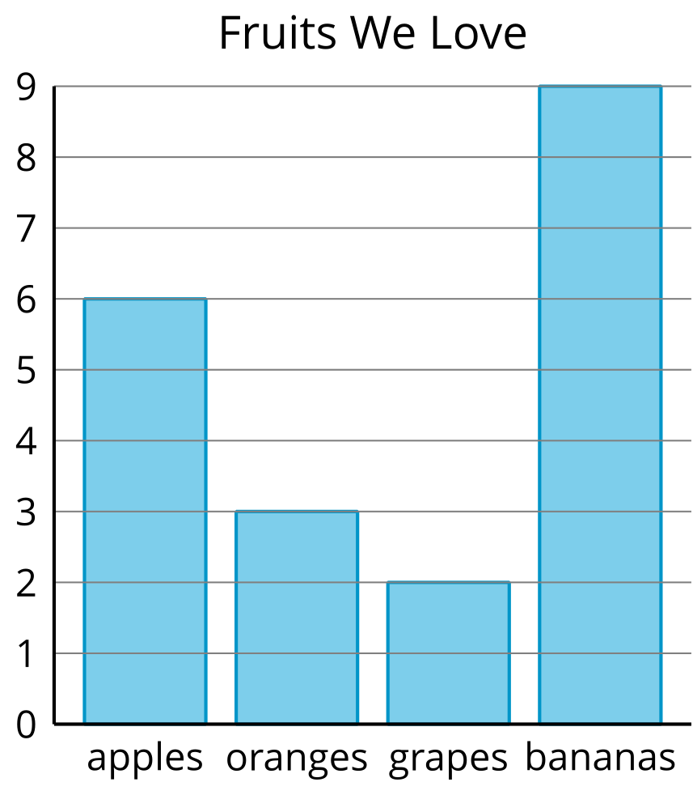
C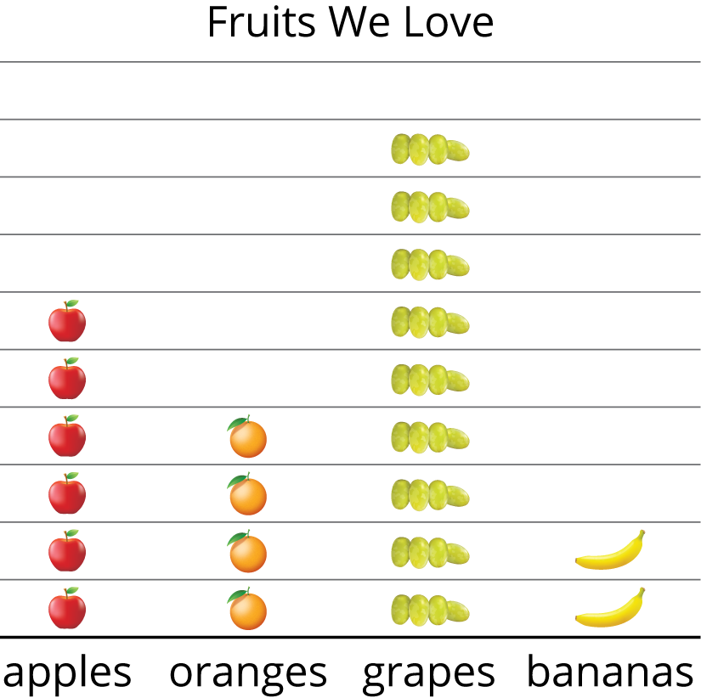
D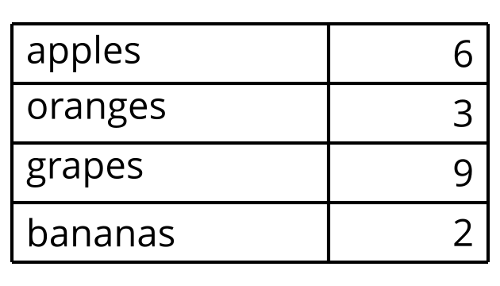

1 Draw Picture Graphs

Student Task Statement
A group of 2nd graders were asked, “What is your favorite sport?” Their responses are shown in this picture graph.
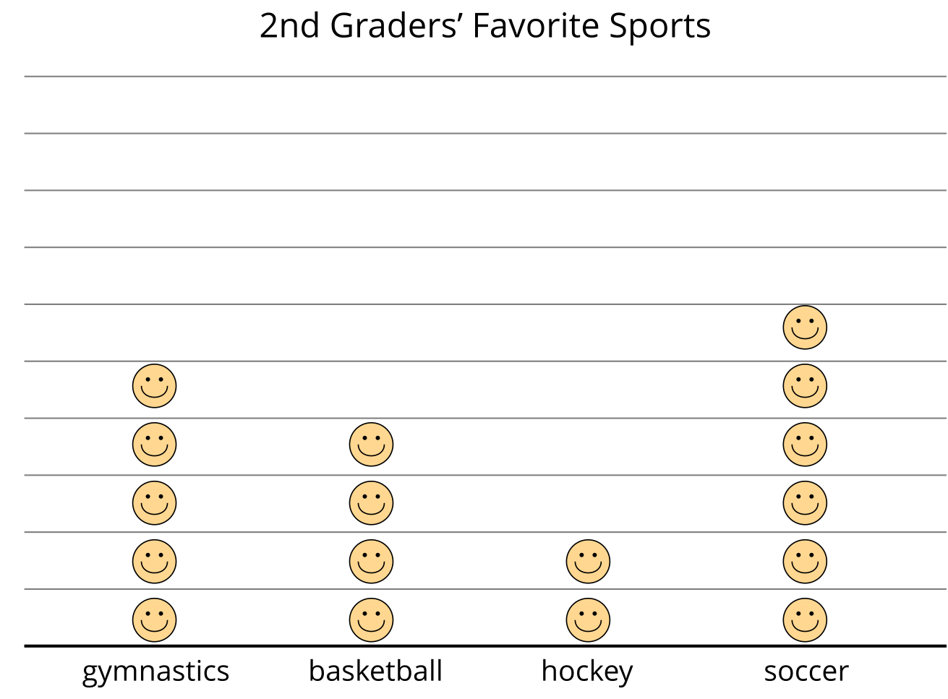
Represent the data shown in your table in a picture graph.
Table # _______

2 Draw Bar Graphs

Student Task Statement
A group of students were asked, “What fruit do you love to eat?” Their responses are shown in this bar graph.
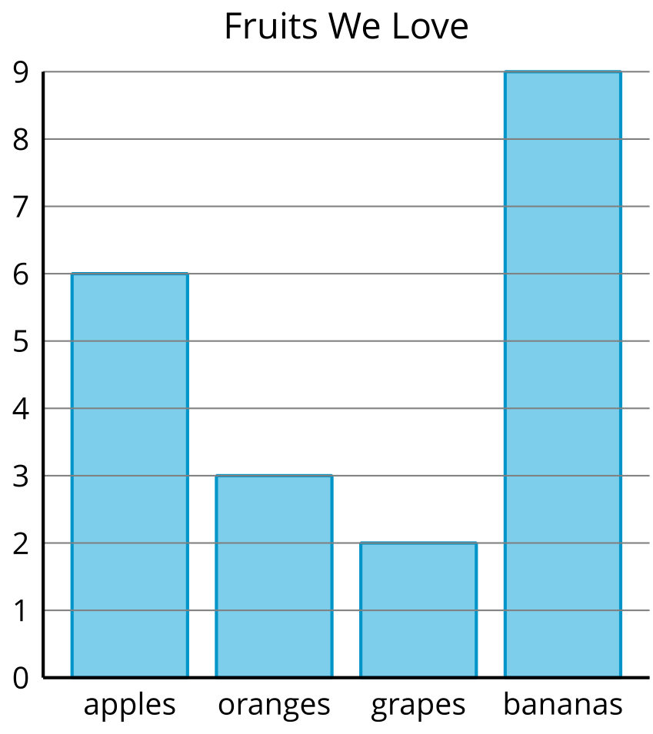
Represent the data shown in your table in a bar graph.
Table # _______
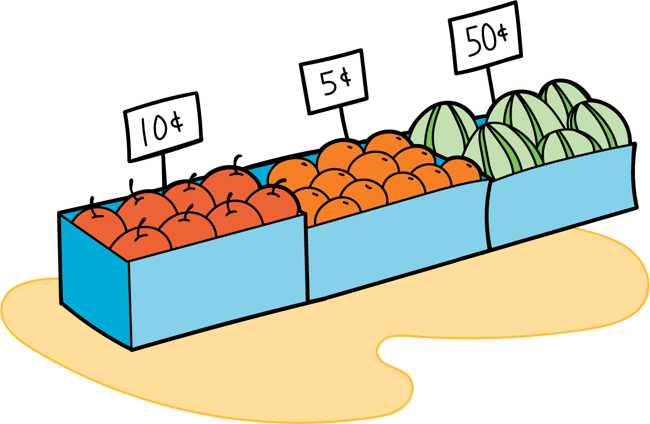
© CC BY 2021 Illustrative Mathematics®

