Lesson 5: Symmetry in Figures (Part 2)
- Let’s draw some figures that have lines of symmetry.

Warm-up: Number Talk: Keeping Track
Find the value of each expression mentally.
- $43+57+50+7+3+40$
- $243+57+43+257$
- $1,​043+257+57+200+43+1,​000$
- $1,​943+257+1+257+1,​000+943$

5.1: Half-drawn Figures
Each shaded triangle is half of a whole figure that has a line of symmetry shown by the dashed line.
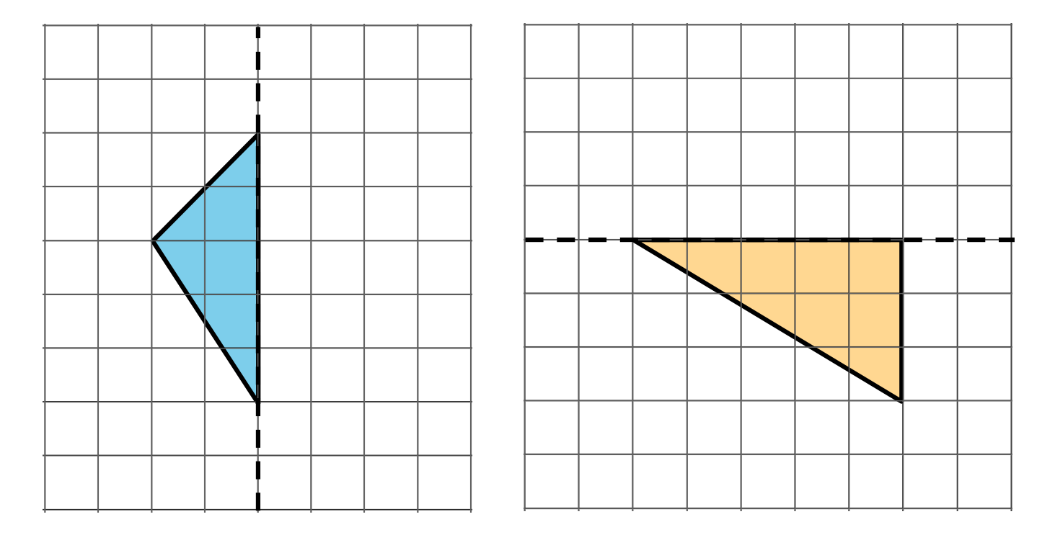
Clare drew in some segments to show the missing half of each figure.
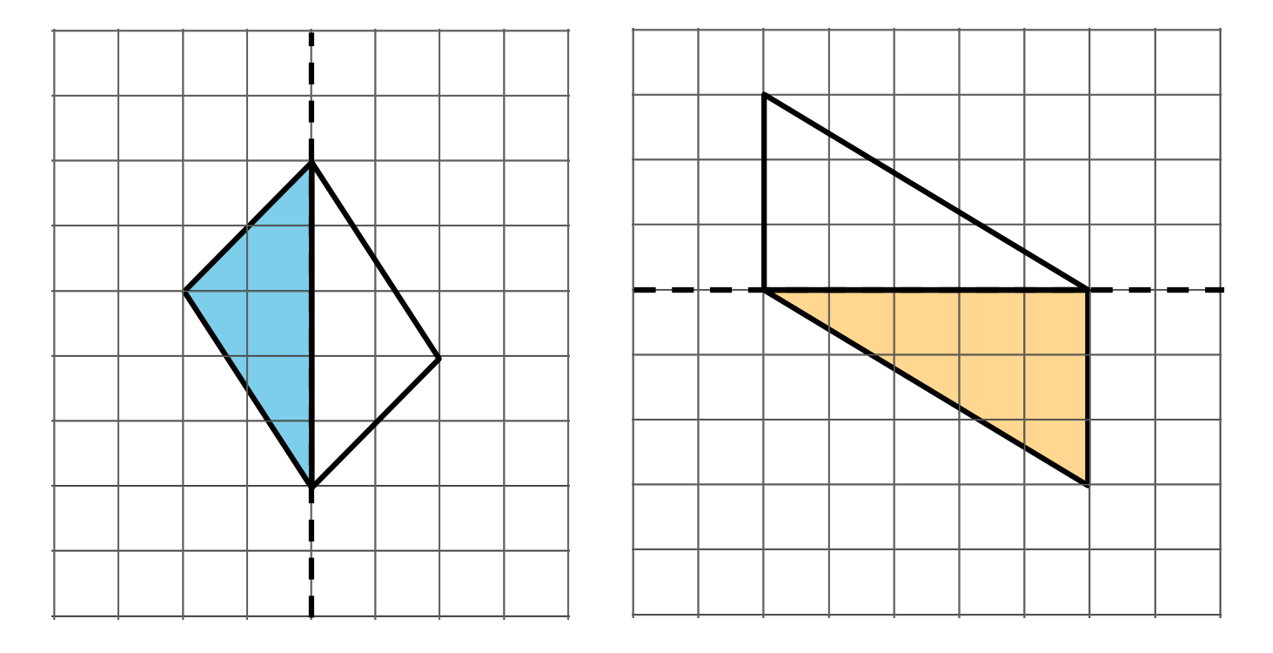
Do you agree that the dashed line is a line of symmetry for each figure Clare completed? Explain your reasoning. If you disagree with Clare's work, show a way to complete the drawing so the dashed line is a line of symmetry.

5.2: What’s the Whole Picture?
- Here are three figures. Each figure is half of a whole figure. The dashed line is a line symmetry of that figure.
- 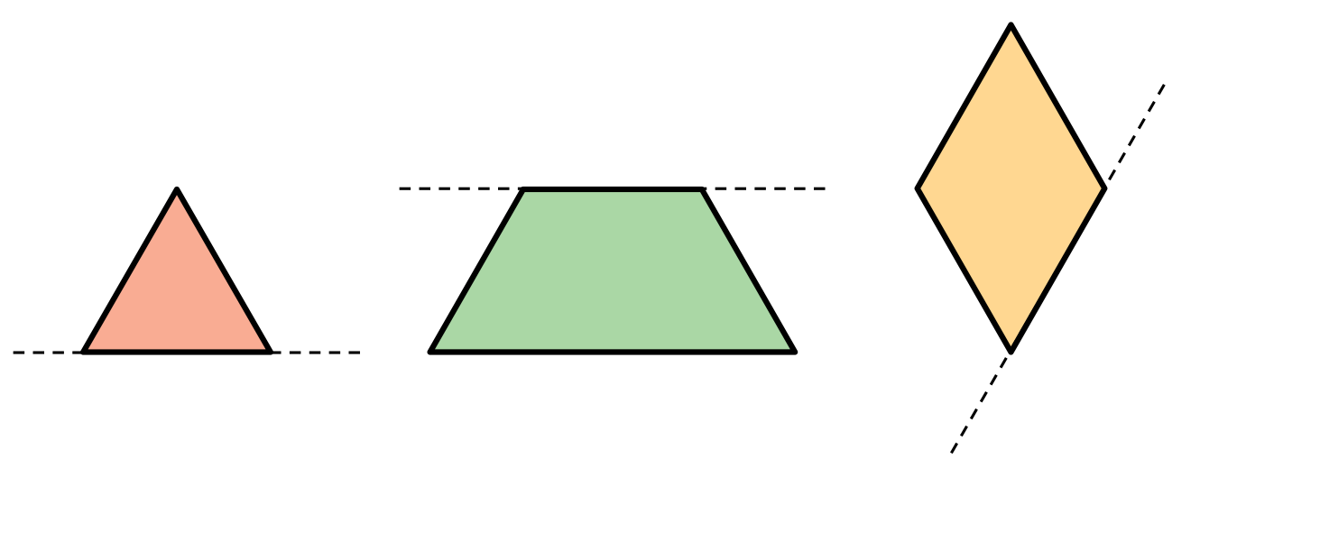
- Use patty paper to help you draw the whole figure.
- Each figure on the grid is half of a whole figure that has a line of symmetry. The dashed line shows the line of symmetry. Use the grid to help you draw the whole figure. Be as precise as possible.
- 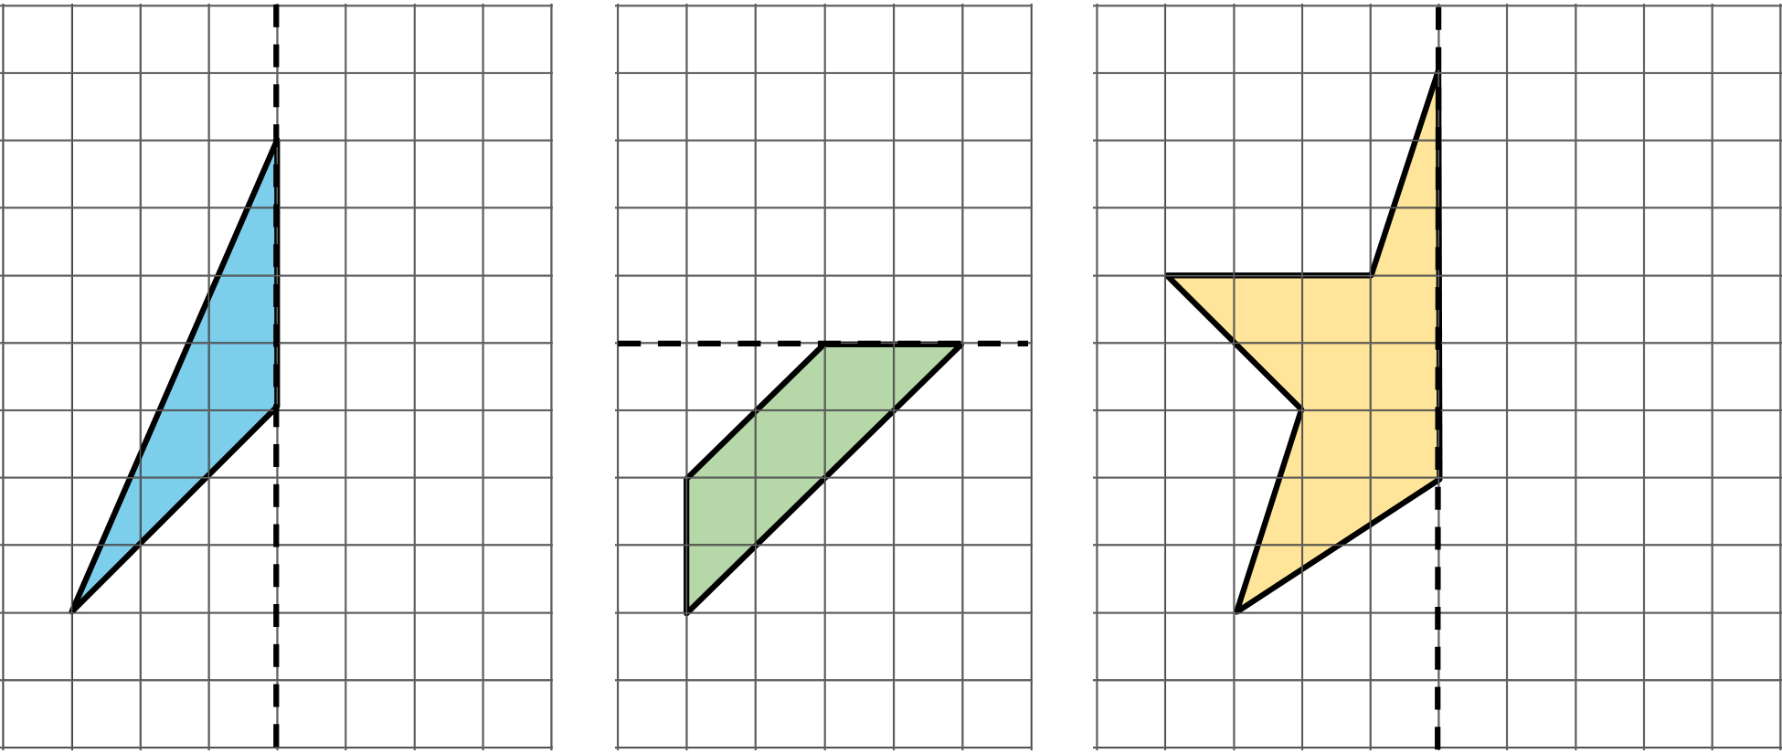
- Here is another figure that is half of a whole figure with a vertical line of symmetry. Draw the whole figure. Be as precise as possible.
- 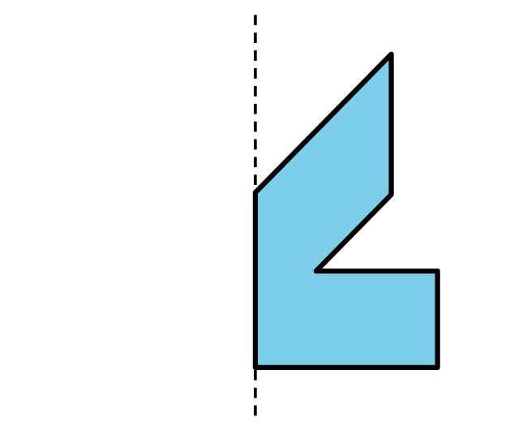

5.3: What Could the Whole Figure Be?
Trace a triangle cutout from your teacher.
If the triangle is half of a whole figure that has line symmetry, what could the whole figure look like? Can you show two possibilities? Three possibilities?
© CC BY 2021 Illustrative Mathematics®

