Unit 3 Lesson 4 Cumulative Practice Problems
- Here are three stories:
  - A family buys 6 tickets to a show. They also pay a $3 parking fee. They spend $27 to see the show.
  - Diego has 27 ounces of juice. He pours equal amounts for each of his 3 friends and has 6 ounces left for himself.
  - Jada works for 6 hours preparing for the art fair. She spends 3 hours on a sculpture and then paints 27 picture frames.
- Here are three equations:
  - $3x+6=27$
  - $6x+3=27$
  - $27x+3=6$
  - Decide which equation represents each story. What does $x$ represent in each equation?
  - Find the solution to each equation. Explain or show your reasoning.
  - What does each solution tell you about its situation?
- Here is a diagram and its corresponding equation. Find the solution to the equation and explain your reasoning.
- 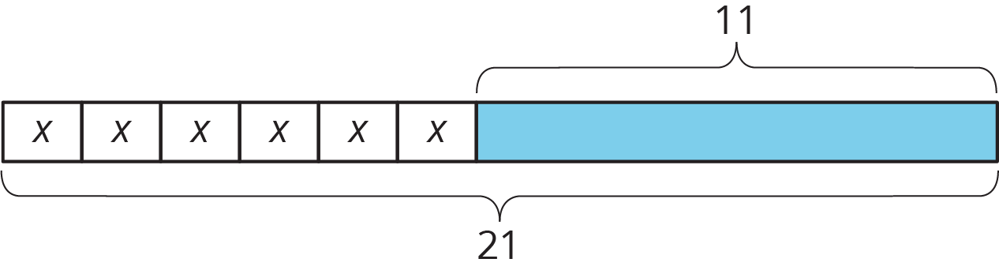
- $6x+11=21$
- For each object, choose an appropriate scale for a drawing that fits on a regular sheet of paper. Not all of the scales on the list will be used.
- Objects
  - A person
  - A football field (120 yards by 53$\frac{1}{3}$ yards)
  - The state of Washington (about 240 miles by 360 miles)
  - The floor plan of a house
  - A rectangular farm (6 miles by 2 mile)
- Scales
  - 1 in : 1 ft
  - 1 cm : 1 m
  - 1: 1000
  - 1 ft: 1 mile
  - 1: 100,000
  - 1 mm: 1 km
  - 1: 10,000,000
- (From Unit 2, Lesson 7.)
- The diagram shows two intersecting lines.
- Find the missing angle measures.
- 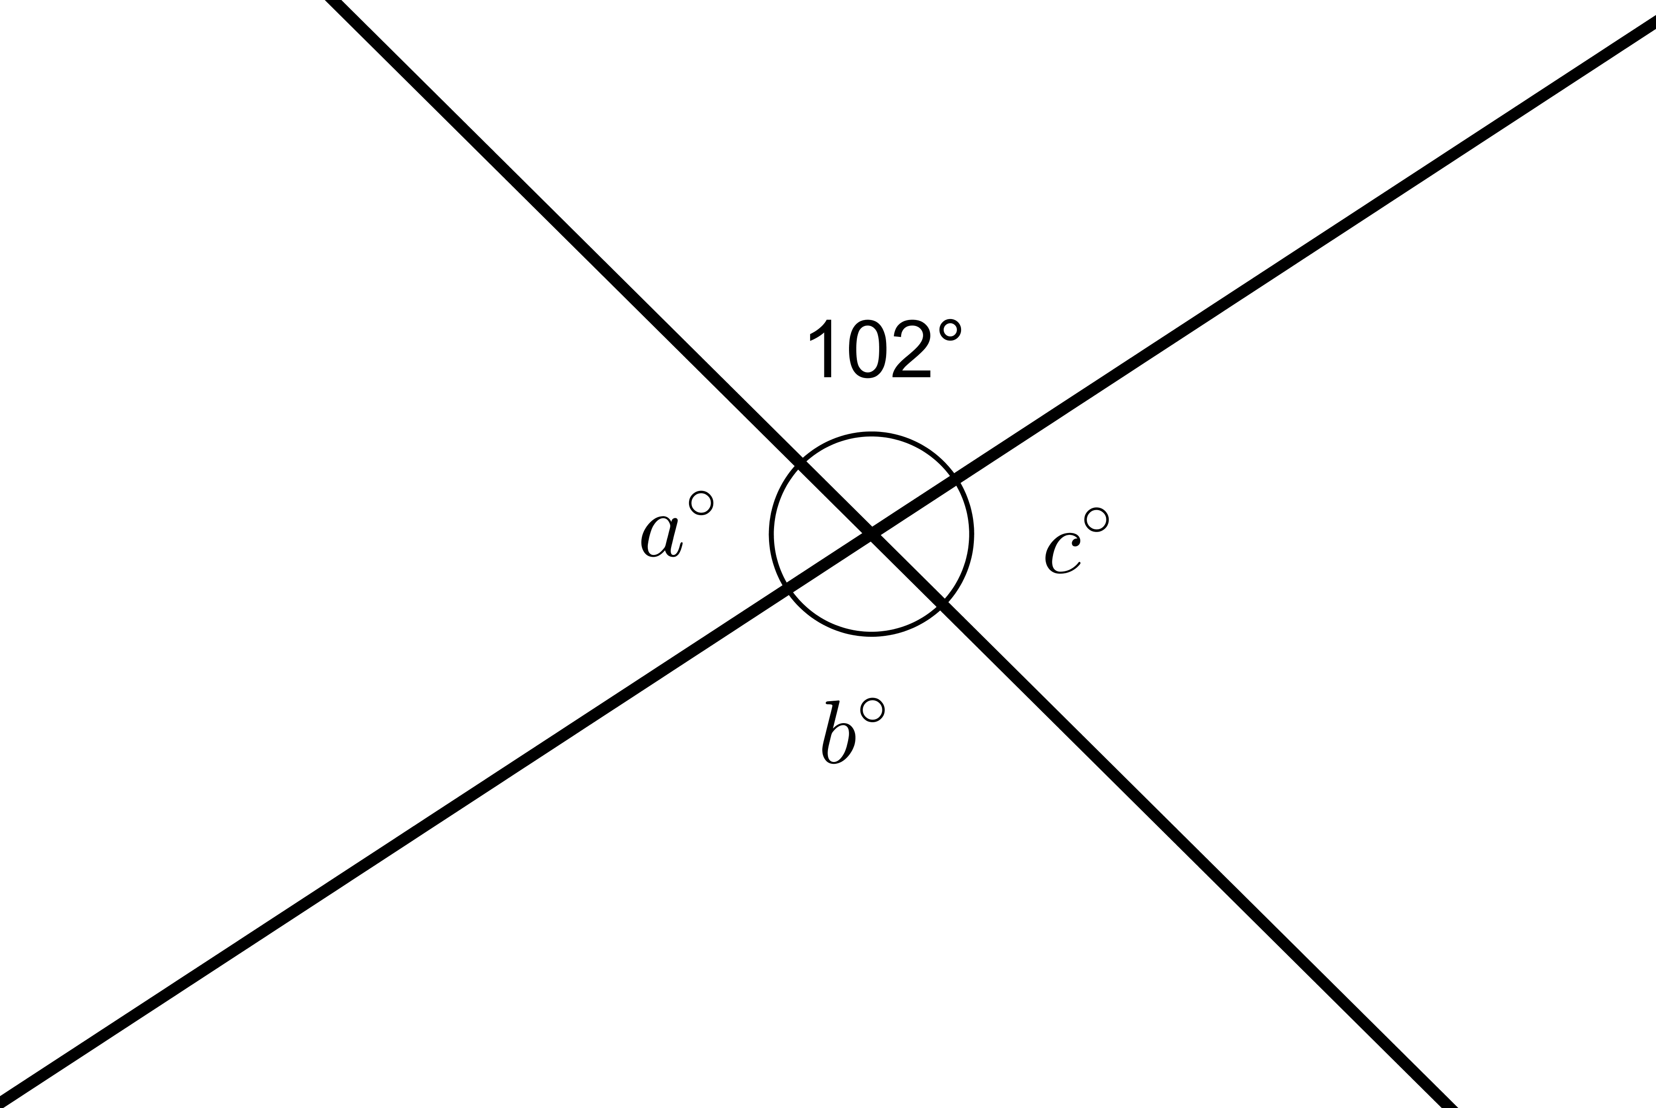
- (From Unit 1, Lesson 12.)
© CC BY Open Up Resources. Adaptations CC BY IM.

