Lesson 14: Decimal Representations of Rational Numbers

14.1: Notice and Wonder: Shaded Bars
What do you notice? What do you wonder?
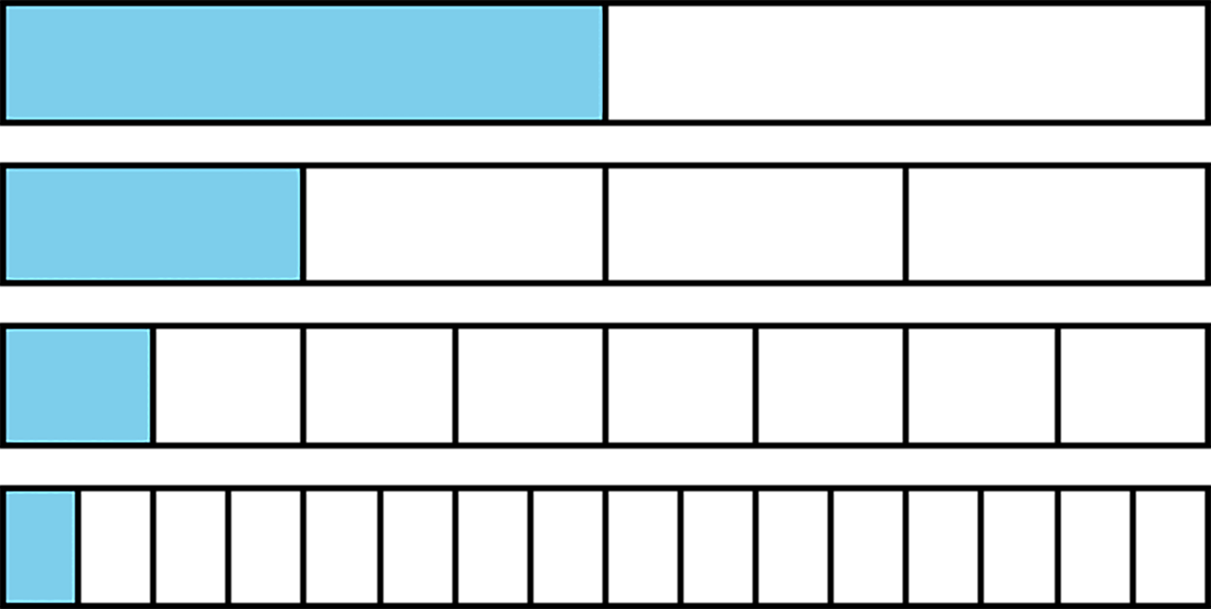

14.2: Halving the Length
Here is a number line from 0 to 1.
- Mark the midpoint between 0 and 1. What is the decimal representation of that number?
- Mark the midpoint between 0 and the newest point. What is the decimal representation of that number?
- Repeat step two. How did you find the value of this number?
- Describe how the value of the midpoints you have added to the number line keep changing as you find more. How do the decimal representations change?

14.3: Recalculating Rational Numbers
- Rational numbers are fractions and their opposites. All of these numbers are rational numbers. Show that they are rational by writing them in the form $\frac{a}{b}$ or $\text{-}\frac{a}{b}$.
  - 0.2
  - $\text{-}\sqrt{4}$
  - 0.333
  - $\sqrt[3]{1000}$
  - -1.000001
  - $\sqrt{\frac{1}{9}}$
- All rational numbers have decimal representations, too. Find the decimal representation of each of these rational numbers.
  - $\frac{3}{8}$
  - $\frac{7}{5}$
  - $\frac{999}{1000}$
  - $\frac{111}{2}$
  - $\sqrt[3]{\frac{1}{8}}$

14.4: Zooming In On $\frac{2}{11}$
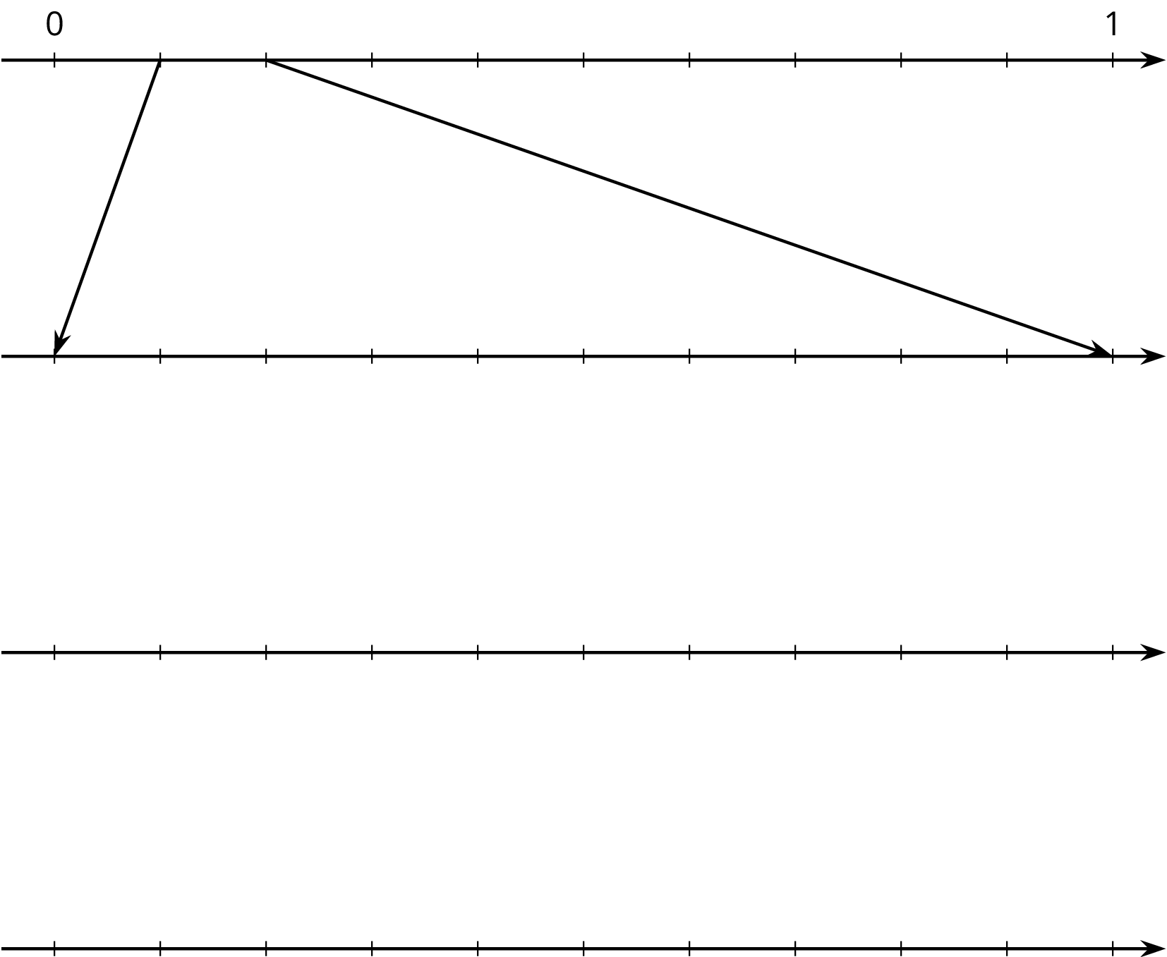
- On the topmost number line, label the tick marks. Next, find the first decimal place of $\frac{2}{11}$ using long division and estimate where $\frac{2}{11}$ should be placed on the top number line.
- Label the tick marks of the second number line. Find the next decimal place of $\frac{2}{11}$ by continuing the long division and estimate where $\frac{2}{11}$ should be placed on the second number line. Add arrows from the second to the third number line to zoom in on the location of $\frac{2}{11}$.
- Repeat the earlier step for the remaining number lines.
- What do you think the decimal expansion of $\frac{2}{11}$ is?

Are you ready for more?
Let $x=\frac{25}{11}=2.272727...$ and $y=\frac{58}{33}=1.75757575...$
For each of the following questions, first decide whether the fraction or decimal representations of the numbers are more helpful to answer the question, and then find the answer.
- Which of $x$ or $y$ is closer to 2?
- Find $x^{2}$.

Lesson 14 Summary
We learned earlier that rational numbers are a fraction or the opposite of a fraction. For example, $\frac{3}{4}$ and $\text{-}\frac{5}{2}$ are both rational numbers. A complicated-looking numerical expression can also be a rational number as long as the value of the expression is a positive or negative fraction. For example, $\sqrt{64}$ and $\text{-}\sqrt[3]{\frac{1}{8}}$ are rational numbers because $\sqrt{64}=8$ and $\text{-}\sqrt[3]{\frac{1}{8}}=\text{-}\frac{1}{2}$.
Rational numbers can also be written using decimal notation. Some have finite decimal expansions, like 0.75, -2.5, or -0.5. Other rational numbers have infinite decimal expansions, like 0.7434343 . . . where the 43s repeat forever. To avoid writing the repeating part over and over, we use the notation $0.7\overline{43}$ for this number. The bar over part of the expansion tells us the part which is to repeat forever.
A decimal expansion of a number helps us plot it accurately on a number line divided into tenths. For example, $0.7\overline{43}$ should be between 0.7 and 0.8. Each further decimal digit increases the accuracy of our plotting. For example, the number $0.7\overline{43}$ is between 0.743 and 0.744.
© CC BY Open Up Resources. Adaptations CC BY IM.

