Unit 5 Lesson 17: Organizing Data

1 Notice and Wonder: Messy Data (Warm up)

Student Task Statement
Here is a table of data. Each row shows two measurements of a triangle.
length of short side (cm) | length of perimeter (cm)
0.25 | 1
2 | 7.5
6.5 | 22
3 | 9.5
0.5 | 2
1.25 | 3.5
3.5 | 12.5
1.5 | 5
4 | 14
1 | 2.5
What do you notice? What do you wonder?

2 Seeing the Data

Images for Launch
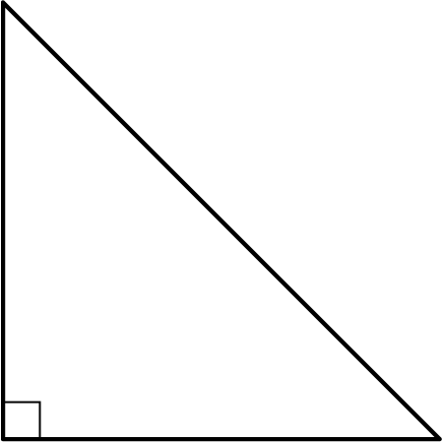

Student Task Statement
Here is the table of isosceles right triangle measurements from the warm-up and an empty table.
length of short sides (cm) | length of perimeter (cm)
0.25 | 1
2 | 7.5
6.5 | 22
3 | 9.5
0.5 | 2
1.25 | 3.5
3.5 | 12.5
1.5 | 5
4 | 14
1 | 2.5

length of short sides (cm) | length of perimeter (cm)
- How can you organize the measurements from the first table so that any patterns are easier to see? Write the organized measurements in the empty table.
- For each of the following lengths, estimate the perimeter of an isosceles right triangle whose short sides have that length. Explain your reasoning for each triangle.
  - length of short sides is 0.75 cm
  - length of short sides is 5 cm
  - length of short sides is 10 cm

Activity Synthesis
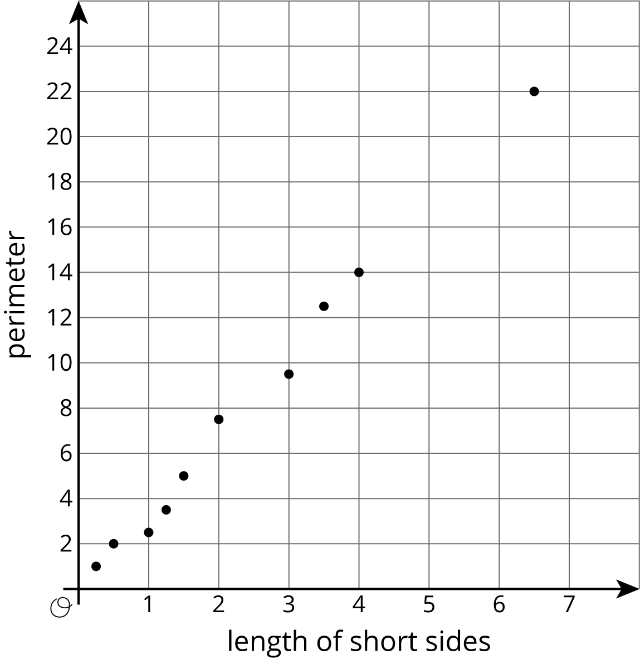

3 Tables and Their Scatter Plots

Student Task Statement
Here are four scatter plots. Your teacher will give you four tables of data.
- Match each table with one of the scatter plots.
- Use information from the tables to label the axes for each scatter plot.
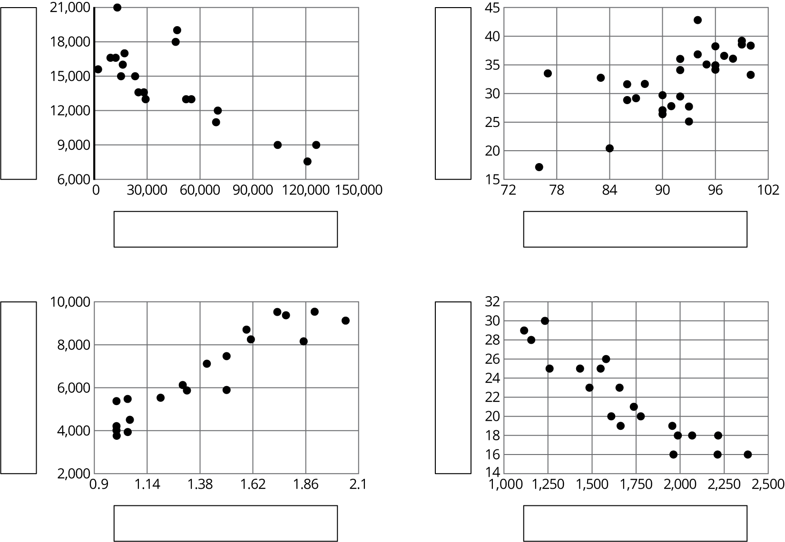

© CC BY Open Up Resources. Adaptations CC BY IM.

