Unit 3 Lesson 4: Situations about Multiplying Fractions

WU Number Talk: More Halving (Warm up)

Student Task Statement
Find the value each expression mentally.
- $\frac{1}{2}×\frac{1}{2}$
- $\frac{1}{3}×\frac{1}{2}$
- $\frac{1}{4}×\frac{1}{2}$
- $\frac{1}{5}×\frac{1}{2}$

1 The Park

Student Task Statement
A city is designing a park on a rectangular piece of land. $\frac{2}{3}$ of the park will be used for different sports. $\frac{1}{2}$ of the land set aside for sports will be soccer fields.
- Draw a diagram of the situation.
- Write a multiplication expression to represent the fraction of the park that will be soccer fields.
- What fraction of the whole park will be soccer fields? Explain or show your reasoning.

2 A Different Park

Student Task Statement
Here is a diagram for a different park that Elena drew.
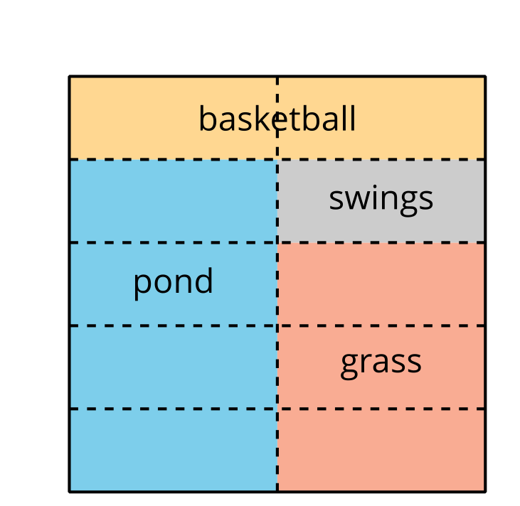
- Which part of the park can be represented with the expression $\frac{3}{5}×\frac{1}{2}$ ? Explain or show your reasoning.
- Pick one of the other parts of the park and write a multiplication expression for the fraction of the park it represents.
- Trade expressions with your partner and figure out which part of the park their expression represents. Be prepared to explain your reasoning.
© CC BY 2021 Illustrative Mathematics®

