Unit 5 Lesson 13: Center Day 3

WU Choral Count: Count Back from 100 (Warm up)

Student Task Statement

1 Introduce Target Numbers, Add Two-Digit Numbers

Student Task Statement
Choose a center.
Target Numbers
Number Puzzles
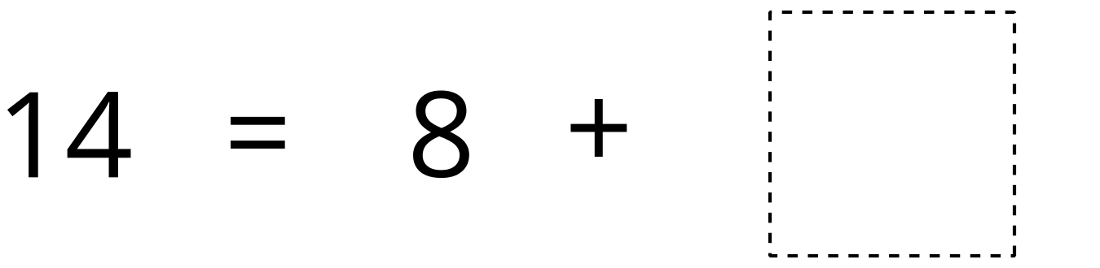
Mystery Number

2 Introduce Five in a Row, Add within 100 with Composing

Student Task Statement
Choose a center.
Five in a Row
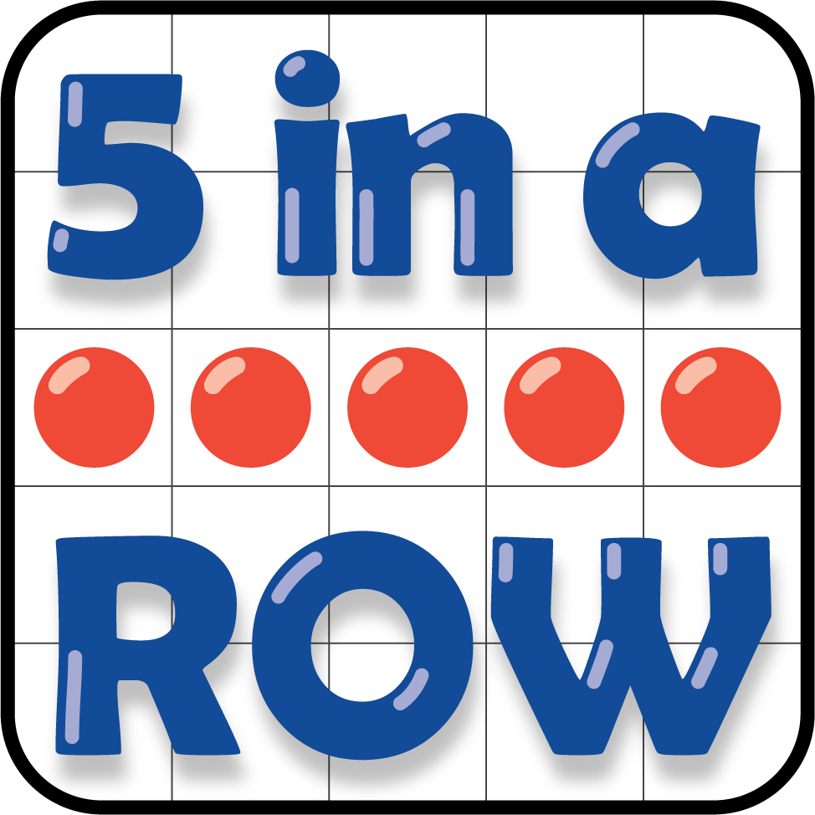
Get Your Numbers in Order
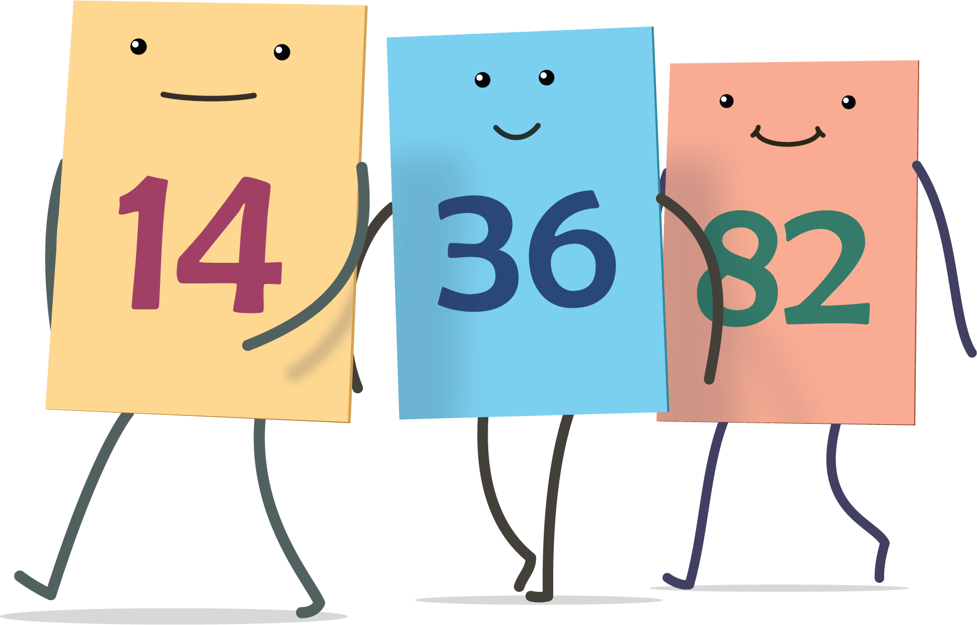
Grab and Count
© CC BY 2021 Illustrative Mathematics®

