Lesson 17: Apply Rounding
- Let’s round large numbers to learn about situations and solve problems.

Warm-up: Notice and Wonder: Plane Altitudes
What do you notice? What do you wonder?
plane | altitude (feet)
WN11 | 35,625
SK51 | 28,999
VT35 | 15,450
BQ64 | 36,000
AL16 | 31,000
AB25 | 35,175
CL48 | 16,600
WN90 | 30,775
NM44 | 30,245

17.1: Apart in the Air
- Altitude is the vertical distance from sea level. Here are the altitudes of ten planes.
- plane | - altitude (feet)
- WN11 | - 35,625
- SK51 | - 28,999
- VT35 | - 15,450
- BQ64 | - 36,000
- AL16 | - 31,000
- AB25 | - 35,175
- CL48 | - 16,600
- WN90 | - 30,775
- NM44 | - 30,245
- 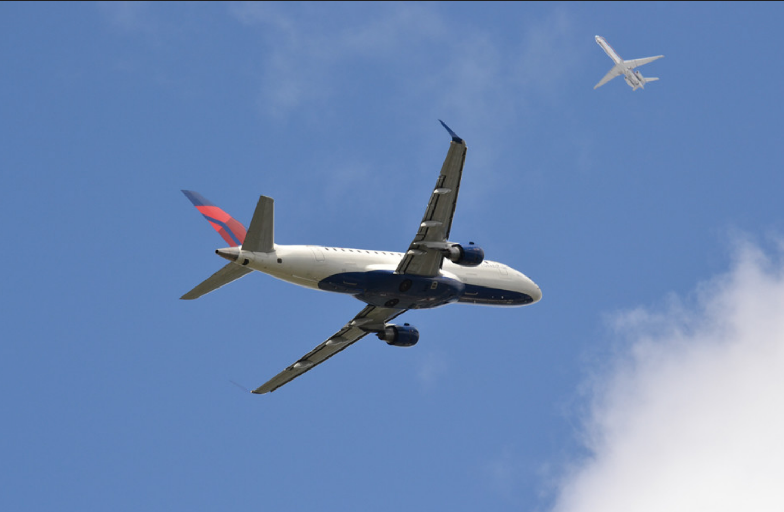

- Which planes are flying at about 30,000 feet? Explain or show your reasoning.
- Planes flying over the same area need to stay at least 1,000 feet apart in altitude.
- Mai said that one way to tell if planes are too close is to round each plane's altitude to the nearest thousand. Do you agree that this is a reliable strategy?
- In the last column, round each altitude to the nearest thousand. Use the rounded values to explain why or why not.

17.2: Safe or Unsafe?
Use the altitude data table from earlier for the following problems.
- Look at the column showing exact altitudes.
  - Find two or more numbers that are within 1,000 feet of one another. Mark them with a circle or a color.
  - Find another set of numbers that are within 1,000 feet of one another. Mark them with a square or a different color.
  - Based on what you just did, which planes are too close to one another?
- 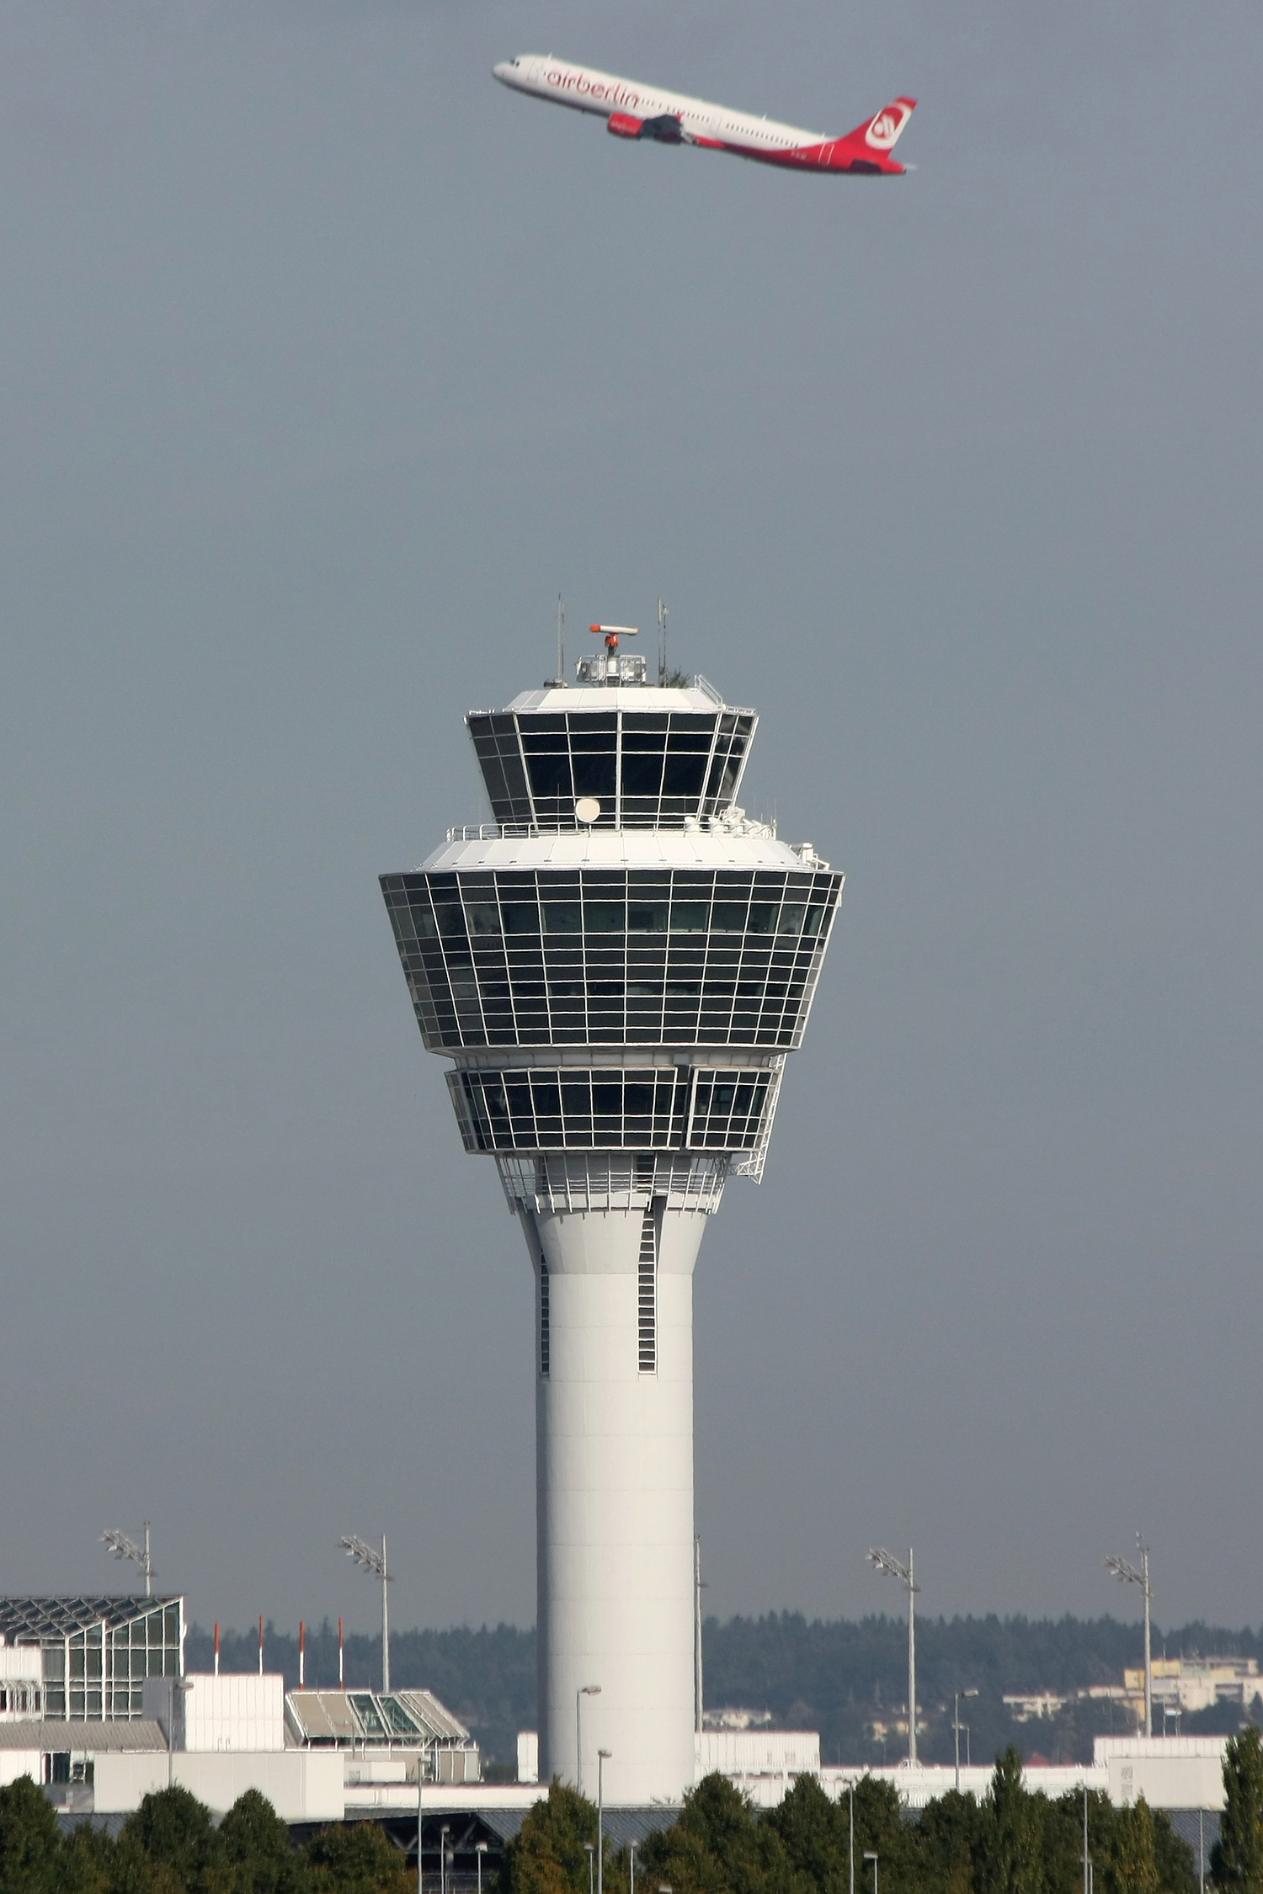
- Repeat what you just did with the rounded numbers in the last column. If we look there, which planes are too close to one another?
- Which set of altitude data should air traffic controllers use to keep airplanes safe while in the air? Explain your reasoning.
- Are there better ways to round these altitudes, or should we not round at all? Explain or show your reasoning.

17.3: No-phone Zone?
In some countries, cell phone use is allowed on a flight only when the plane is at a certain altitude, usually around 40,000 feet.
Here are six planes and their altitudes.
plane | altitude (feet)
A | 40,990
B | 39,524
C | 36,138
D | 40,201
E | 35,472
F | 30,956
Jada says the passengers in all planes except for plane F can use their phones.
Elena says only those in B and D can do so.
Do you agree with either of them? Explain your reasoning.

Section Summary
Section Summary
In this section, we learned to compare, order, and round numbers up to 1,000,000.
We started by using what we know about place value to compare large whole numbers. For instance, we know that 45,892 is less than 407,892 because the 4 in 45,892 represents four ten-thousands and the 4 in 407,892 represents four hundred-thousands.
Next, we found multiples of 1,000, 10,000, and 100,000 that are closest to given numbers—at first with the help of number lines, and later without. For example, for 407,892, we know that:
- 408,000 is the nearest multiple of 1,000
- 410,000 is the nearest multiple of 10,000
- 400,000 is the nearest multiple of 100,000
Finally, we used what we know about finding nearest multiples to round large numbers to the nearest thousand, ten-thousand, and hundred-thousand.
© CC BY 2021 Illustrative Mathematics®

