Lesson 6: All Kinds of Attributes
- Let’s use what we know about attributes of figures to create drawings.

Warm-up: How Many Do You See: Dot after Dot
How many do you see? How do you see them?
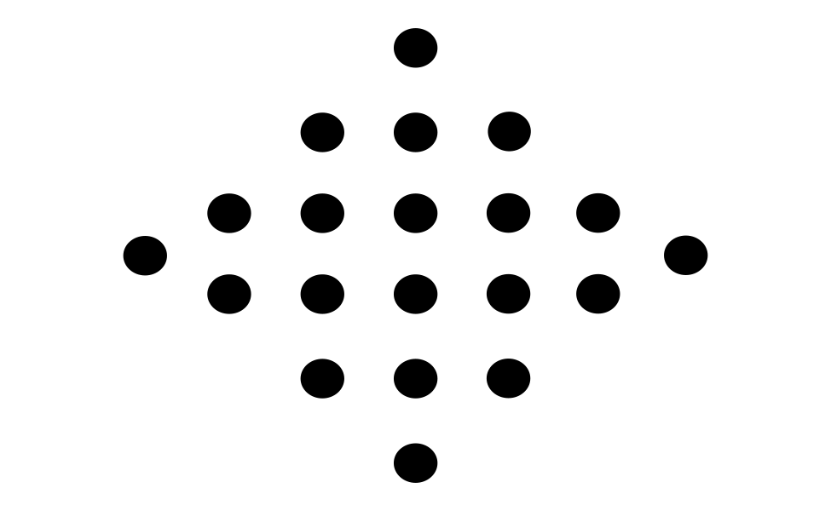

6.1: You’re Gonna Draw It: It’s Symmetric
- Here is a pair of parallel segments that have the same length.
- 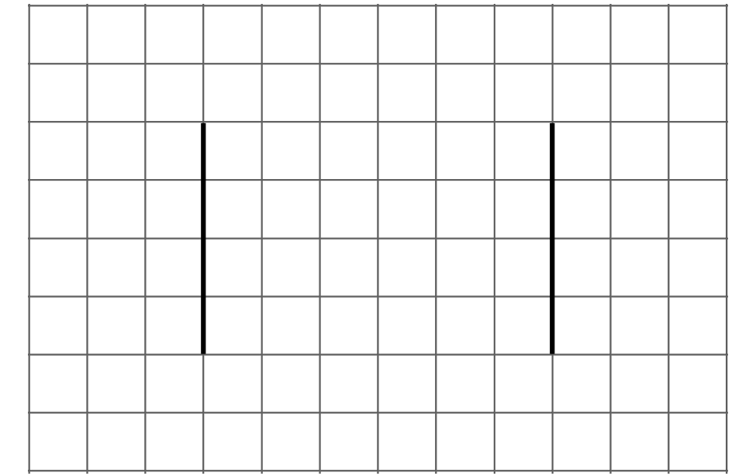
- Add one or more segments to create a figure with only 1 line of symmetry.
- Here are two more pairs of parallel segments. Add more segments to make:
  - a figure with 2 lines of symmetry
  - a figure with no lines of symmetry
If you have time: Here are some other pairs of parallel lines. Add more segments to create a figure with 1 line of symmetry.
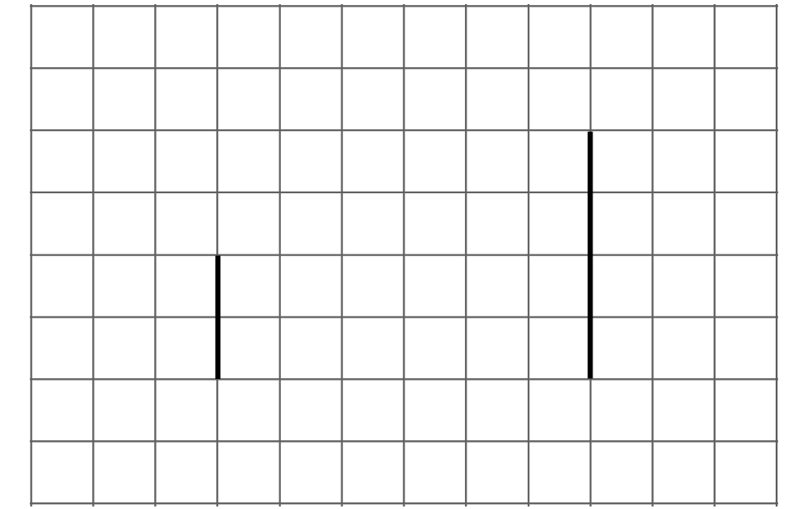
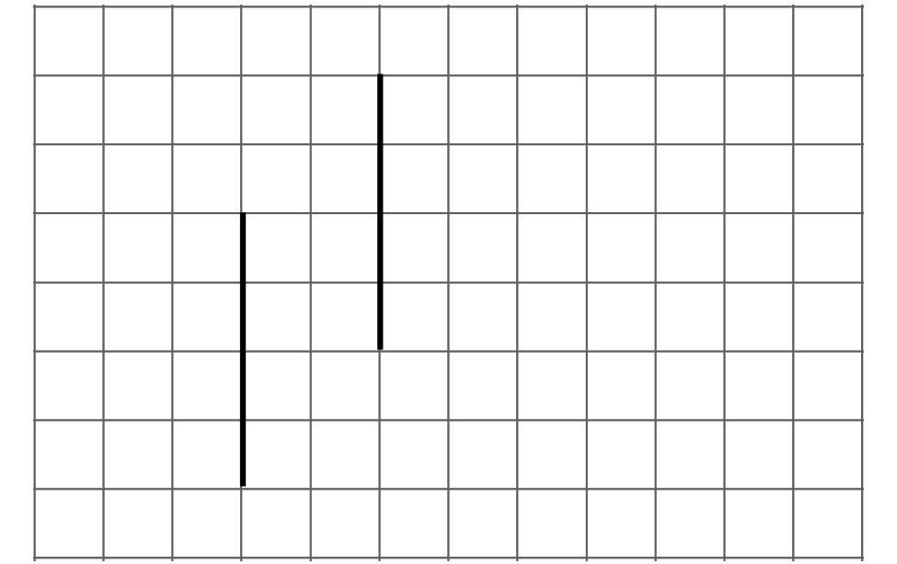

6.2: Hidden Shapes
Here is a field of dots.
Can you connect the dots to create each of the following shapes? If so, draw the shapes. If not, be prepared to explain your reasoning.
- A triangle with only one line of symmetry
- A quadrilateral with only one line of symmetry
- A quadrilateral with two pairs of parallel sides
- A quadrilateral with one pair of perpendicular sides
- A rectangle
- A six-sided shape with only one line of symmetry

Section Summary
Section Summary
In this section, we looked at different attributes of shapes, such as the number and length of sides, the measurements of sides and angles, and whether the shapes had parallel and perpendicular sides.
We then used these attributes to classify quadrilaterals and triangles.
Triangles with a right angle are right triangles.
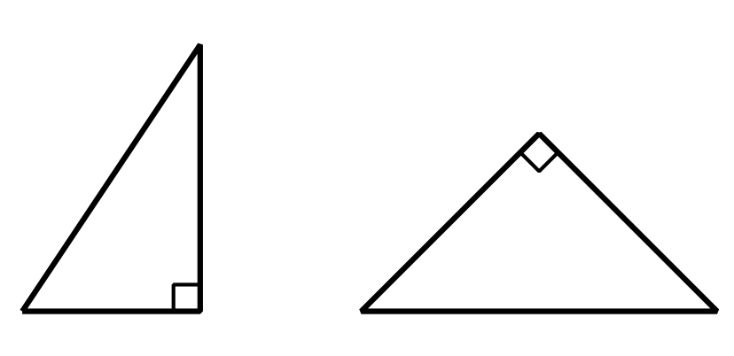
Quadrilaterals with two pairs of parallel sides are parallelograms.
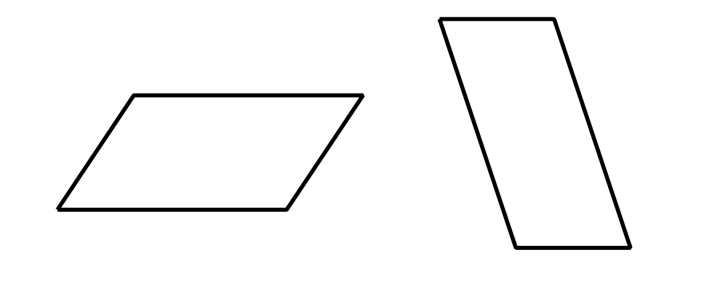
Quadrilaterals with two pairs of parallel sides and four right angles are rectangles.
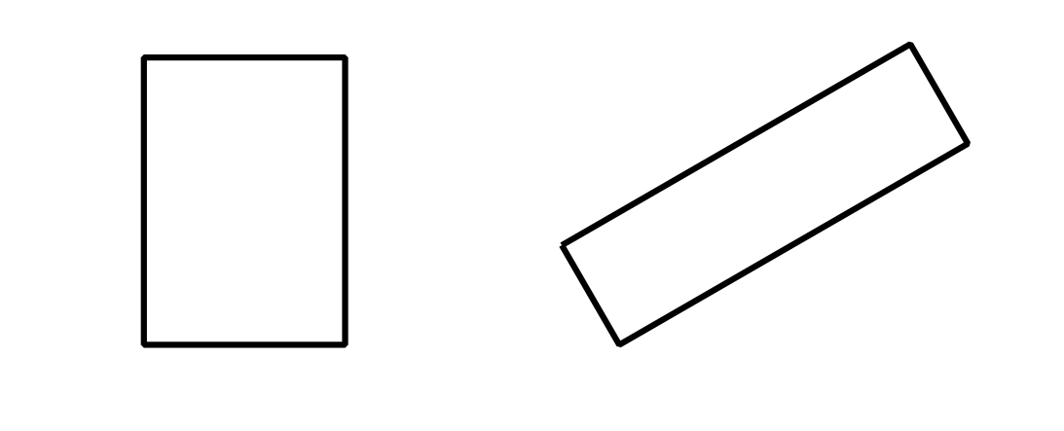
Quadrilaterals with four equal sides are rhombuses.
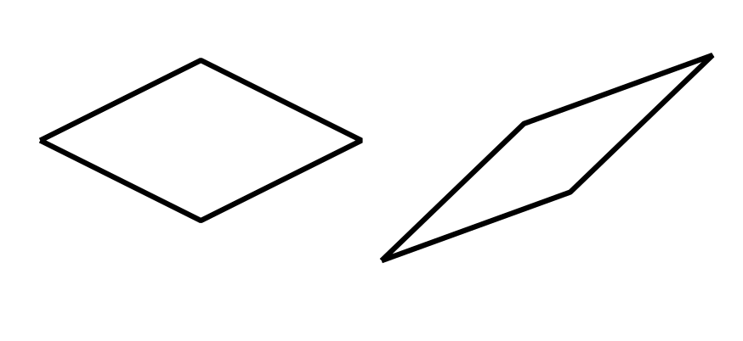
Quadrilaterals with four equal sides and four right angles are squares.
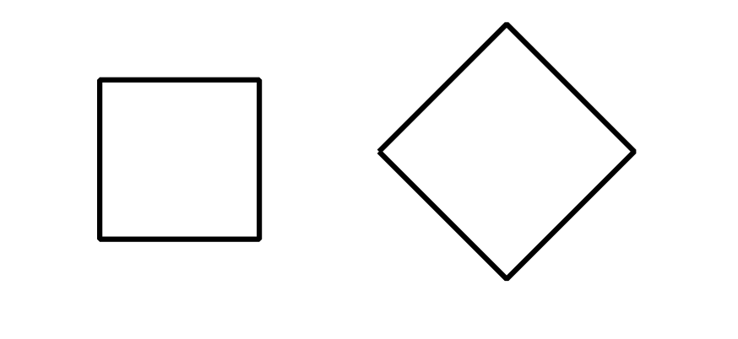
We also learned about lines of symmetry. A figure that has a line of symmetry can be folded along that line to create two halves that match up exactly.
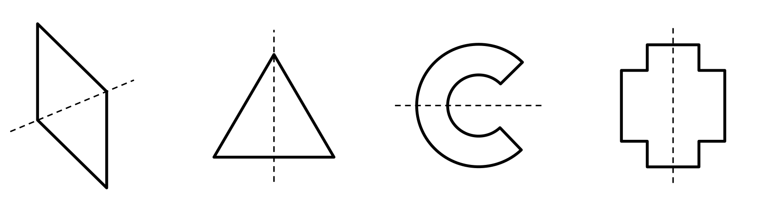
© CC BY 2021 Illustrative Mathematics®

