Lesson 7: Multi-step Conversion Problems: Customary Length
- Let’s solve multi-step problems about customary length.

Warm-up: Number Talk: Multiples of 12
Find the value of each expression mentally.
- $45×10$
- $45×2$
- $45×12$
- $46×12$

7.1: Card Sort: Customary Measurements
- Your teacher will give you a set of cards that show different measurements. Sort the cards into 2 categories of your choosing. Be prepared to explain the meaning of your categories.
- (Pause for teacher directions.)
- Match the cards with equal measurements. Then, list the groups of matching measurements in increasing order.

7.2: Run a Mile or Two
- A rectangular field is 90 yards long and $42\frac{1}{4}$ yards wide. Priya says that 6 laps around the field is more than a mile. Do you agree with Priya?
- Explain or show your reasoning.
- 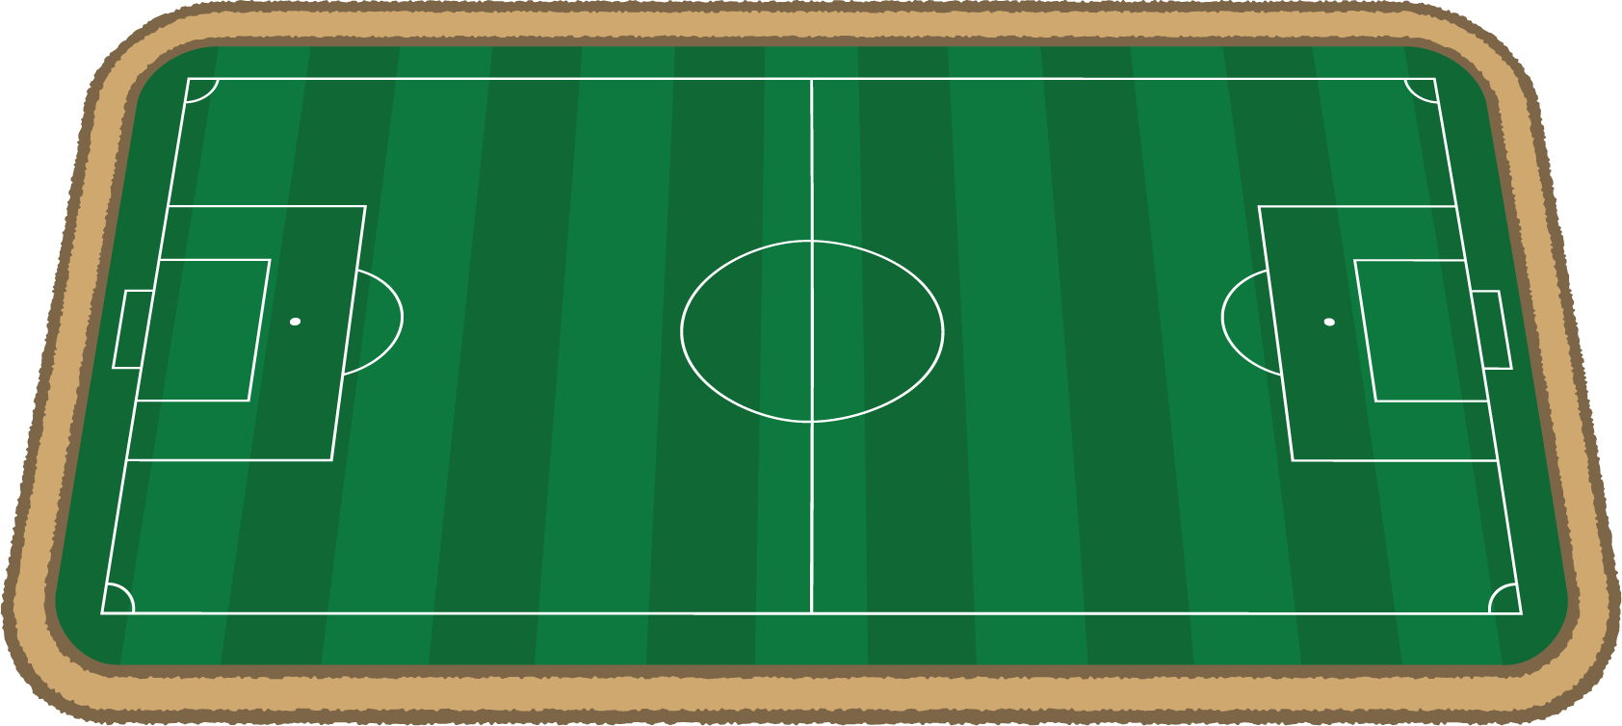
- A different rectangular field is $408\frac{1}{2}$ feet long and $240\frac{1}{4}$ feet wide. How many laps around this field would Priya need to run if she wants to run at least 2 miles?

Section Summary
Section Summary
In this section we studied powers of 10 and conversions between units. We learned that we can write a product of 10s like $10×10×10×10$ as ${10}^{4}$. The number 4 is an exponent and it means that there are 4 factors of 10.
We also converted between different measurement units, mostly metric lengths. For example, there are 1,000 millimeters in a meter and 1,000 meters in a kilometer. This means that there are $1,​000×1,​000$ or $1,​000,​000$ millimeters in a kilometer. We could also say that there are ${10}^{6}$ millimeters in a kilometer. We also used our understanding of decimals to make conversions. For example, since there are 1,000 meters in a kilometer that means that each meter is $\frac{1}{1,000}$ or 0.001 kilometers. So 853 meters can also be written as 0.853 kilometers.
© CC BY 2021 Illustrative Mathematics®

