Lesson 11 Practice Problems
- Find the sum of the sequence:
  - $\frac{1}{3}+\frac{1}{9}$
  - $\frac{2}{3}+\frac{2}{9}$
  - $\frac{1}{3}+\frac{1}{9}+\frac{1}{27}$
  - $\frac{2}{3}+\frac{2}{9}+\frac{2}{27}$
  - $\frac{1}{3}+\frac{1}{9}+\frac{1}{27}+\frac{1}{81}$
  - $\frac{2}{3}+\frac{2}{9}+\frac{2}{27}+\frac{2}{81}$
- Priya is walking down a long hallway. She walks halfway and stops. Then, she walks half of the remaining distance, and stops again. She continues to stop every time she goes half of the remaining distance.
  - What fraction of the length of the hallway will Priya have covered after she starts and stops two times?
  - What fraction of the length of the hallway will Priya have covered after she starts and stops four times?
  - Will Priya ever reach the end of the hallway, repeatedly starting and stopping at half the remaining distance? Explain your thinking.
- A geometric sequence $h$ starts with 10, 5, . . . Explain how you would calculate the value of the 100th term.
- (From Unit 1, Lesson 8.)
- Here is a graph of sequence $r$. Define $r$ recursively using function notation.
- 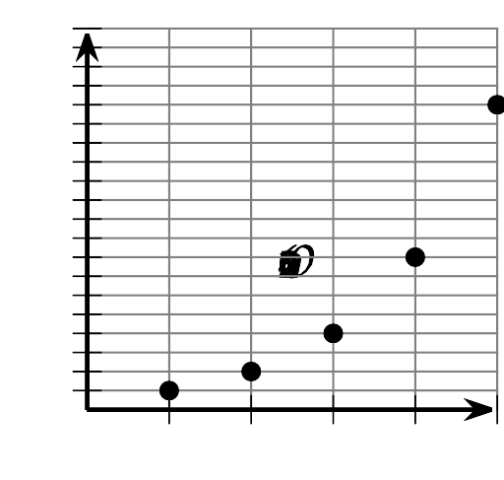
- (From Unit 1, Lesson 6.)
- An unfolded piece of paper is 0.05 mm thick.
  - Complete the table with the thickness of the piece of paper $T(n)$ after it is folded in half $n$ times.
  - Define $T$ for the $n^{\text{th}}$ term.
  - What is a reasonable domain for the function $T$? Explain how you know.
- $n$ | - $T(n)$
- 0 | - 0.05
- 1
- 2
- 3
- (From Unit 1, Lesson 9.)
- A piece of paper is 0.05 mm thick.
  - Complete the table with the thickness of the paper $t(n)$, in mm, after it has been folded $n$ times.
  - Does $t(0.5)$ make sense? Explain how you know.
- $n$ | - $t(n)$
- 0 | - $0.05$
- 1
- 2
- 3
- (From Unit 1, Lesson 9.)
- An arithmetic sequence $a$ starts 84, 77, . . .
  - Define $a$ recursively.
  - Define $a$ for the $n^{\text{th}}$ term.
- (From Unit 1, Lesson 10.)
- Here is a pattern of growing rectangles:
  - Describe how the rectangle grows from Step 0 to Step 2.
  - Write an equation for sequence $S$, so that $S(n)$ is the number of squares in Step $n$.
  - Is $S$ a geometric sequence, an arithmetic sequence, or neither? Explain how you know.
- (From Unit 1, Lesson 10.)
© CC BY 2019 by Illustrative Mathematics®

