Unit 5 Lesson 14: Food Drive

WU Estimation Exploration: Food Drive (Warm up)

Student Task Statement
How many cans did the first graders collect for the food drive?
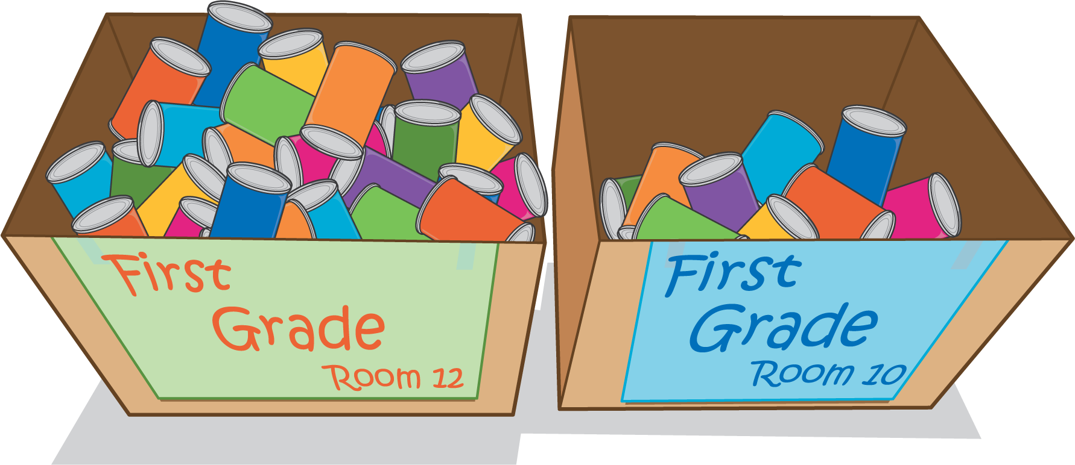
Record an estimate that is:
too low | about right | too high

1 Cans for the Food Drive

Student Task Statement
Student | Cans Collected
Lin | 18
Priya | 24
Han | 13
Tyler | 30
Partner A: Write an equation to represent your thinking.
- How many cans did Lin and Priya collect altogether?
- How many cans did Han and Tyler collect altogether?
- How many cans did all four students collect altogether?
Partner B: Write an equation to represent your thinking.
- How many cans did Tyler and Priya collect altogether?
- How many cans did Lin and Han collect altogether?
- How many cans did all four students collect altogether?

2 Boxes of Cans

Student Task Statement
Room | Cans Collected on Day 1
Kindergarten | 18
1st grade | 51
2nd grade | 23
3rd grade | 13
4th grade | 39
5th grade | 40
6th grade | 8
7th grade | 29
8th grade | 30
Find different ways they can pack the cans from 2 grades in a box together and have 35 to 65 cans in each box.
Try to find as many different ways as you can.
Write an equation to represent your thinking.
If you have time: Can any box have cans from 3 grade levels?
What is the least amount of boxes the school can pack to send to the Food Bank?
© CC BY 2021 Illustrative Mathematics®

