Unit 1 Lesson 12: Center Day 2

WU Number Talk: Differences (Warm up)

Student Task Statement
Find the value of each expression mentally.
- $17−7$
- $17−9$
- $15−5$
- $15−8$

1 Revisit Sort and Display

Student Task Statement

2 Centers Choice Time

Student Task Statement
Choose a center.
What's Behind My Back?
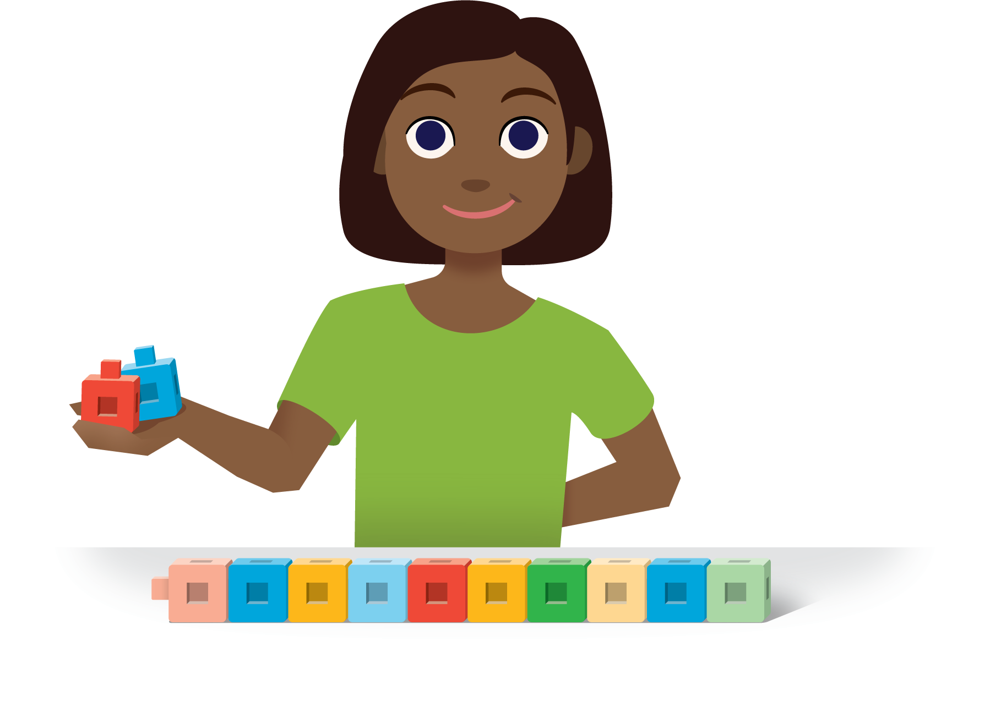
How Close?
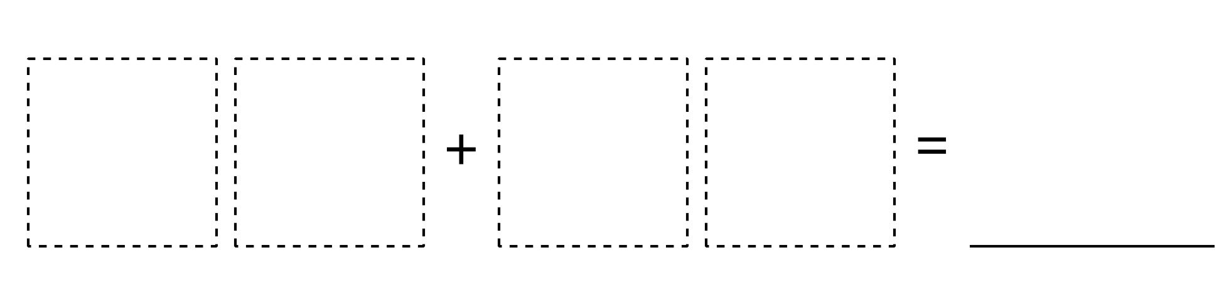
Number Puzzles
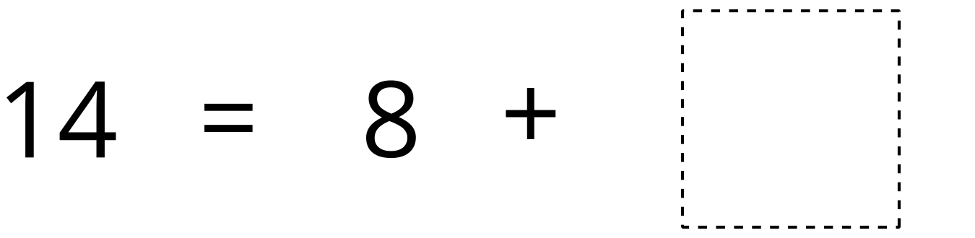
© CC BY 2021 Illustrative Mathematics®

