Unit 2 Lesson 11: Use Factors to Find Equivalent Fractions

WU Which One Doesn’t Belong: Four Representations (Warm up)

Student Task Statement
Which one doesn't belong?
- 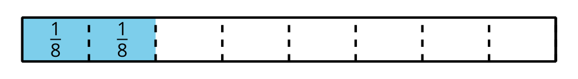
- $\frac{1}{4}$

1 The Other Way Around

Student Task Statement
- Andre drew a number line and marked a point on it. Label the point with the fraction it represents.
- To find other fractions that the point represents, Andre made copies of the number line. He drew darker marks on some of the existing tick marks.
- Label the darker tick marks Andre made on each number line.
- Kiran wrote the same fractions for the points but used a different strategy, as shown. Analyze his reasoning.
- $\frac{8 ÷ 4}{12 ÷ 4}=\frac{2}{3}$
- $\frac{8 ÷ 2}{12 ÷ 2}=\frac{4}{6}$
- How do you think Andre’s and Kiran’s strategies are related?
- Try using Kiran’s strategy to find one or more fractions that are equivalent to $\frac{10}{12}$ and $\frac{18}{12}$.

2 How Would You Find Them?

Student Task Statement
Find at least two fractions that are equivalent to each fraction. Show your reasoning.
- $\frac{16}{8}$
- $\frac{40}{10}$
- $\frac{7}{6}$
- $\frac{90}{100}$
- $\frac{5}{4}$

3 Card Sort: Fractions Galore (Optional)

Student Task Statement
Your teacher will give you a set of cards. Find as many sets of equivalent fractions as you can. Be prepared to explain or show your reasoning.
Record the sets of equivalent fractions here.
Record fractions that do not have an equivalent fraction here.
© CC BY 2021 Illustrative Mathematics®

