Unit 3 Lesson 6 Cumulative Practice Problems
- Match each equation to a story. (Two of the stories match the same equation.)
  - $3(x+5)=17$
  - $3x+5=17$
  - $5(x+3)=17$
  - $5x+3=17$
  - Jada’s teacher fills a travel bag with 5 copies of a textbook. The weight of the bag and books is 17 pounds. The empty travel bag weighs 3 pounds. How much does each book weigh?
  - A piece of scenery for the school play is in the shape of a 5-foot-long rectangle. The designer decides to increase the length. There will be 3 identical rectangles with a total length of 17 feet. By how much did the designer increase the length of each rectangle?
  - Elena spends $17 and buys a $3 book and a bookmark for each of her 5 cousins. How much does each bookmark cost?
  - Noah packs up bags at the food pantry to deliver to families. He packs 5 bags that weigh a total of 17 pounds. Each bag contains 3 pounds of groceries and a packet of papers with health-related information. How much does each packet of papers weigh?
  - Andre has 3 times as many pencils as Noah and 5 pens. He has 17 pens and pencils all together. How many pencils does Noah have?
- Elena walked 20 minutes more than Lin. Jada walked twice as long as Elena. Jada walked for 90 minutes. The equation $2(x+20)=90$ describes this situation. Match each expression with the statement in the story with the expression it represents.
  - $x$
  - $x+20$
  - $2(x+20)$
  - 90
  - The number of minutes that Jada walked
  - The number of minutes that Elena walked
  - The number of minutes that Lin walked
- A school ordered 3 large boxes of board markers. After giving 15 markers to each of 3 teachers, there were 90 markers left. The diagram represents the situation. How many markers were originally in each box?
- 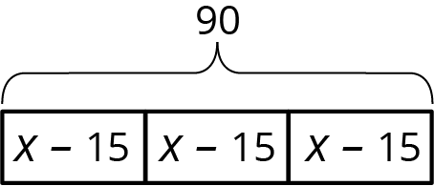

- (From Unit 3, Lesson 2.)
- Select all the pairs of points so that the line between those points has slope $\frac{2}{3}$.
  - $(0,0)$ and $(2,3)$
  - $(0,0)$ and $(3,2)$
  - $(1,5)$ and $(4,7)$
  - $(\text{-}2,\text{-}2)$ and $(4,2)$
  - $(20,30)$ and $(\text{-}20,\text{-}30)$
- (From Unit 2, Lesson 16.)
© CC BY Open Up Resources. Adaptations CC BY IM.

