Lesson 6: The Pythagorean Identity (Part 2)
Let’s use the Pythagorean Identity.

6.1: Math Talk: Which Quadrant?
For an angle $θ$ in the quadrant indicated, use mental estimation to identify the values of $\text{cos}(θ)$, $\text{sin}(θ)$, and $\text{tan}(θ)$ as either positive or negative.
Quadrant 1
Quadrant 2
Quadrant 3
Quadrant 4

6.2: Andre's Calculations
Suppose that the angle $θ$, in radians, is in quadrant 4 of the unit circle. If $\text{cos}(θ)=0.28$, what are the values of $\text{sin}(θ)$ and $\text{tan}(θ)$?
Andre uses the Pythagorean Identity and determines that the value of $\text{sin}(θ)$ is -0.96. Using the values of sine and cosine, he then calculates the value of tangent:
$\begin{matrix}\text{tan}(θ) & =\frac{\text{sin}(θ)}{\text{cos}(θ)} \\ & =\frac{\text{-}0.96}{0.28} \\ & ≈\text{-}3.43\end{matrix}$
Do you agree with Andre? Explain or show your reasoning.

6.3: Card Sort: Where's the Point?
Your teacher will give you a set of cards that should be arranged face up with cards showing values for sine, cosine, and tangent on one side and cards showing quadrants on the other.
- Take turns with your partner matching pairs of cards. Identify 2 pairs that are possible on the unit circle and 2 pairs that are not possible, in any order.
  - For each pair, explain to your partner how you know if the pair is or is not possible on the unit circle. Once a pair is identified, place the cards in front of you to use later.
  - For each pair that your partner draws, listen carefully to their explanation. If you disagree, discuss your thinking and work to reach an agreement.
- Once you and your partner have identified 4 pairs each, pick 1 of your possible matches and then calculate the values of the two missing trigonometric ratios for that match. When you finish, trade calculations with your partner and check each other's work. If you disagree, discuss your thinking and work to reach an agreement.

Are you ready for more?
Suppose $\text{tan}(θ)=2$ and the angle $θ$ is in quadrant 1. Find the values of $\text{cos}(θ)$ and $\text{sin}(θ)$.

Lesson 6 Summary
Say we know that $\text{sin}(θ)=\text{-}\frac{\sqrt{2}}{2}$ and that $θ$ is an angle in quadrant 3. What can we say about the values of cosine and tangent at $θ$?
Since we can think of $\text{sin}(θ)$ as the $y$-coordinate of a point $P$ in quadrant 3, let’s start with a sketch of the unit circle showing point $P$.
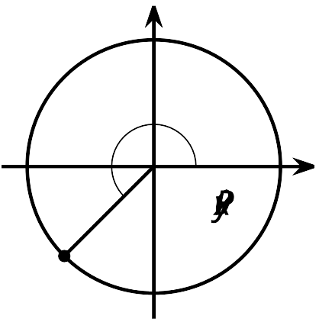
The sketch helps us see that the $x$-coordinate, which is $\text{cos}(θ)$, is also negative. Using the Pythagorean Identity, we can calculate the value of $\text{cos}(θ)$:
$\begin{matrix}{\text{cos}}^{2}(θ)+{\text{sin}}^{2}(θ) & =1^{2} \\ {\text{cos}}^{2}(θ)+{\left(\text{-}\frac{\sqrt{2}}{2}\right)}^{2} & =1 \\ {\text{cos}}^{2}(θ) & =1−{\left(\text{-}\frac{\sqrt{2}}{2}\right)}^{2} \\ {\text{cos}}^{2}(θ) & =1−\frac{2}{4} \\ \text{cos}(θ) & =\text{-}\sqrt{1−\frac{1}{2}} \\ \text{cos}(θ) & =\text{-}\sqrt{\frac{1}{2}}\end{matrix}$
Now that we know the value of cosine, we can calculate the value of tangent with some division:
$\text{tan}(θ)=\frac{\text{-}\frac{\sqrt{2}}{2}}{\text{-}\sqrt{\frac{1}{2}}}=\frac{\frac{\sqrt{2}}{2}}{\frac{\sqrt{2}}{2}}=1$
We can use one piece of information and the structure of the unit circle to figure out a whole bunch more, similar to how we used the value of one side length, the hypotenuse, and the structure of right triangles in the past to figure out the other side length of the right triangle.
© CC BY 2019 by Illustrative Mathematics®

