Lesson 10: Escribamos números de dos dígitos

Standards Alignments
Addressing | 1.NBT.A.1, 1.NBT.B.2

Teacher-facing Learning Goals
- Write numbers to represent different base-ten representations.

Student-facing Learning Goals
- Escribamos números de dos dígitos.

Lesson Purpose
The purpose of this lesson is for students to write numbers to represent different base-ten representations including base-ten diagrams, _____ tens _____ ones, and expressions that show the value of the tens and ones digits.
In previous lessons, students read two-digit numbers and interpreted and created representations of those numbers. In this lesson, students write two-digit numbers to match different base-ten representations. Students also learn a new center that provides practice counting and writing numbers up to 99.

Access for:

Students with Disabilities
- Engagement (Activity 1)

English Learners
- MLR8 (Activity 2)

Instructional Routines
Notice and Wonder (Warm-up)

Materials to Gather
- Connecting cubes in towers of 10 and singles: Activity 1
- Dry erase markers: Activity 2
- Sheet protectors: Activity 2

Materials to Copy
- Write the Number Stage 1 Gameboard, Spanish (groups of 2): Activity 2

Lesson Timeline
Warm-up | 10 min
Activity 1 | 15 min
Activity 2 | 20 min
Lesson Synthesis | 10 min
Cool-down | 5 min

Teacher Reflection Question
Reflect on how you can reinforce number writing outside of math class. When can you ask students to write two-digit numbers that represent quantities around them? What questions can you ask to help them see the tens and ones in these quantities?

Cool-down
(to be completed at the end of the lesson) 5min
Escribe números

Standards Alignments
Addressing | 1.NBT.A.1, 1.NBT.B.2

Student-facing Task Statement
Escribe el número que corresponda a cada representación.
- $30+9$
- ___________________

- 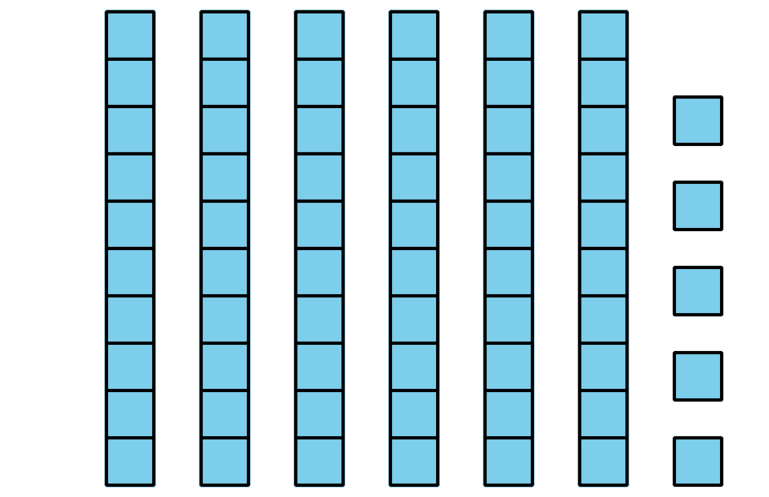
- ___________________

- 7 unidades 9 decenas
- ___________________

Student Responses
- 39
- 65
- 97

