Lesson 8: Add and Subtract Fractions
- Let’s add and subtract fractions.

Warm-up: Which One Doesn’t Belong: Fraction Representations
Which one doesn’t belong?
A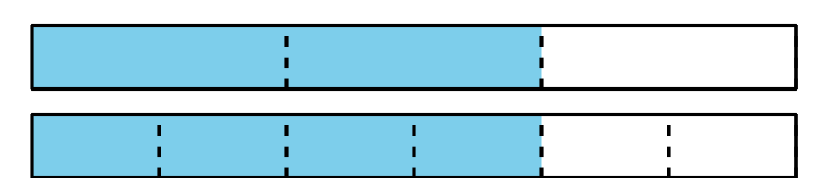
B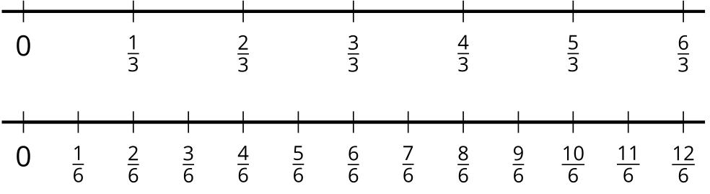
C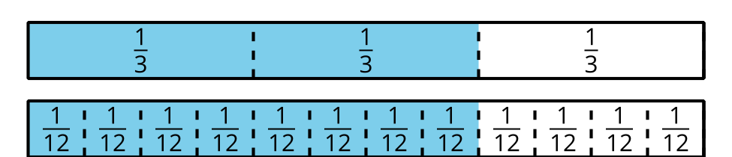
D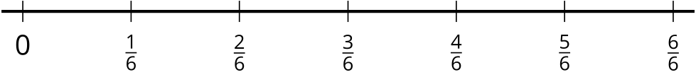

8.1: Card Sort: Fraction Sums and Differences
Your teacher will give you a set of cards that show expressions.
- Sort the cards into 2 categories of your choosing. Be prepared to explain the meaning of your categories.
- Sort the cards into 2 categories in a different way. Be prepared to explain the meaning of your new categories.

8.2: Add and Subtract
Find the value of each expression. Explain or show your thinking.
- $\frac{2}{3}+\frac{2}{3}$
- $\frac{2}{3}−\frac{1}{6}$
- $\frac{2}{3}+\frac{1}{2}$
© CC BY 2021 Illustrative Mathematics®

