Unit 3 Lesson 6: Multiply Fractions

WU Which One Doesn’t Belong: More Pieces (Warm up)

Student Task Statement
Which one doesn’t belong?
A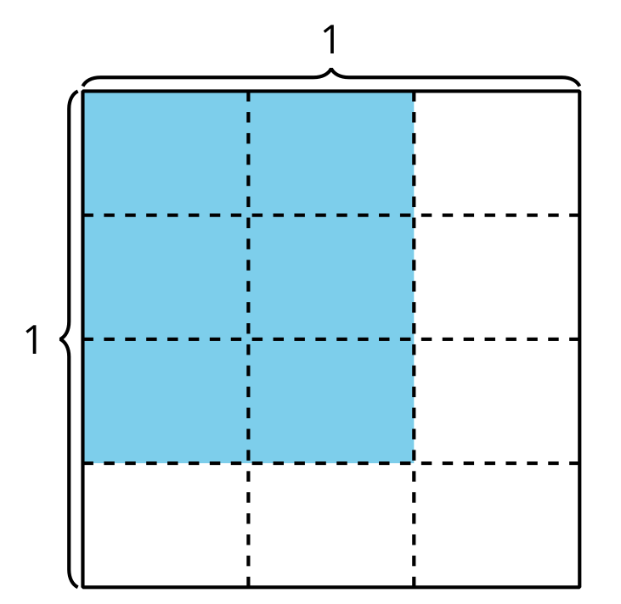
B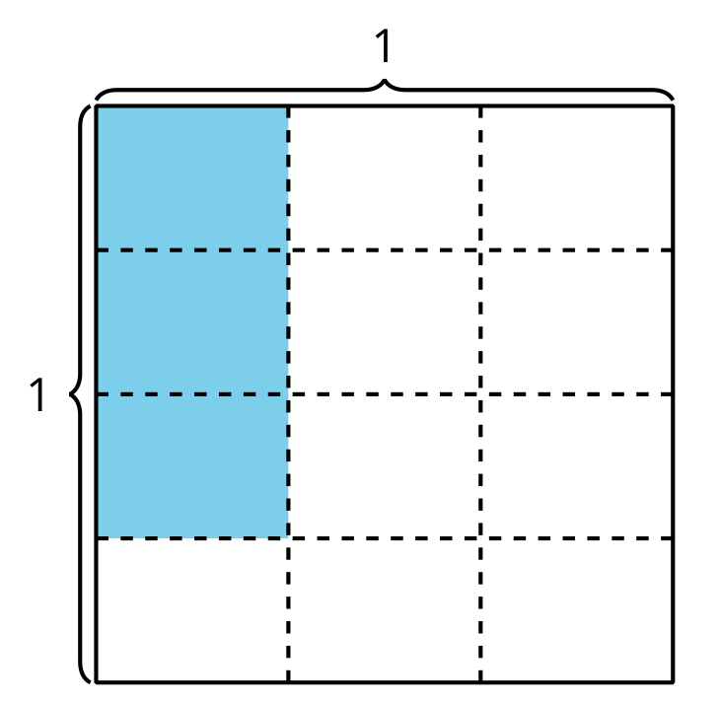
C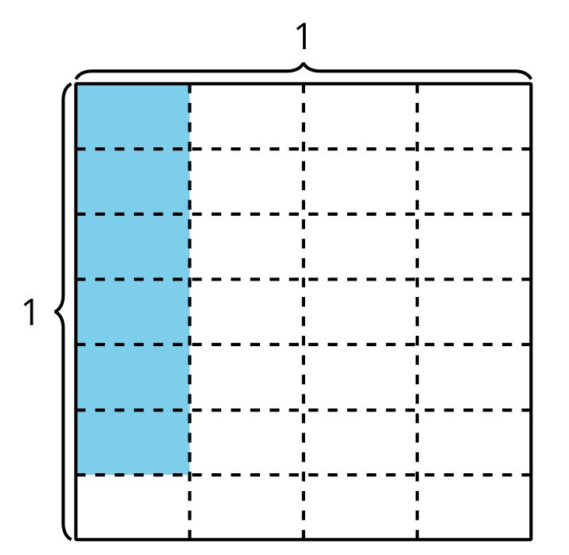
D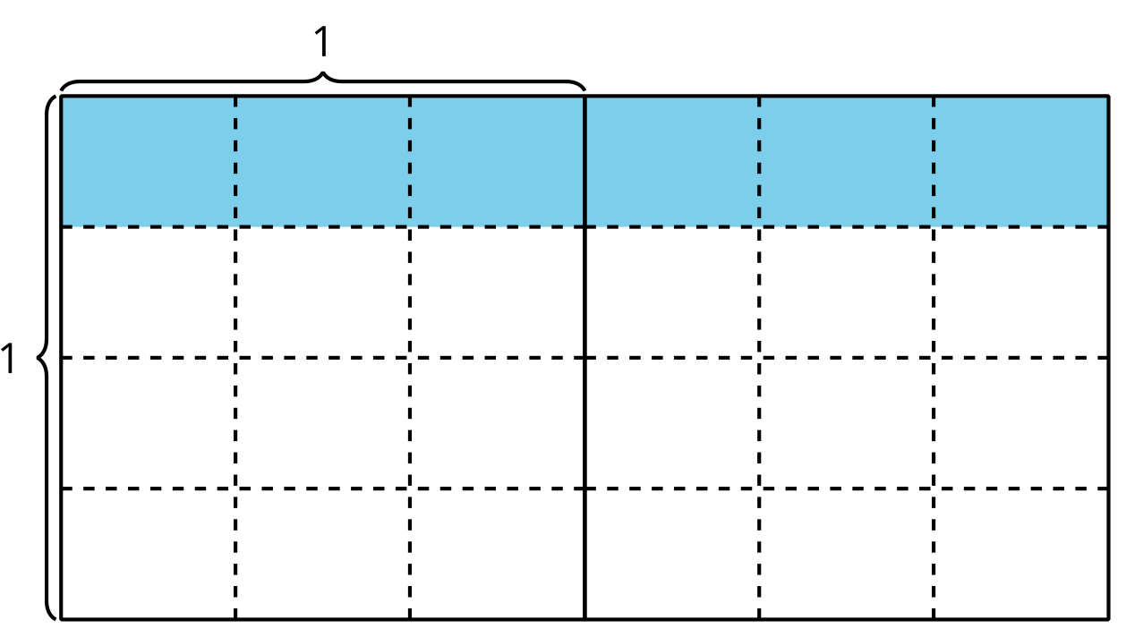

1 Many Expressions

Student Task Statement
Explain or show how each expression can represent the area of the shaded region in square units. Be prepared to share your thinking.
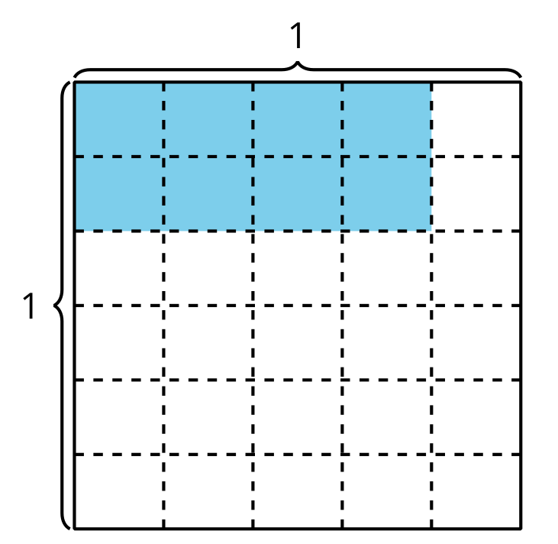
- $\frac{8}{30}$
- $2×4×\left(\frac{1}{5}×\frac{1}{6}\right)$
- $\frac{2}{6}×\frac{4}{5}$

2 More Patterns

Student Task Statement
- Complete the table.
- diagram | - multiplication  expression | - shaded area  (square units)
- A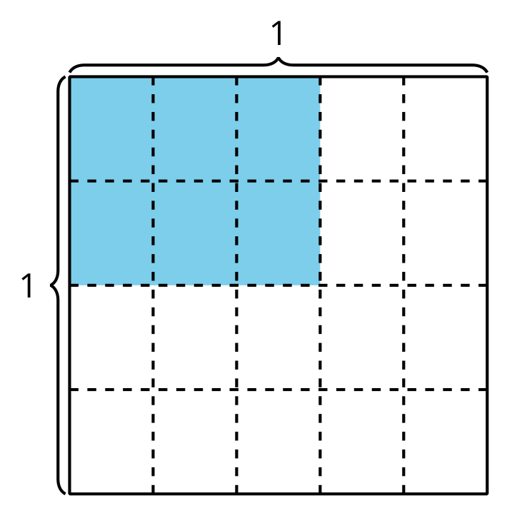
- B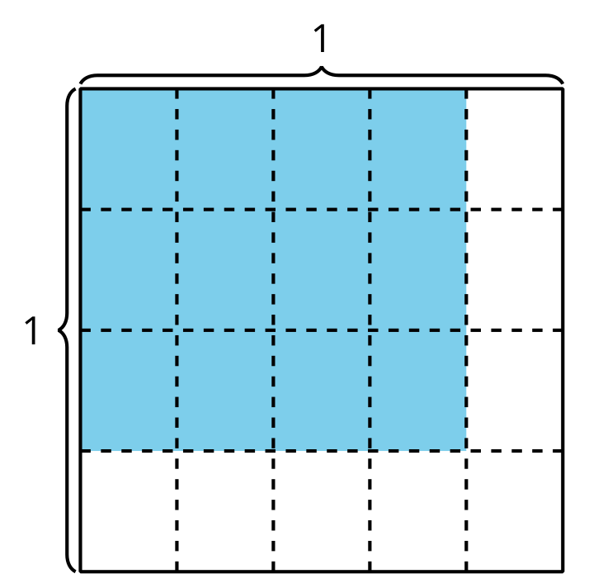

- diagram | - multiplication  expression | - shaded area  (square units)
- C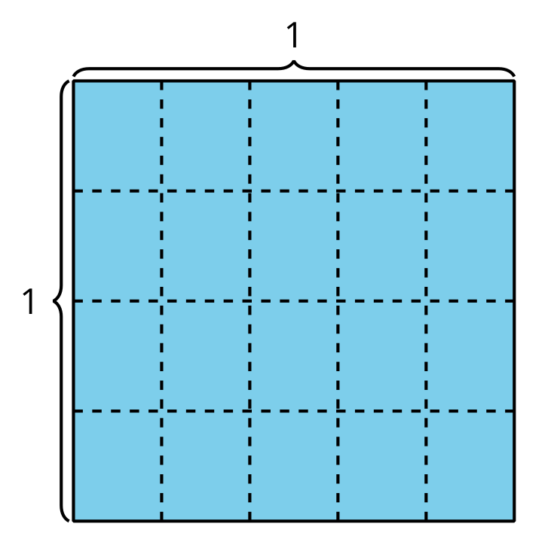
- D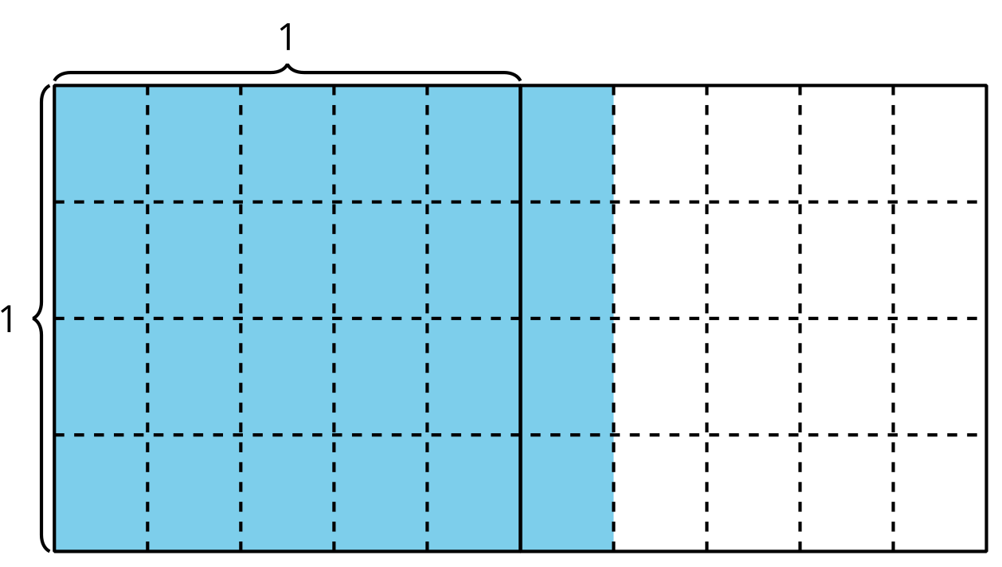
- What patterns do you notice in the table?
- Explain or show how the expression $\frac{6×4}{5×4}$ represents the last diagram in the table.
© CC BY 2021 Illustrative Mathematics®

