Lesson 8: Ways to Find Unknown Length (Part 2)
- Let’s find the unknown lengths in figures.

Warm-up: True or False: Equations with Fractions
Decide if each statement is true or false. Be prepared to explain your reasoning.
- $1\frac{1}{5}+2\frac{2}{5}+3\frac{3}{5}+4\frac{4}{5}=12$
- $10−\frac{1}{2}−\frac{2}{2}−\frac{3}{2}−\frac{4}{2}=5$
- $1\frac{1}{6}+2\frac{2}{6}+3\frac{3}{6}+4\frac{4}{6}+5\frac{5}{6}=15\frac{3}{6}$
- $\frac{1}{3}+\frac{2}{3}+\frac{3}{3}=3×\frac{2}{3}$

8.1: Unknown Lengths
Here are four shapes.
- Each shape has a perimeter of 64 inches.
- P, R, and S each have 1 line of symmetry.
- Q has 4 lines of symmetry.
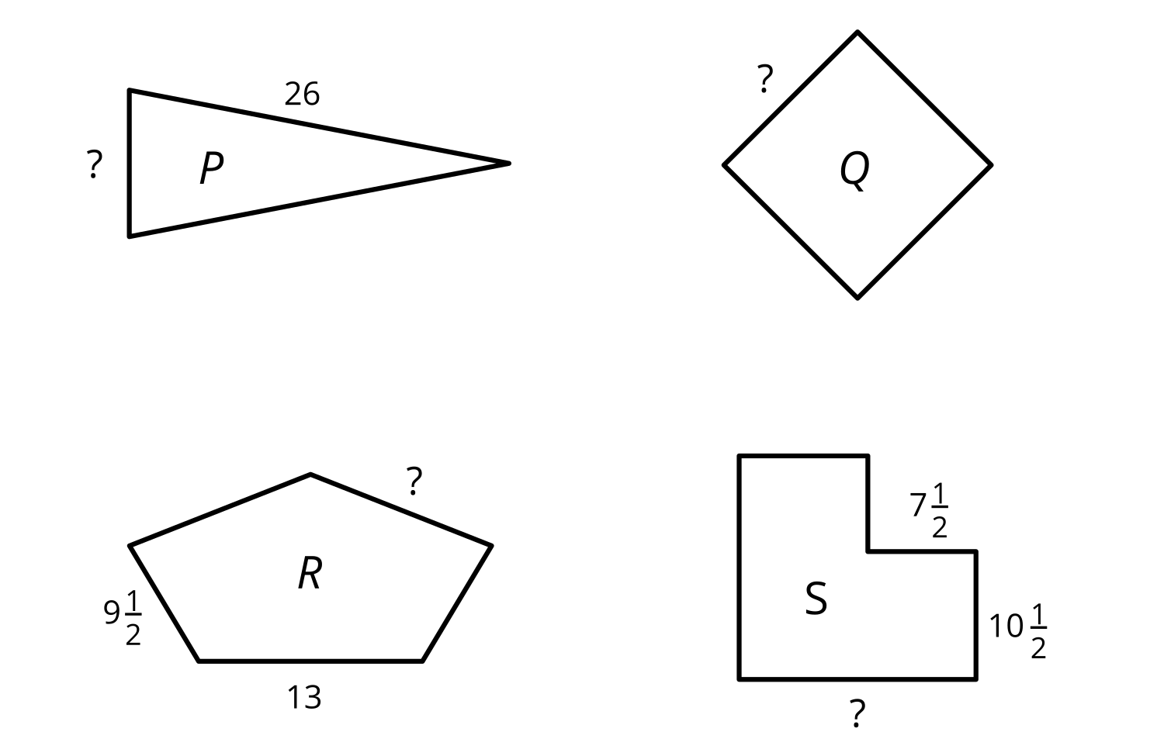
- Draw the lines of symmetry of each shape.
- Find the unknown side length in each shape. Show your reasoning.

8.2: Lin’s Design
Lin is using 145 inches of fancy tape for the outline of a design with line symmetry.
Here is half of the design. The dashed line is the line of symmetry.
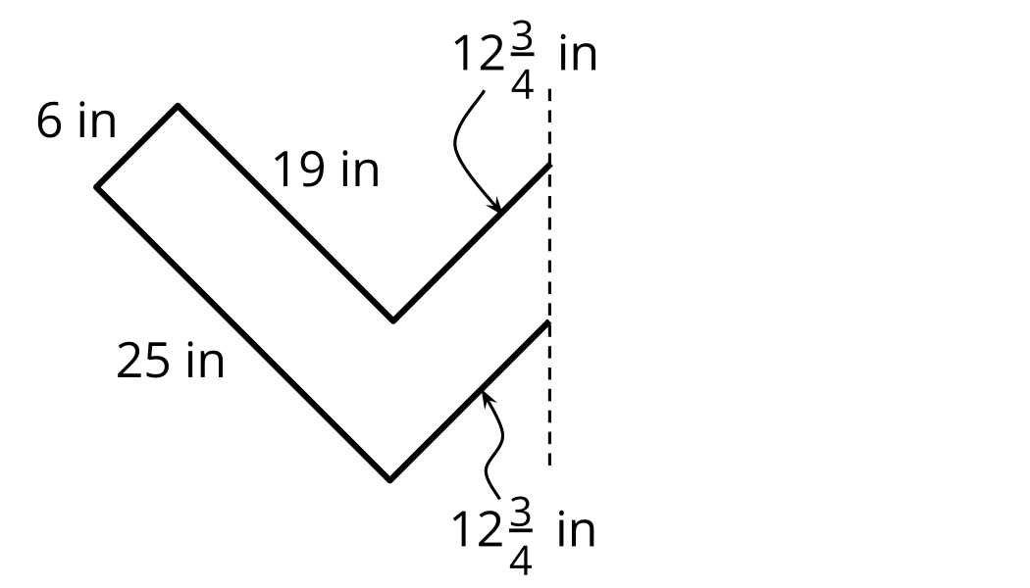
- Sketch Lin’s entire design.
- Does she have enough tape for the entire outline? Show your reasoning.
If you have time: Lin has a sheet of fancy paper that she can cut up to cover the inside of the design. The paper is a rectangle that is 30 inches by 18 inches. If the angles in the design are right angles, does Lin have enough paper to cover the inside of the design? Show your reasoning.

Section Summary
Section Summary
In this section, we used the attributes such as side lengths, angles, lines of symmetry, and parallel sides to solve problems about perimeter of shapes.
We learned that, if a shape has certain attributes, we can use them to find its perimeter, even if we don't have all of its side lengths. Or, if we know the perimeter of a shape, we can find its side lengths if there is enough information about their attributes.
For example, here are two shapes:
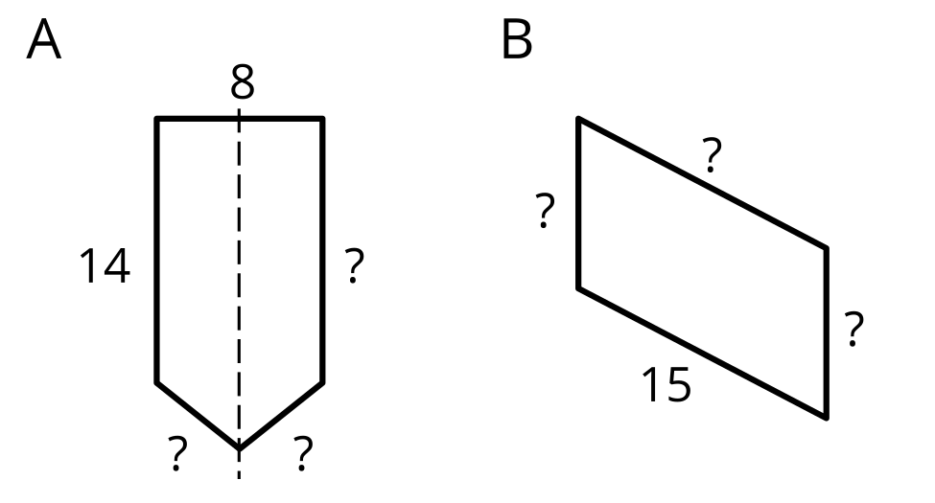
If we know the perimeter of each shape is 48 units and the dashed line through shape A is a line of symmetry, we can find the missing side lengths.
Shape B doesn't have a line of symmetry, but if we were told that its opposite sides have equal lengths, then we can also reason about the three missing side lengths.
© CC BY 2021 Illustrative Mathematics®

