Unit 5 Lesson 13: Systems of Equations

1 Milkshakes (Warm up)

Student Task Statement
Diego and Lin are drinking milkshakes. Lin starts with 12 ounces and drinks $\frac{1}{4}$ ounce per second. Diego starts with 20 ounces and drinks $\frac{2}{3}$ ounce per second.
- How long will it take Lin and Diego to finish their milkshakes?
- Without graphing, explain what the graphs in this situation would look like. Think about slope, intercepts, axis labels, units, and intersection points to guide your thinking.
- Discuss your description with your partner. If you disagree, work to reach an agreement.

2 Passing on the Trail

Student Task Statement
There is a hiking trail near the town where Han and Jada live that starts at a parking lot and ends at a lake. Han and Jada both decide to hike from the parking lot to the lake and back, but they start their hikes at different times.
At the time that Han reaches the lake and starts to turn back, Jada is 0.6 miles away from the parking lot and hiking at a constant speed of 3.2 miles per hour towards the lake. Han’s distance, $d$, from the parking lot can be expressed as $d=\text{-}2.4t+4.8$, where $t$ represents the time in hours since he left the lake.
- What is an equation for Jada’s distance from the parking lot as she heads toward the lake?
- Draw both graphs: one representing Han's equation and one representing Jada’s equation. It is important to be very precise! Be careful, work in pencil, and use a ruler.
- 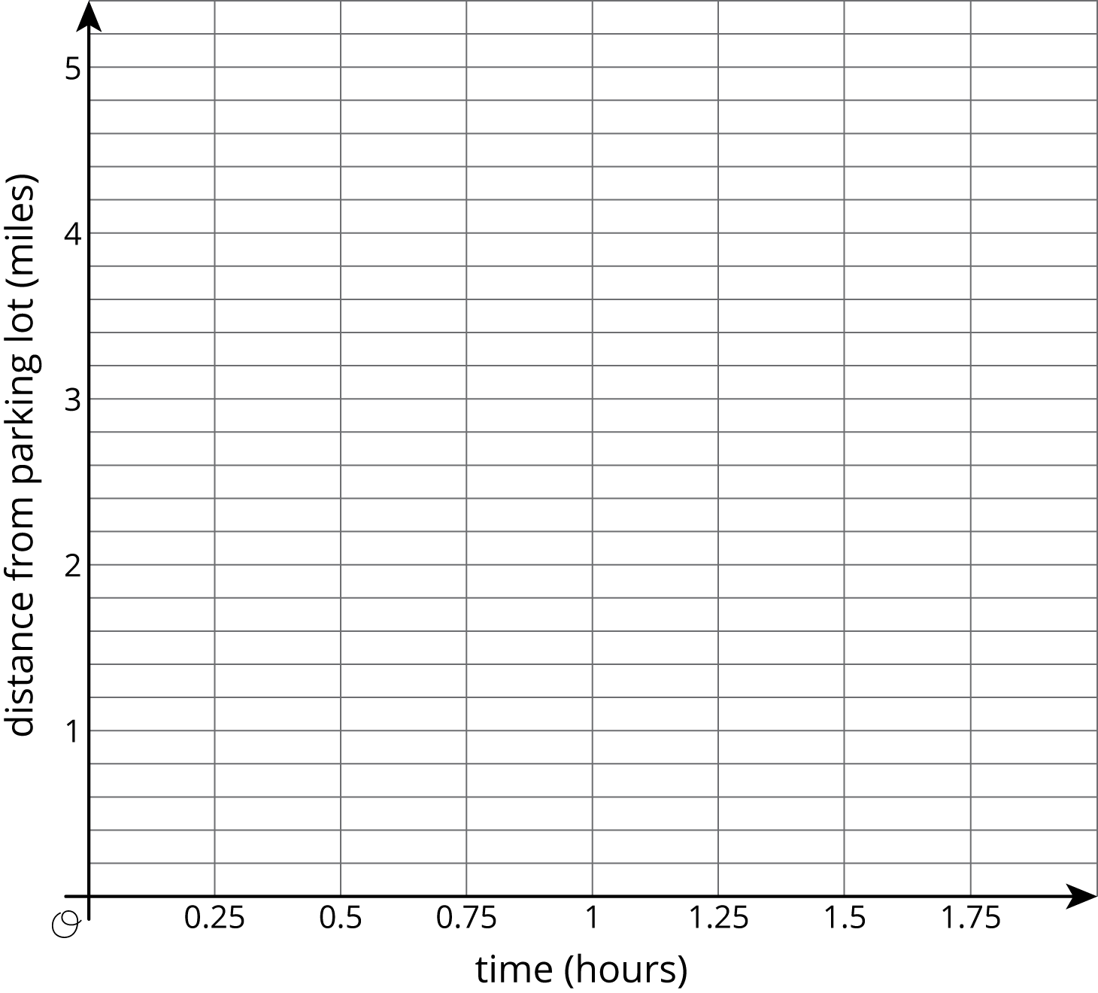
- Find the point where the two graphs intersect each other. What are the coordinates of this point?
- What do the coordinates mean in this situation?
- What has to be true about the relationship between these coordinates and Jada’s equation?
- What has to be true about the relationship between these coordinates and Han’s equation?

3 Stacks of Cups

Student Task Statement
A stack of $n$ small cups has a height, $h$, in centimeters of $h=1.5n+6$. A stack of $n$ large cups has a height, $h$, in centimeters of $h=1.5n+9$.
- Graph the equations for each cup on the same set of axes. Make sure to label the axes and decide on an appropriate scale.
- For what number of cups will the two stacks have the same height?
© CC BY Open Up Resources. Adaptations CC BY IM.

