Unit 3 Lesson 7 Cumulative Practice Problems
- Explain how the parts of the balanced hanger compare to the parts of the equation.
- $7=2x+3$
- 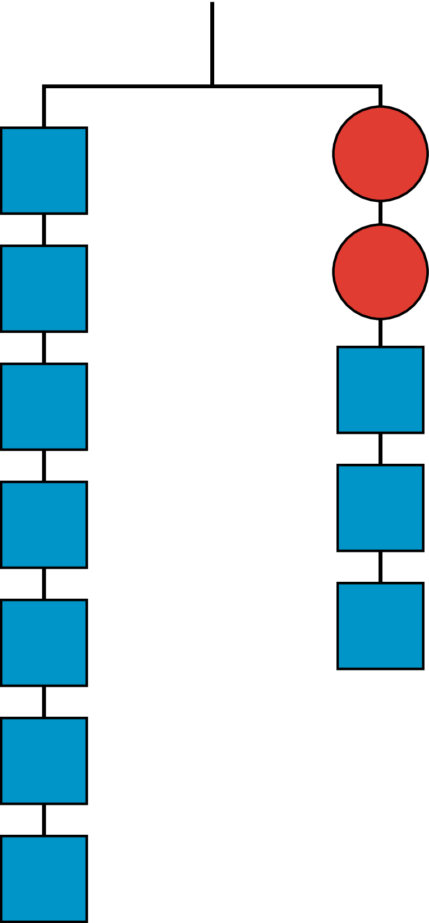
- For the hanger below:
  - Write an equation to represent the hanger.
  - Draw more hangers to show each step you would take to find $x$. Explain your reasoning.
  - Write an equation to describe each hanger you drew. Describe how each equation matches its hanger.
- 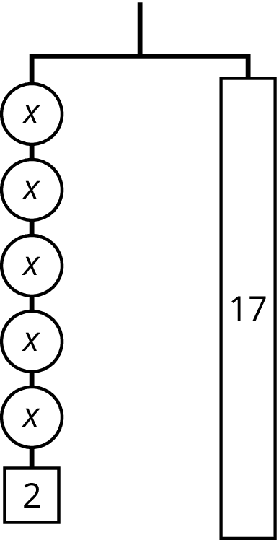
- Clare drew this diagram to match the equation $2x+16=50$, but she got the wrong solution as a result of using this diagram.
- 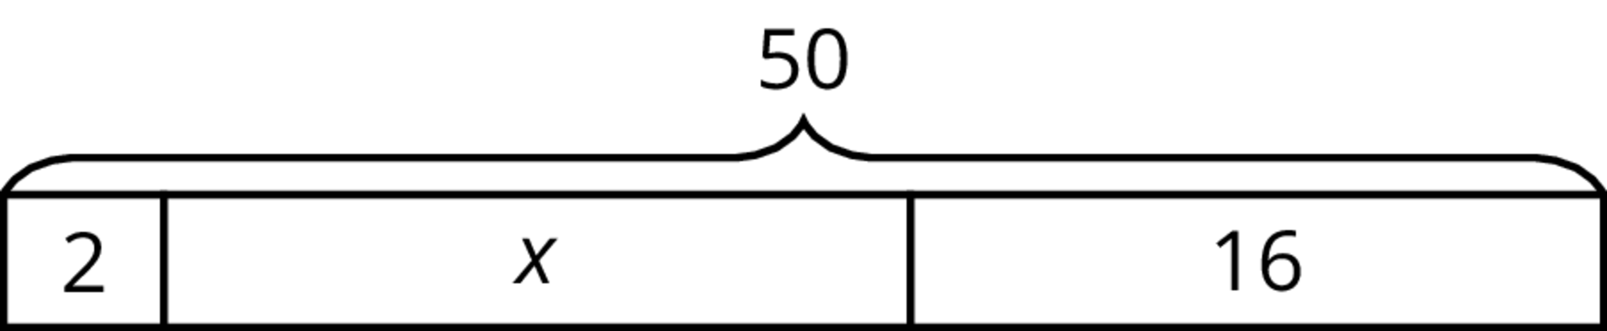

  - What value for $x$ can be found using the diagram?
  - Show how to fix Clare’s diagram to correctly match the equation.
  - Use the new diagram to find a correct value for $x$.
  - Explain the mistake Clare made when she drew her diagram.
- (From Unit 3, Lesson 3.)
© CC BY Open Up Resources. Adaptations CC BY IM.

