Unit 8 Lesson 18: Comparing Populations Using Samples

1 Same Mean? Same MAD? (Warm up)

Student Task Statement
Without calculating, tell whether each pair of data sets have the same mean and whether they have the same mean absolute deviation.

- set A
- 1
- 3
- 3
- 5
- 6
- 8
- 10
- 14

- set B
- 21
- 23
- 23
- 25
- 26
- 28
- 30
- 34

- set X
- 1
- 2
- 3
- 4
- 5

- set Y
- 1
- 2
- 3
- 4
- 5
- 6

- set P
- 47
- 53
- 58
- 62

- set Q
- 37
- 43
- 68
- 72

2 With a Heavy Load

Student Task Statement
Consider the question: Do tenth-grade students' backpacks generally weigh more than seventh-grade students' backpacks?
Here are dot plots showing the weights of backpacks for a random sample of students from these two grades:
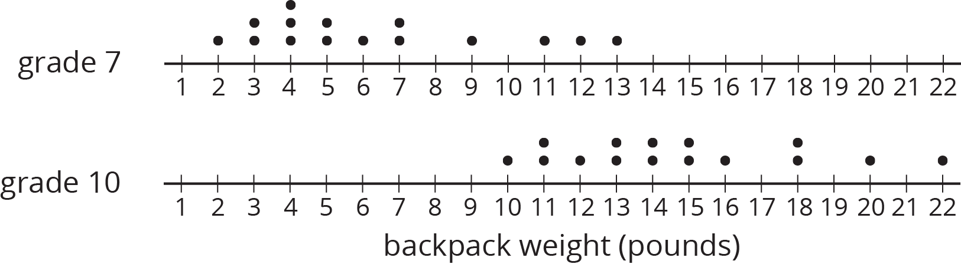
- Did any seventh-grade backpacks in this sample weigh more than a tenth-grade backpack?
- The mean weight of this sample of seventh-grade backpacks is 6.3 pounds. Do you think the mean weight of backpacks for all seventh-grade students is exactly 6.3 pounds?
- The mean weight of this sample of tenth-grade backpacks is 14.8 pounds. Do you think there is a meaningful difference between the weight of all seventh-grade and tenth-grade students' backpacks? Explain or show your reasoning.

3 Do They Carry More?

Student Task Statement
Here are 10 more random samples of seventh-grade students' backpack weights.
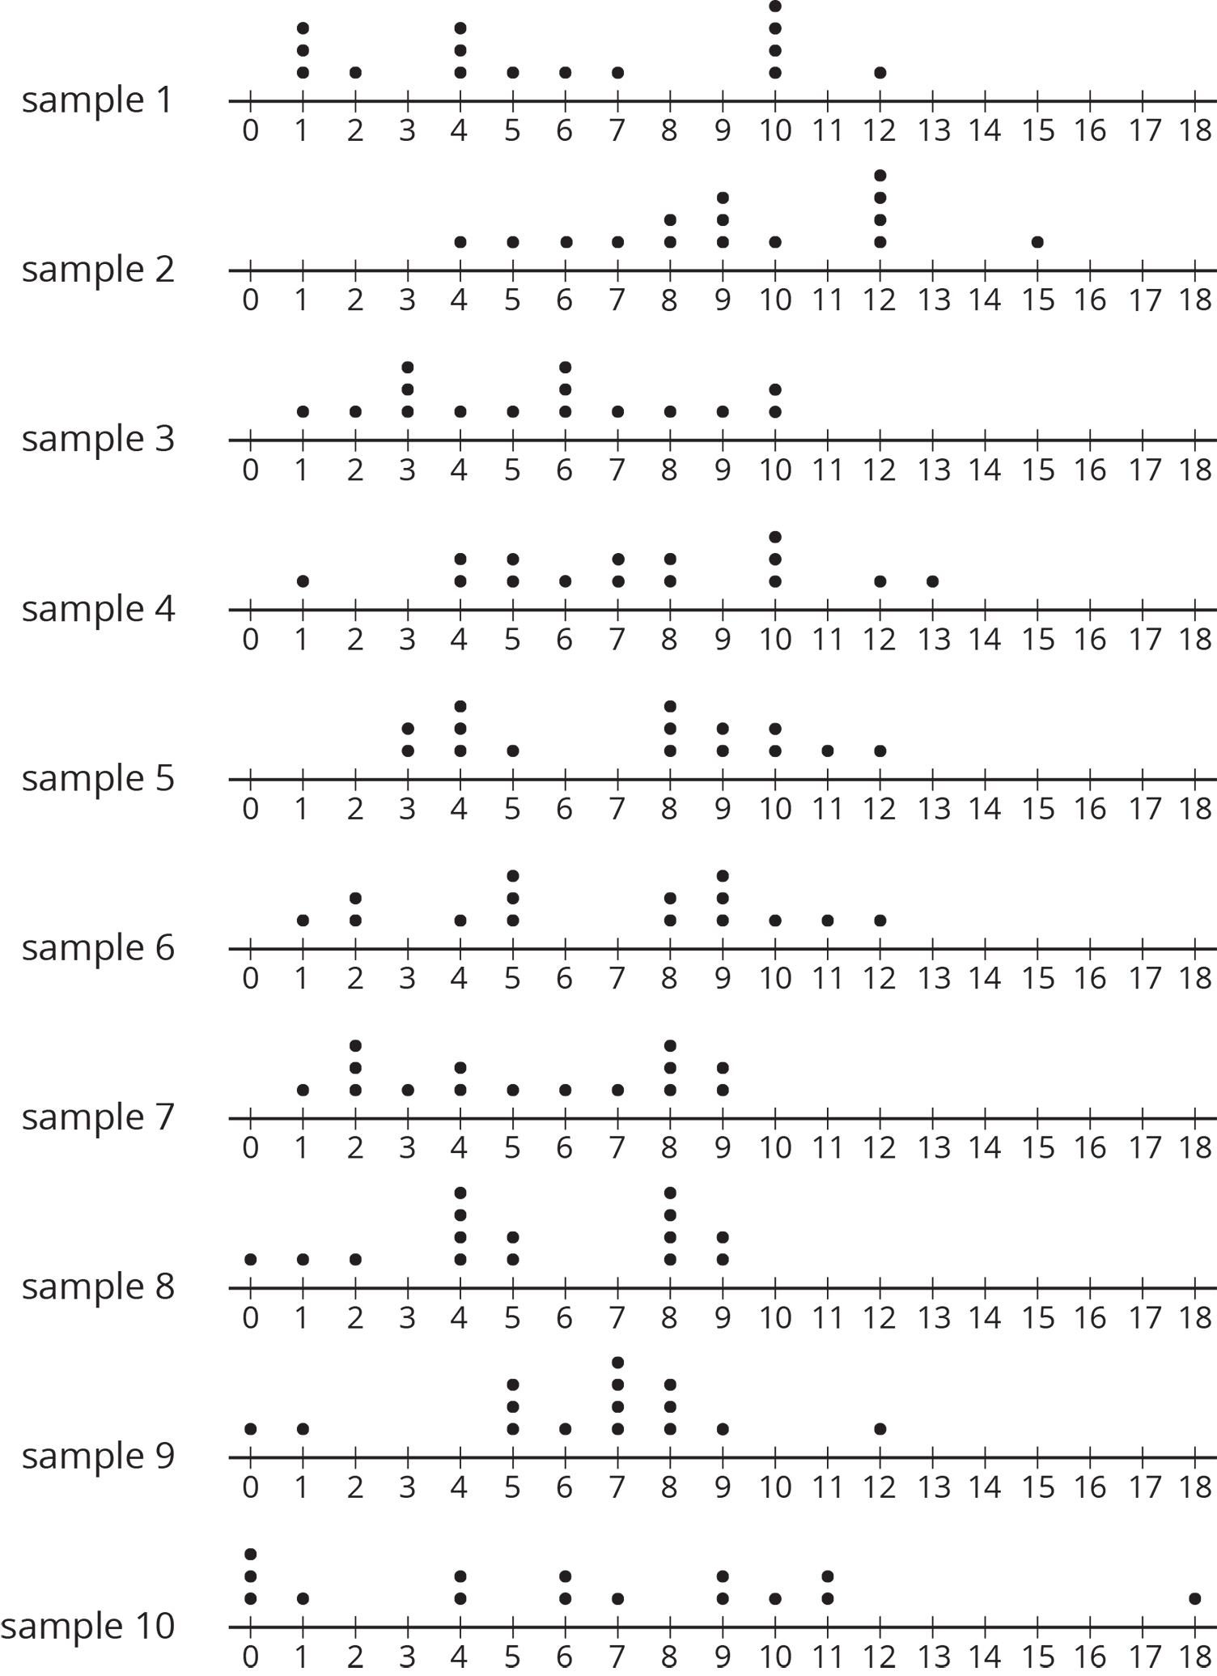
sample  number | mean weight  (pounds)
1 | 5.8
2 | 9.2
3 | 5.5
4 | 7.3
5 | 7.2
6 | 6.6
7 | 5.2
8 | 5.3
9 | 6.3
10 | 6.4

  - Which sample has the highest mean weight?
  - Which sample has the lowest mean weight?
  - What is the difference between these two sample means?
- All of the samples have a mean absolute deviation of about 2.8 pounds. Express the difference between the highest and lowest sample means as a multiple of the MAD.
- Are these samples very different? Explain or show your reasoning.
- Remember our sample of tenth-grade students' backpacks had a mean weight of 14.8 pounds. The MAD for this sample is 2.7 pounds. Your teacher will assign you one of the samples of seventh-grade students' backpacks to use.
  - What is the difference between the sample means for the the tenth-grade students' backpacks and the seventh-grade students' backpacks?
  - Express the difference between these two sample means as a multiple of the larger of the MADs.
- Do you think there is a meaningful difference between the weights of all seventh-grade and tenth-grade students' backpacks? Explain or show your reasoning.

4 Steel from Different Regions

Student Task Statement
When anthropologists find steel artifacts, they can test the amount of carbon in the steel to learn about the people that made the artifacts. Here are some box plots showing the percentage of carbon in samples of steel that were found in two different regions:
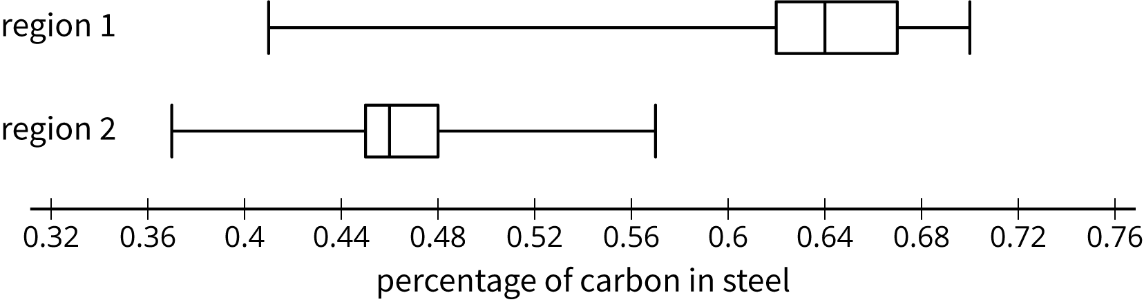
- Was there any steel found in region 1 that had:
  - more carbon than some of the steel found in region 2?
  - less carbon than some of the steel found in region 2?
- Do you think there is a meaningful difference between all the steel artifacts found in regions 1 and 2?
- Which sample has a distribution that is not approximately symmetric?
- What is the difference between the sample medians for these two regions?
 | - sample  median (%) | - IQR  (%)
- region 1 | - 0.64 | - 0.05
- region 2 | - 0.47 | - 0.03
- Express the difference between these two sample medians as a multiple of the larger interquartile range.
- The anthropologists who conducted the study concluded that there was a meaningful difference between the steel from these regions. Do you agree? Explain or show your reasoning.
© CC BY Open Up Resources. Adaptations CC BY IM.

