Lesson 17: Squares and Cubes
Let’s investigate perfect squares and perfect cubes.

17.1: Perfect Squares
- The number 9 is a perfect square. Find four numbers that are perfect squares and two numbers that are not perfect squares.
- A square has side length 7 in. What is its area?
- The area of a square is 64 sq cm. What is its side length?
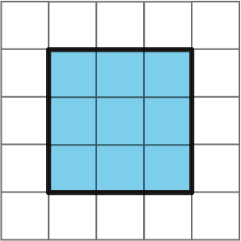

17.2: Building with 32 Cubes
Your teacher will give you 32 snap cubes. Use them to build the largest single cube you can. Each small cube has an edge length of 1 unit.
- How many snap cubes did you use?
- What is the edge length of the cube you built?
- What is the area of each face of the built cube? Be prepared to explain your reasoning.
- What is the volume of the built cube? Be prepared to explain your reasoning.

17.3: Perfect Cubes
- The number 27 is a perfect cube. Find four other numbers that are perfect cubes and two numbers that are not perfect cubes.
- A cube has side length 4 cm. What is its volume?
- A cube has side length 10 inches. What is its volume?
- A cube has side length $s$ units. What is its volume?
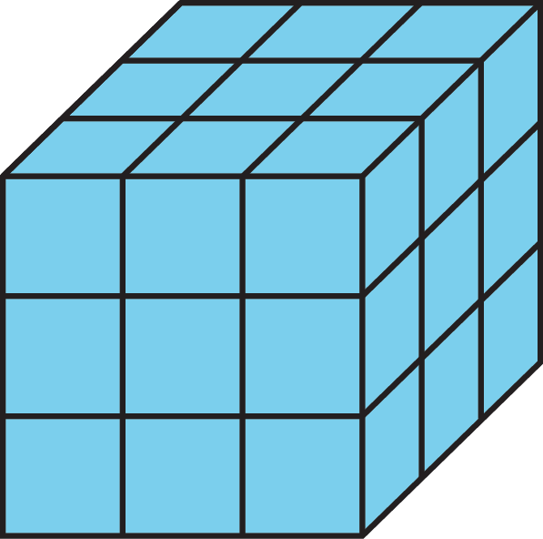

17.4: Introducing Exponents
Make sure to include correct units of measure as part of each answer.
- A square has side length 10 cm. Use an exponent to express its area.
- The area of a square is $7^{2}$ sq in. What is its side length?
- The area of a square is 81 m². Use an exponent to express this area.
- A cube has edge length 5 in. Use an exponent to express its volume.
- The volume of a cube is $6^{3}$ cm³. What is its edge length?
- A cube has edge length $s$ units. Use an exponent to write an expression for its volume.

Are you ready for more?
The number 15,625 is both a perfect square and a perfect cube. It is a perfect square because it equals ${125}^{2}$. It is also a perfect cube because it equals ${25}^{3}$. Find another number that is both a perfect square and a perfect cube. How many of these can you find?

Lesson 17 Summary
When we multiply two of the same numbers together, such as $5⋅5$, we say we are squaring the number. We can write it like this: $5^{2}$
Because $5⋅5=25$, we write $5^{2}=25$ and we say, “5 squared is 25.”
When we multiply three of the same numbers together, such as $4⋅4⋅4$, we say we are cubing the number. We can write it like this: $4^{3}$
Because $4⋅4⋅4=64$, we write $4^{3}=64$ and we say, “4 cubed is 64.”
We also use this notation for square and cubic units.
- A square with side length 5 inches has area 25 in².
- A cube with edge length 4 cm has volume 64 cm³.
To read 25 in², we say “25 square inches,” just like before.
The area of a square with side length 7 kilometers is $7^{2}$ km². The volume of a cube with edge length 2 millimeters is $2^{3}$ mm³.
In general, the area of a square with side length $s$ is $s^{2}$, and the volume of a cube with edge length $s$ is $s^{3}$.
© CC BY Open Up Resources. Adaptations CC BY IM.

