Unit 3 Lesson 7: Generalize Fraction Multiplication

WU Notice and Wonder: Two Diagrams (Warm up)

Student Task Statement
What do you notice? What do you wonder?
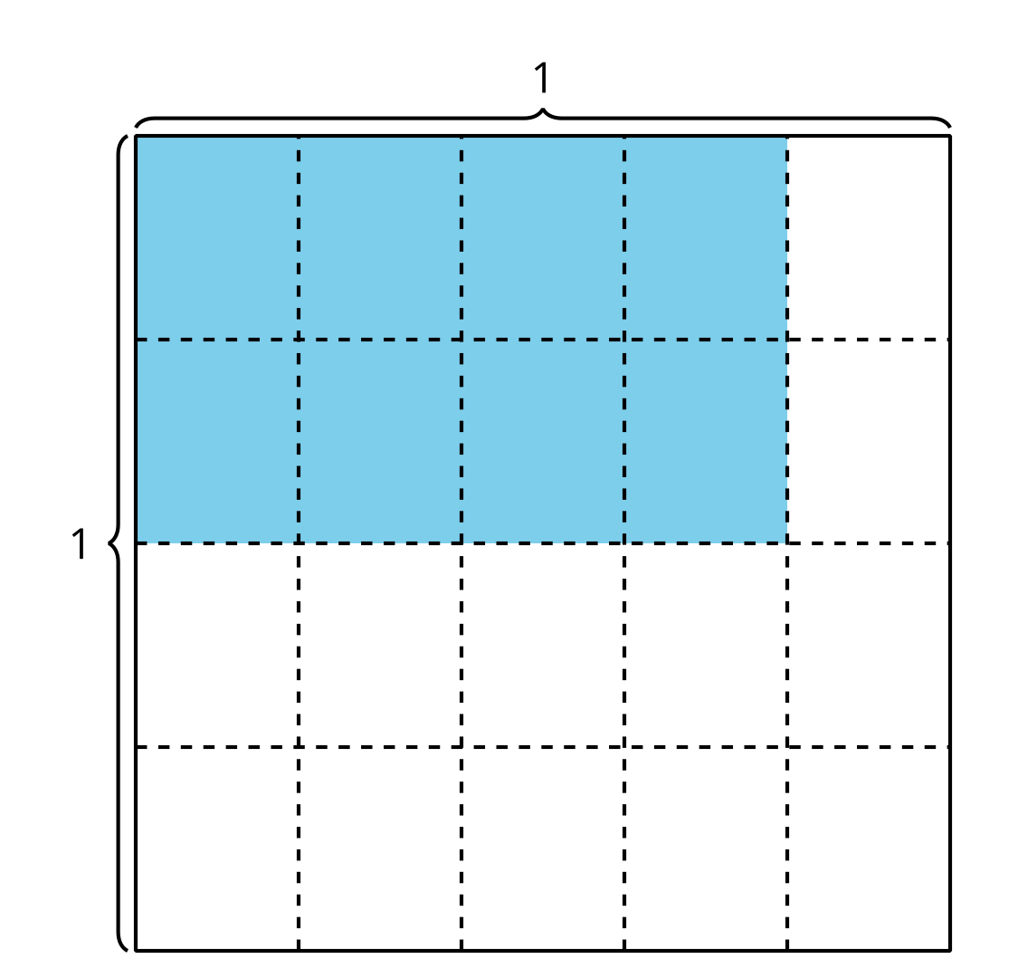
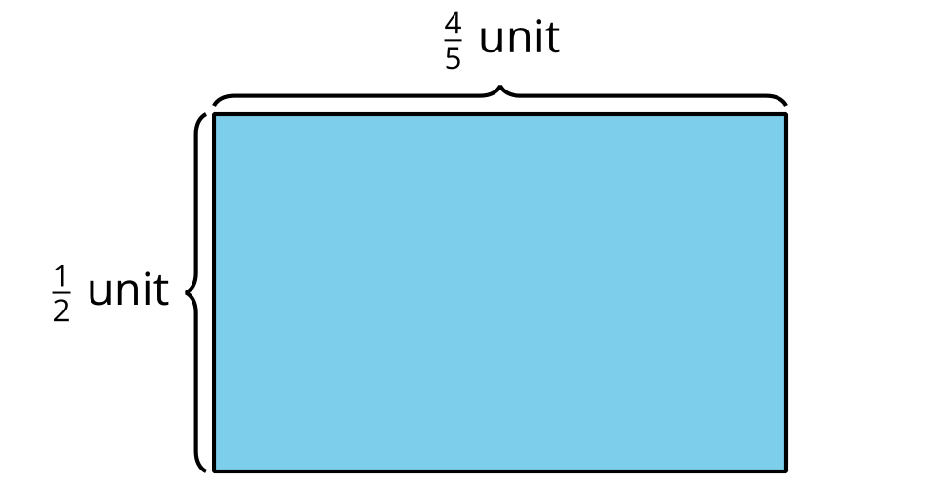

1 Equations and Area

Student Task Statement
- Find the value of each product. Draw an area diagram if it is helpful.
  - $\frac{2}{5}×\frac{3}{4}$
  - 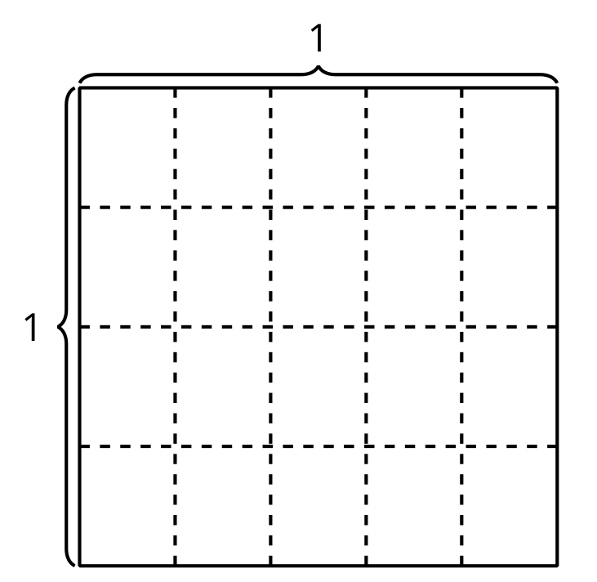
  - $\frac{3}{7}×\frac{4}{5}$
  - $\frac{9}{11}×\frac{5}{8}$
- How did you decide whether or not to draw a diagram? How did the diagrams influence how you found the products?
- Diego drew this diagram for the product $\frac{9}{11}×\frac{5}{8}$. How can the diagram help Diego find the value of $\frac{9}{11}×\frac{5}{8}$?
- 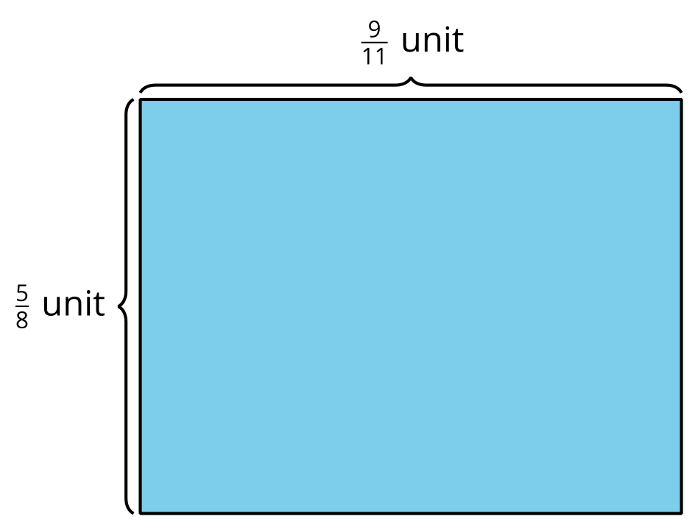

2 Multiply Fractions

Student Task Statement
Find the value that makes each equation true. Draw a diagram, if it is helpful.
- $\frac{3}{8}×\frac{2}{5}=\underset{_}{}$
- $\frac{3}{4}×\frac{9}{5}=\underset{_}{}$
- $\frac{10}{5}×\frac{6}{5}=\underset{_}{}$
- $\frac{8}{9}×\underset{_}{}=\frac{56}{36}$
- $5×\underset{_}{}=\frac{15}{8}$
© CC BY 2021 Illustrative Mathematics®

