Unit 1 Lesson 14: Use Diagrams to Compare

WU Notice and Wonder: What Kind of Graph Is This? (Warm up)

Student Task Statement
What do you notice? What do you wonder?
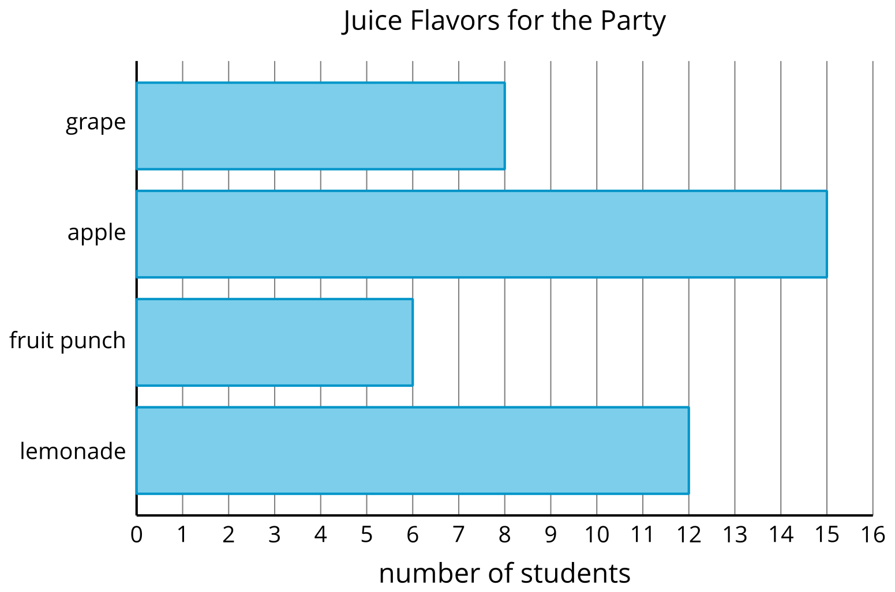
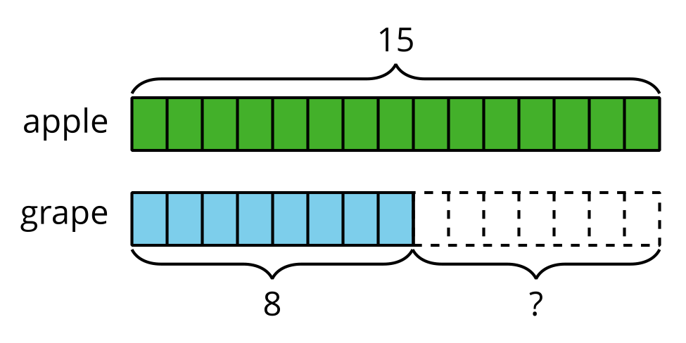
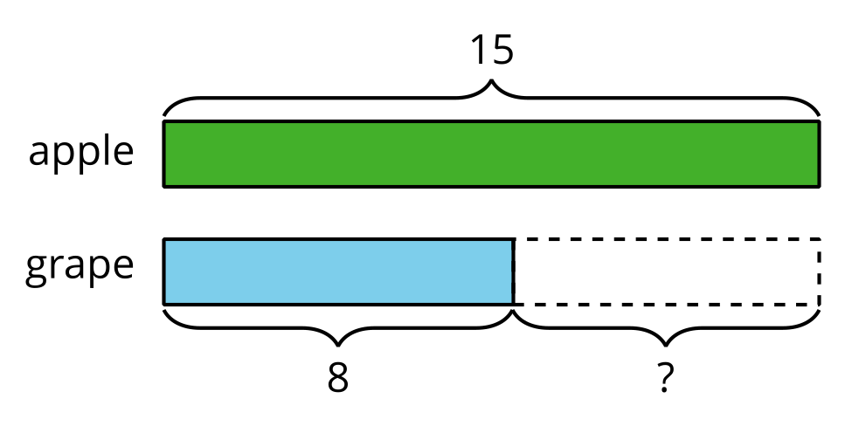

1 Party Time (Part 1)

Images for Launch
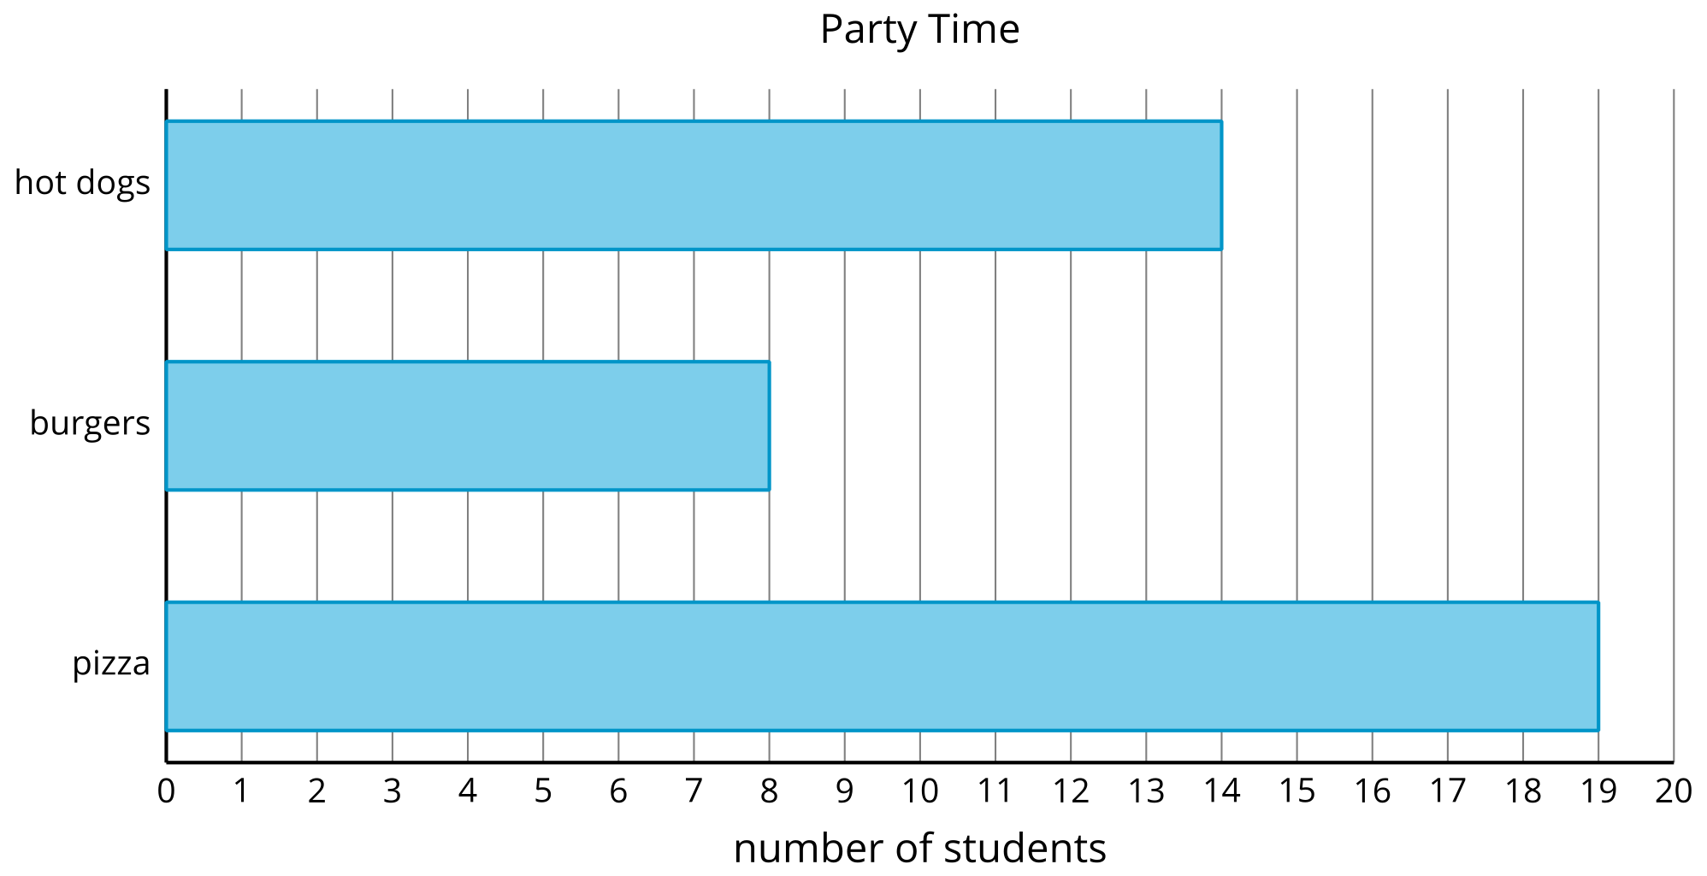

Student Task Statement
- Glue down the two bars that compare the number of students who picked hot dogs to the number who picked burgers.
- Write two statements that compare the number of students who picked hot dogs to the number who picked burgers.

2 Party Time (Part 2)

Student Task Statement
- Use the data from the bar graph to complete the diagram.
- 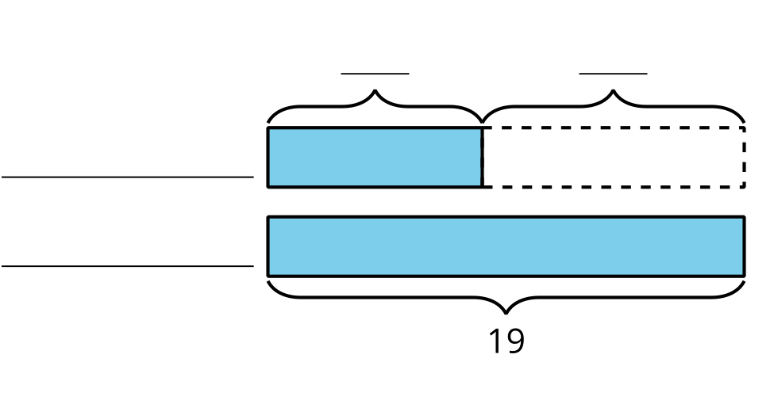
- How many more students chose pizza than chose burgers? Write an equation to show how you found the difference.
- Use the data from the bar graph to complete the diagram.
- 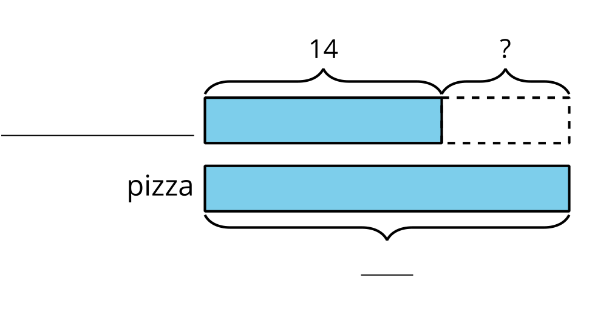
- Write a statement that compares the student votes in the diagram.

Images for Activity Synthesis
© CC BY 2021 Illustrative Mathematics®

