Unit 5 Lesson 14: Solving Systems of Equations

1 True or False: Two Lines (Warm up)

Student Task Statement
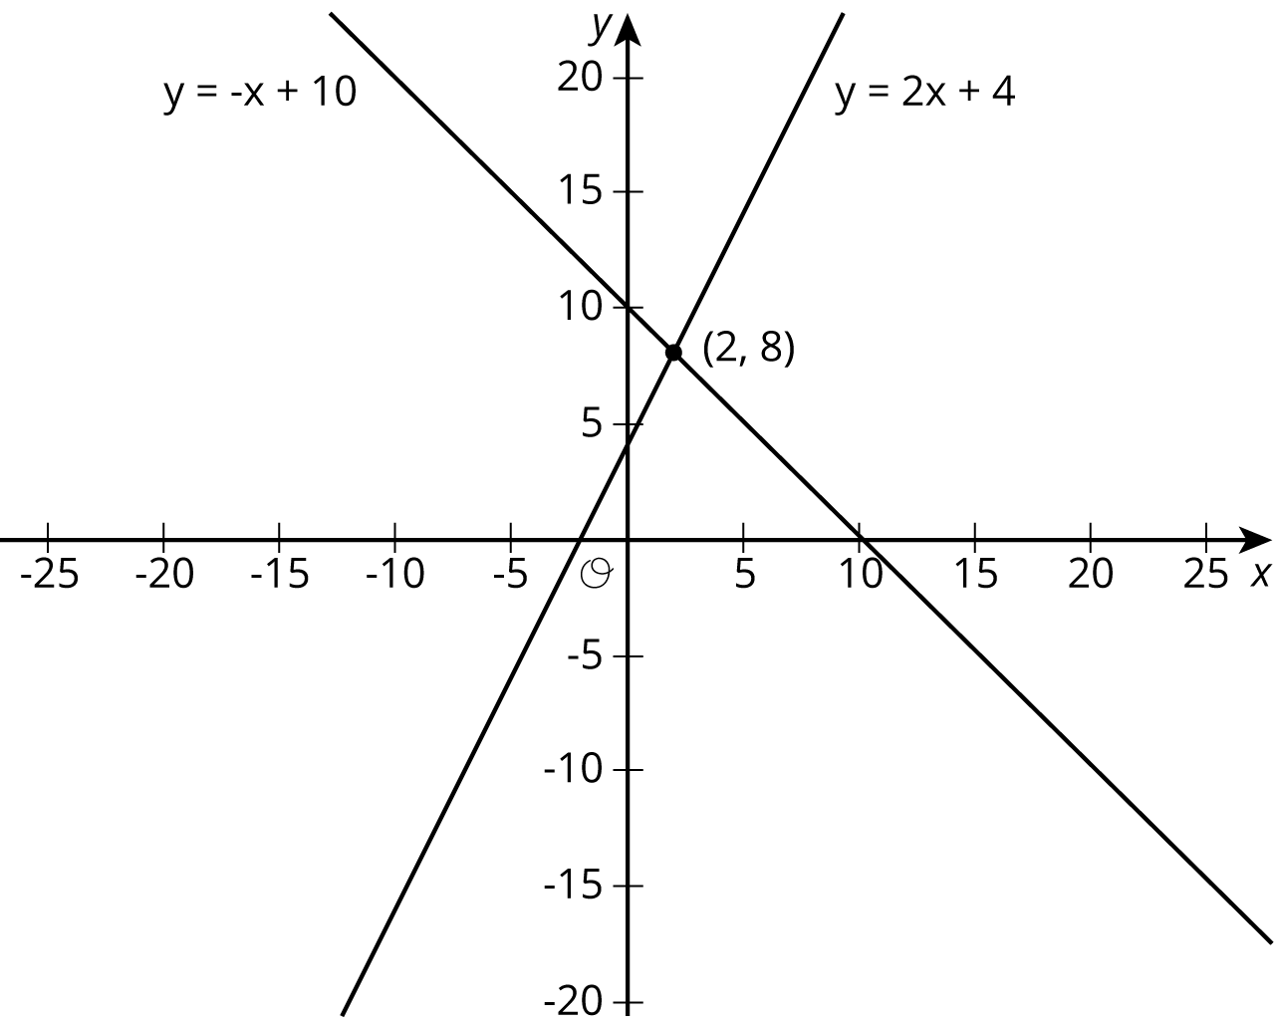
Use the lines to decide whether each statement is true or false. Be prepared to explain your reasoning using the lines.
- A solution to $8=\text{-}x+10$ is 2.
- A solution to $2=2x+4$ is 8.
- A solution to $\text{-}x+10=2x+4$ is 8.
- A solution to $\text{-}x+10=2x+4$ is 2.
- There are no values of $x$ and $y$ that make $y=\text{-}x+10$ and $y=2x+4$ true at the same time.

2 Matching Graphs to Systems

Student Task Statement
Here are three systems of equations graphed on a coordinate plane:
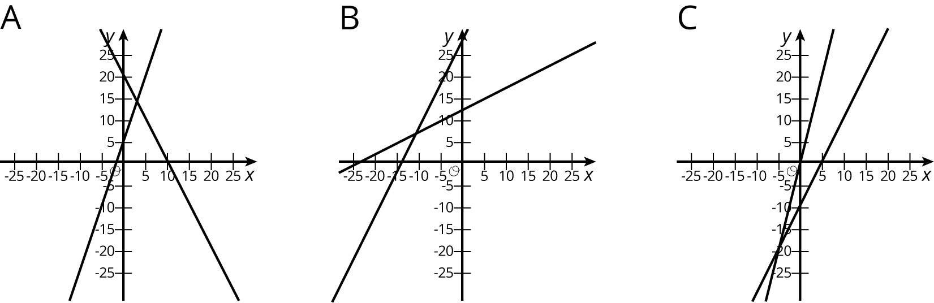
- Match each figure to one of the systems of equations shown here.
  - $\left\{\begin{matrix}y=3x+5 \\ y=\text{-}2x+20\end{matrix}\right.$
  - $\left\{\begin{matrix}y=2x−10 \\ y=4x−1\end{matrix}\right.$
  - $\left\{\begin{matrix}y=0.5x+12 \\ y=2x+27\end{matrix}\right.$
- Find the solution to each system and check that your solution is reasonable based on the graph.

3 Different Types of Systems

Student Task Statement
Your teacher will give you a page with some systems of equations.
- Graph each system of equations carefully on the provided coordinate plane.
- Describe what the graph of a system of equations looks like when it has . . .
  - 1 solution
  - 0 solutions
  - infinitely many solutions
© CC BY Open Up Resources. Adaptations CC BY IM.

