Unit 3 Lesson 8 Cumulative Practice Problems
- Here is a hanger:
  - Write an equation to represent the hanger.
  - Solve the equation by reasoning about the equation or the hanger. Explain your reasoning.
- 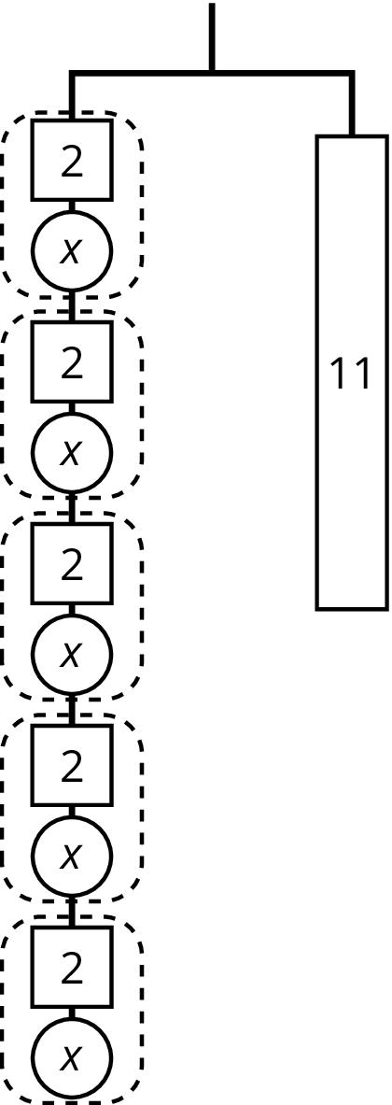
- Explain how each part of the equation $9=3(x+2)$ is represented in the hanger.
  - $x$
  - 9
  - 3
  - $x+2$
  - $3(x+2)$
  - the equal sign
- 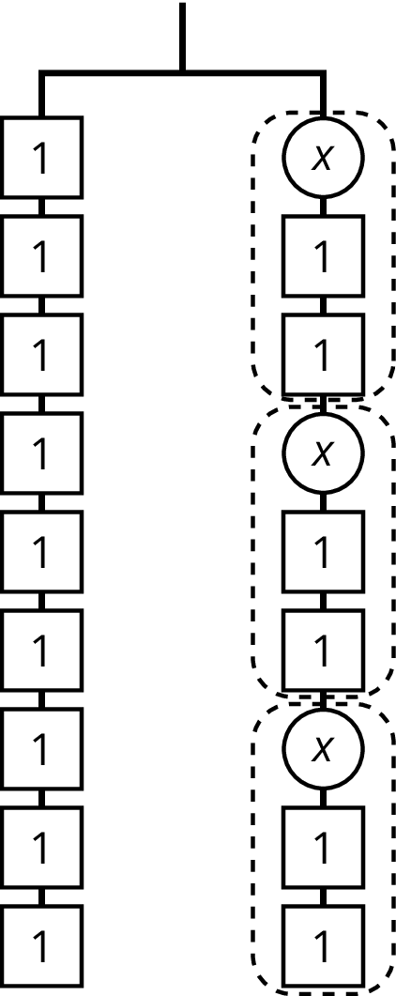
- Andre is solving the equation $4(x+\frac{3}{2})=7$. He says, “I can subtract $\frac{3}{2}$ from each side to get $4x=\frac{11}{2}$ and then divide by 4 to get $x=\frac{11}{8}$.” Kiran says, “I think you made a mistake.”
  - How can Kiran know for sure that Andre’s solution is incorrect?
  - Describe Andre’s error and explain how to correct his work.
- Lin has a scale model of a modern train. The model is created at a scale of 1 to 48.
  - The height of the model train is 102 millimeters. What is the actual height of the train in meters? Explain your reasoning.
  - On the scale model, the distance between the wheels on the left and the wheels on the right is $1\frac{1}{4}$ inches. The state of Wyoming has old railroad tracks that are 4.5 feet apart. Can the modern train travel on those tracks? Explain your reasoning.
- (From Unit 2, Lesson 7.)
© CC BY Open Up Resources. Adaptations CC BY IM.

