Lesson 1 Practice Problems
- Lin is interested in how many of her classmates watch her favorite TV show, so she starts asking around at lunch. She gets the following responses:
- yes | - yes | - yes | - no | - no | - no | - no | - no
- no | - no | - yes | - no | - no | - no

- If she asks one more person randomly in the cafeteria, do you think they will say “yes” or “no”? Explain your reasoning.
- An engineer tests the strength of a new material by seeing how much weight it can hold before breaking. Previous tests have held these weights in pounds:
- 1,200 | - 1,400 | - 1,300 | - 1,500 | - 950 | - 1,600 | - 1,100

- Do you think that this material will be able to hold more than 1,000 pounds in the next test? Explain your reasoning.
- A company tests two new products to make sure they last for more than a year.
  - Product 1 had 950 out of 1,000 test items last for more than a year.
  - Product 2 had 150 out of 200 last for more than a year.
- If you had to choose one of these two products to use for more than a year, which one is more likely to last? Explain your reasoning.
- Put these numbers in order from least to greatest.
- $\frac{1}{2}$ | - $\frac{1}{3}$ | - $\frac{2}{5}$ | - 0.6 | - 0.3

- A small staircase is made so that the horizontal piece of each step is 10 inches long and 25 inches wide. Each step is 5 inches above the previous one. What is the surface area of this staircase?
- 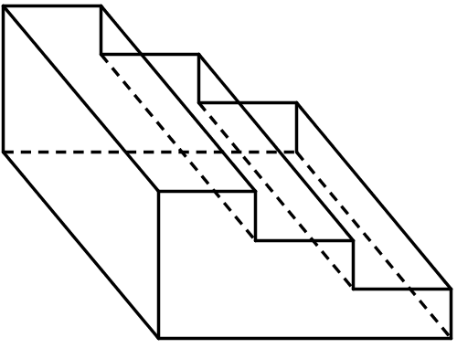
- (From Unit 7, Lesson 15.)
© CC BY Open Up Resources. Adaptations CC BY IM.

