Lesson 11 Practice Problems
- Here are two three-dimensional figures.
- Tell whether each of the following statements describes Figure A, Figure B, both, or neither.
- 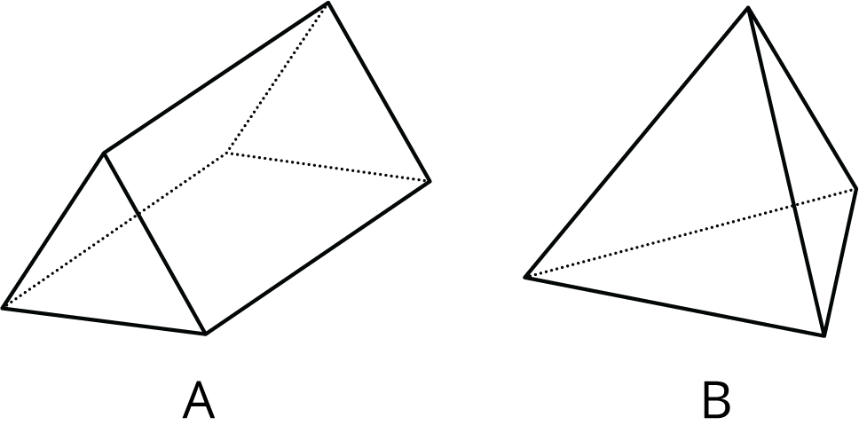
  - This figure is a polyhedron.
  - This figure has triangular faces.
  - There are more vertices than edges in this figure.
  - This figure has rectangular faces.
  - This figure is a pyramid.
  - There is exactly one face that can be the base for this figure.
  - The base of this figure is a triangle.
  - This figure has two identical and parallel faces that can be the base.

  - Is this polyhedron a prism, a pyramid, or neither? Explain how you know.
  - 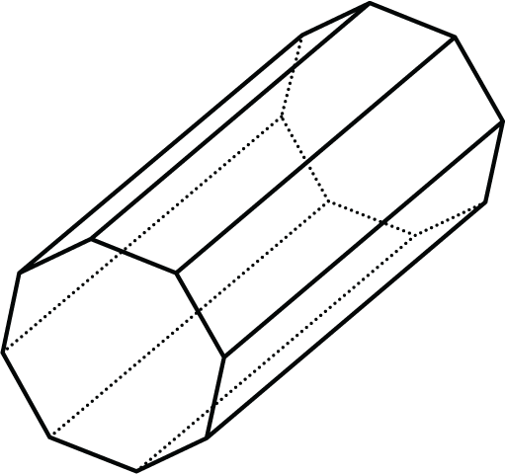
  - How many faces, edges, and vertices does it have?

  - What polyhedron can be assembled from this net? Explain how you know.
  - 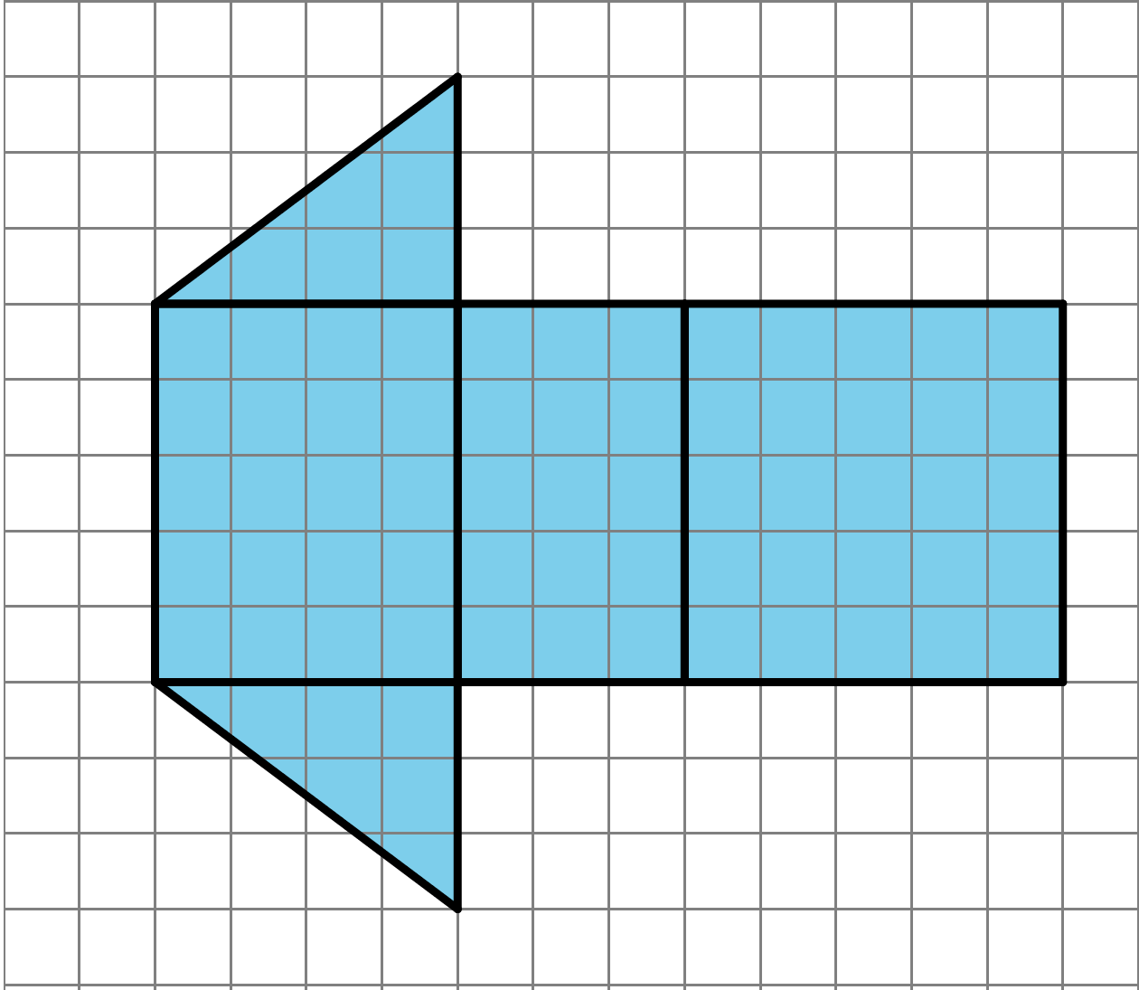
  - Find the surface area of this polyhedron. Show your reasoning.

  - A parallelogram has a base of 12 meters and a height of 1.5 meters. What is its area?
  - A triangle has a base of 16 inches and a height of $\frac{1}{8}$ inches. What is its area?
  - A parallelogram has an area of 28 square feet and a height of 4 feet. What is its base?
  - A triangle has an area of 32 square millimeters and a base of 8 millimeters. What is its height?
- (From Unit 1, Lesson 8.)
- Find the area of the shaded region. Show or explain your reasoning.
- 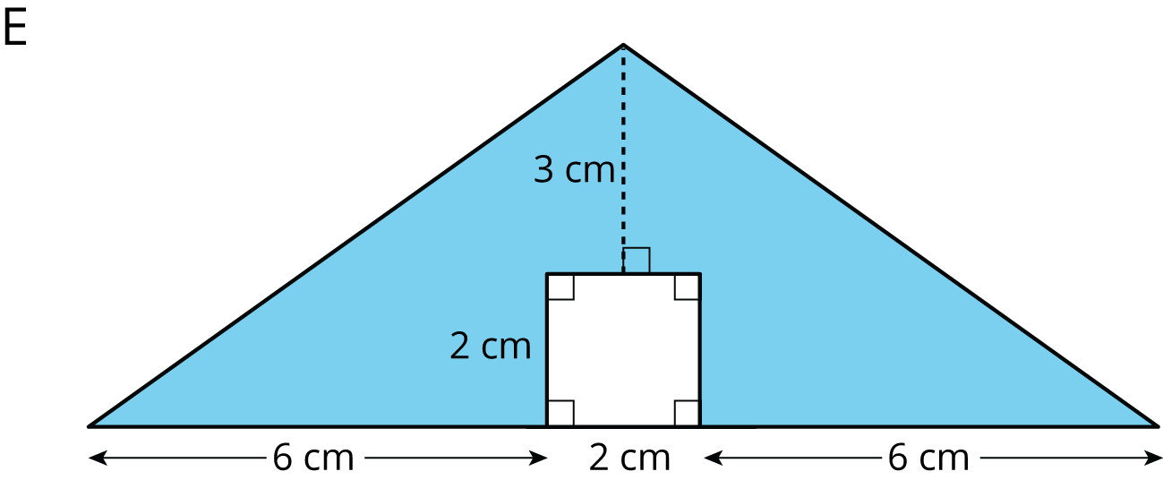
- (From Unit 1, Lesson 3.)
© CC BY Open Up Resources. Adaptations CC BY IM.

