Lesson 10: Rewriting Quadratic Expressions in Factored Form (Part 4)
- Let’s transform more-complicated quadratic expressions into the factored form.

10.1: Which One Doesn’t Belong: Quadratic Expressions
Which one doesn’t belong?
A. $\left(x+4\right)\left(x−3\right)$
B. $3x^{2}−8x+5$
C. $x^{2}−25$
D. $x^{2}+2x+3$

10.2: A Little More Advanced
Each row in each table has a pair of equivalent expressions. Complete the tables. If you get stuck, try drawing a diagram.
- factored form | - standard form
- $\left(3x+1\right)\left(x+4\right)$
- $\left(3x+2\right)\left(x+2\right)$
- $\left(3x+4\right)\left(x+1\right)$
- factored form | - standard form
 | - $5x^{2}+21x+4$
 | - $3x^{2}+15x+12$
 | - $6x^{2}+19x+10$

Are you ready for more?
Here are three quadratic equations, each with two solutions. Find both solutions to each equation, using the zero product property somewhere along the way. Show each step in your reasoning.
$x^{2}=6x$
$x\left(x+4\right)=x+4$
$2x\left(x−1\right)+3x−3=0$

10.3: Timing A Blob of Water
An engineer is designing a fountain that shoots out drops of water. The nozzle from which the water is launched is 3 meters above the ground. It shoots out a drop of water at a vertical velocity of 9 meters per second.
Function $h$ models the height in meters, $h$, of a drop of water $t$ seconds after it is shot out from the nozzle. The function is defined by the equation $h\left(t\right)=\text{-}5t^{2}+9t+3$.
How many seconds until the drop of water hits the ground?
- Write an equation that we could solve to answer the question.
- Try to solve the equation by writing the expression in factored form and using the zero product property.
- Try to solve the equation by graphing the function using graphing technology. Explain how you found the solution.

10.4: Making It Simpler
Here is a clever way to think about quadratic expressions that would make it easier to rewrite them in factored form.
$9x^{2}+21x+10{\left(3x\right)}^{2}+7\left(3x\right)+10N^{2}+7N+10\left(N+2\right)\left(N+5\right)\left(3x+2\right)\left(3x+5\right)$
- Use the distributive property to expand $\left(3x+2\right)\left(3x+5\right)$. Show your reasoning and write the resulting expression in standard form. Is it equivalent to $9x^{2}+21x+10$?
- Study the method and make sense of what was done in each step. Make a note of your thinking and be prepared to explain it.
- Try the method to write each of these expressions in factored form.
- $4x^{2}+28x+45$
- $25x^{2}−35x+6$
- You have probably noticed that the coefficient of the squared term in all of the previous examples is a perfect square. What if that coefficient is not a perfect square?
- Here is an example of an expression whose squared term has a coefficient that is not a squared term.
- $5x^{2}+17x+6\frac{1}{5}⋅5⋅\left(5x^{2}+17x+6\right)\frac{1}{5}\left(25x^{2}+85x+30\right)\frac{1}{5}\left({\left(5x\right)}^{2}+17\left(5x\right)+30\right)\frac{1}{5}\left(N^{2}+17N+30\right)\frac{1}{5}\left(N+15\right)\left(N+2\right)\frac{1}{5}\left(5x+15\right)\left(5x+2\right)\left(x+3\right)\left(5x+2\right)$
- Use the distributive property to expand $\left(x+3\right)\left(5x+2\right)$. Show your reasoning and write the resulting expression in standard form. Is it equivalent to $5x^{2}+17x+6$?
- Study the method and make sense of what was done in each step and why. Make a note of your thinking and be prepared to explain it.
- Try the method to write each of these expressions in factored form.
- $3x^{2}+16x+5$
- $10x^{2}−41x+4$

Lesson 10 Summary
Only some quadratic equations in the form of $ax^{2}+bx+c=0$ can be solved by rewriting the quadratic expression into factored form and using the zero product property. In some cases, finding the right factors of the quadratic expression is quite difficult.
For example, what is the factored form of $6x^{2}+11x−35$?
We know that it could be 3x+302x+30, or 6x+30x+30, but will the second number in each factor be -5 and 7, 5 and -7, 35 and -1, or -35 and 1? And in which order?
We have to do some guessing and checking before finding the equivalent expression that would allow us to solve the equation $6x^{2}+11x−35=0$.
Once we find the right factors, we can proceed to solving using the zero product property, as shown here:​​​​​​
$\begin{matrix}6x^{2}+11x−35 & =0 \\ \left(3x−5\right)\left(2x+7\right) & =0\end{matrix}$
$\begin{matrix}3x−5=0 & \text{or} 2x+7=0 \\ x=\frac{5}{3} & \text{or} x=\text{-}\frac{7}{2} \end{matrix}$
What is even trickier is that most quadratic expressions can’t be written in factored form!
Let’s take $x^{2}−4x−3$ for example. Can you find two numbers that multiply to make -3 and add up to -4? Nope! At least not easy-to-find rational numbers.
We can graph the function defined by $x^{2}−4x−3$ using technology, which reveals two $x$-intercepts, at around $\left(\text{-}0.646,0\right)$ and $\left(4.646,0\right)$. These give the approximate zeros of the function, -0.646 and 4.646, so they are also approximate solutions to $x^{2}−4x−3=0$.
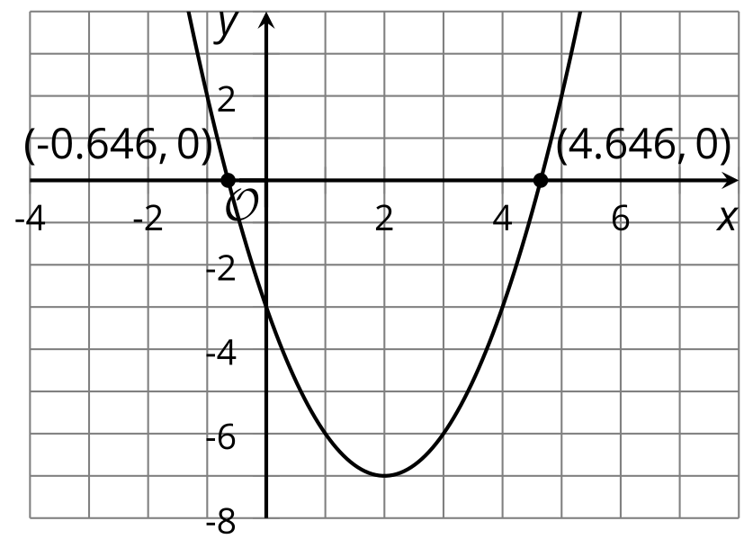
The fact that the zeros of this function don’t seem to be simple rational numbers is a clue that it may not be possible to easily rewrite the expression in factored form.​​​​​​
It turns out that rewriting quadratic expressions in factored form and using the zero product property is a very limited tool for solving quadratic equations.
In the next several lessons, we will learn some ways to solve quadratic equations that work for any equation.
© CC BY 2019 by Illustrative Mathematics®

