Unit 8 Lesson 4: Tables of Relative Frequencies

1 Notice and Wonder: Dog City (Warm up)

Student Task Statement
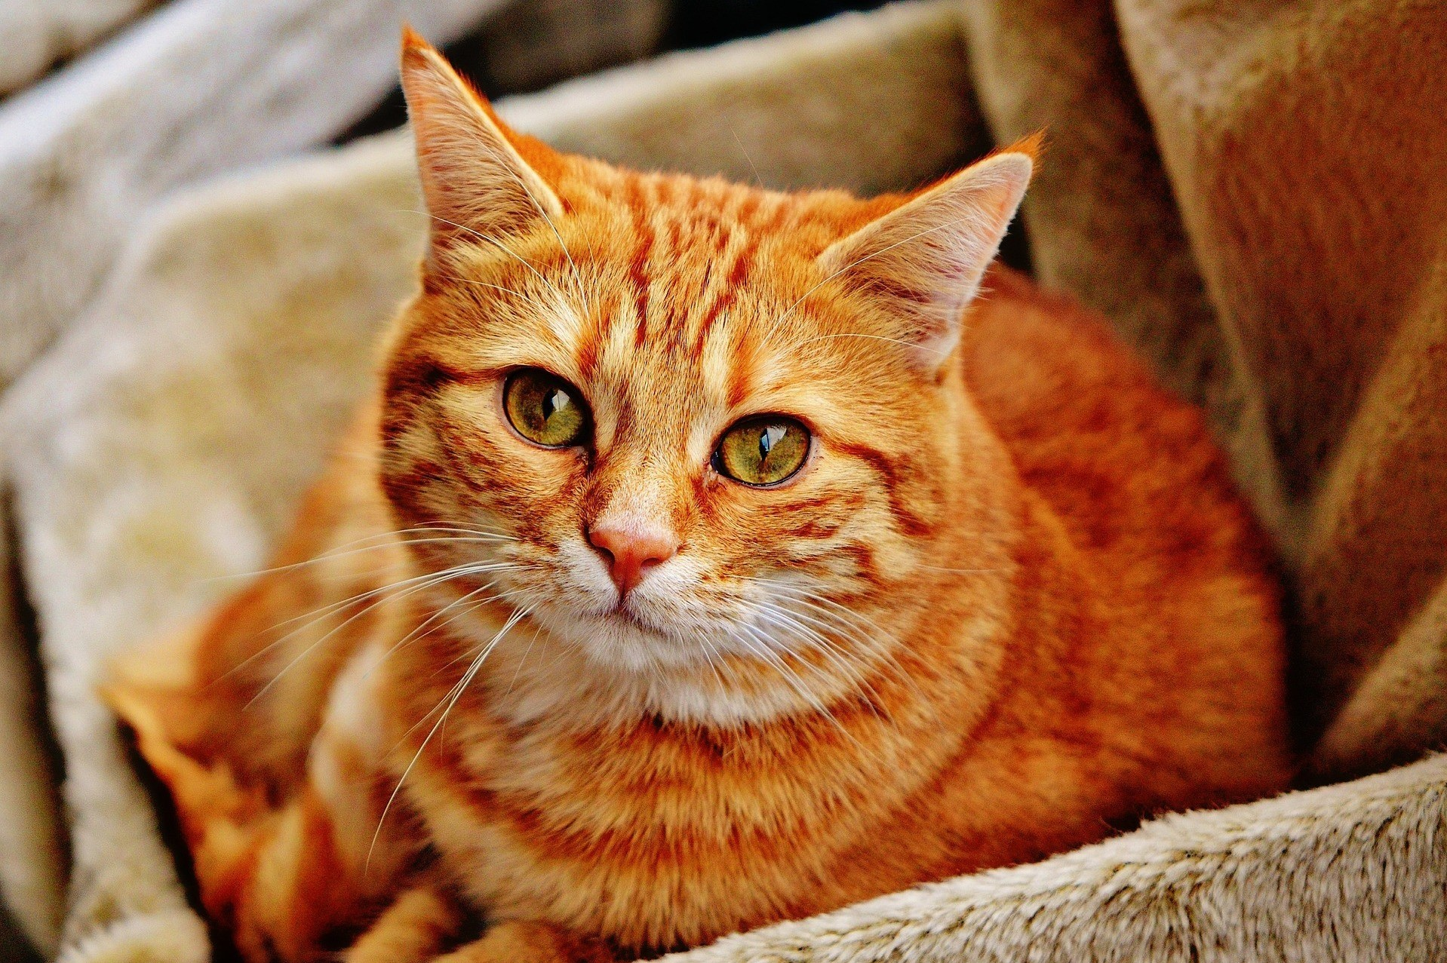
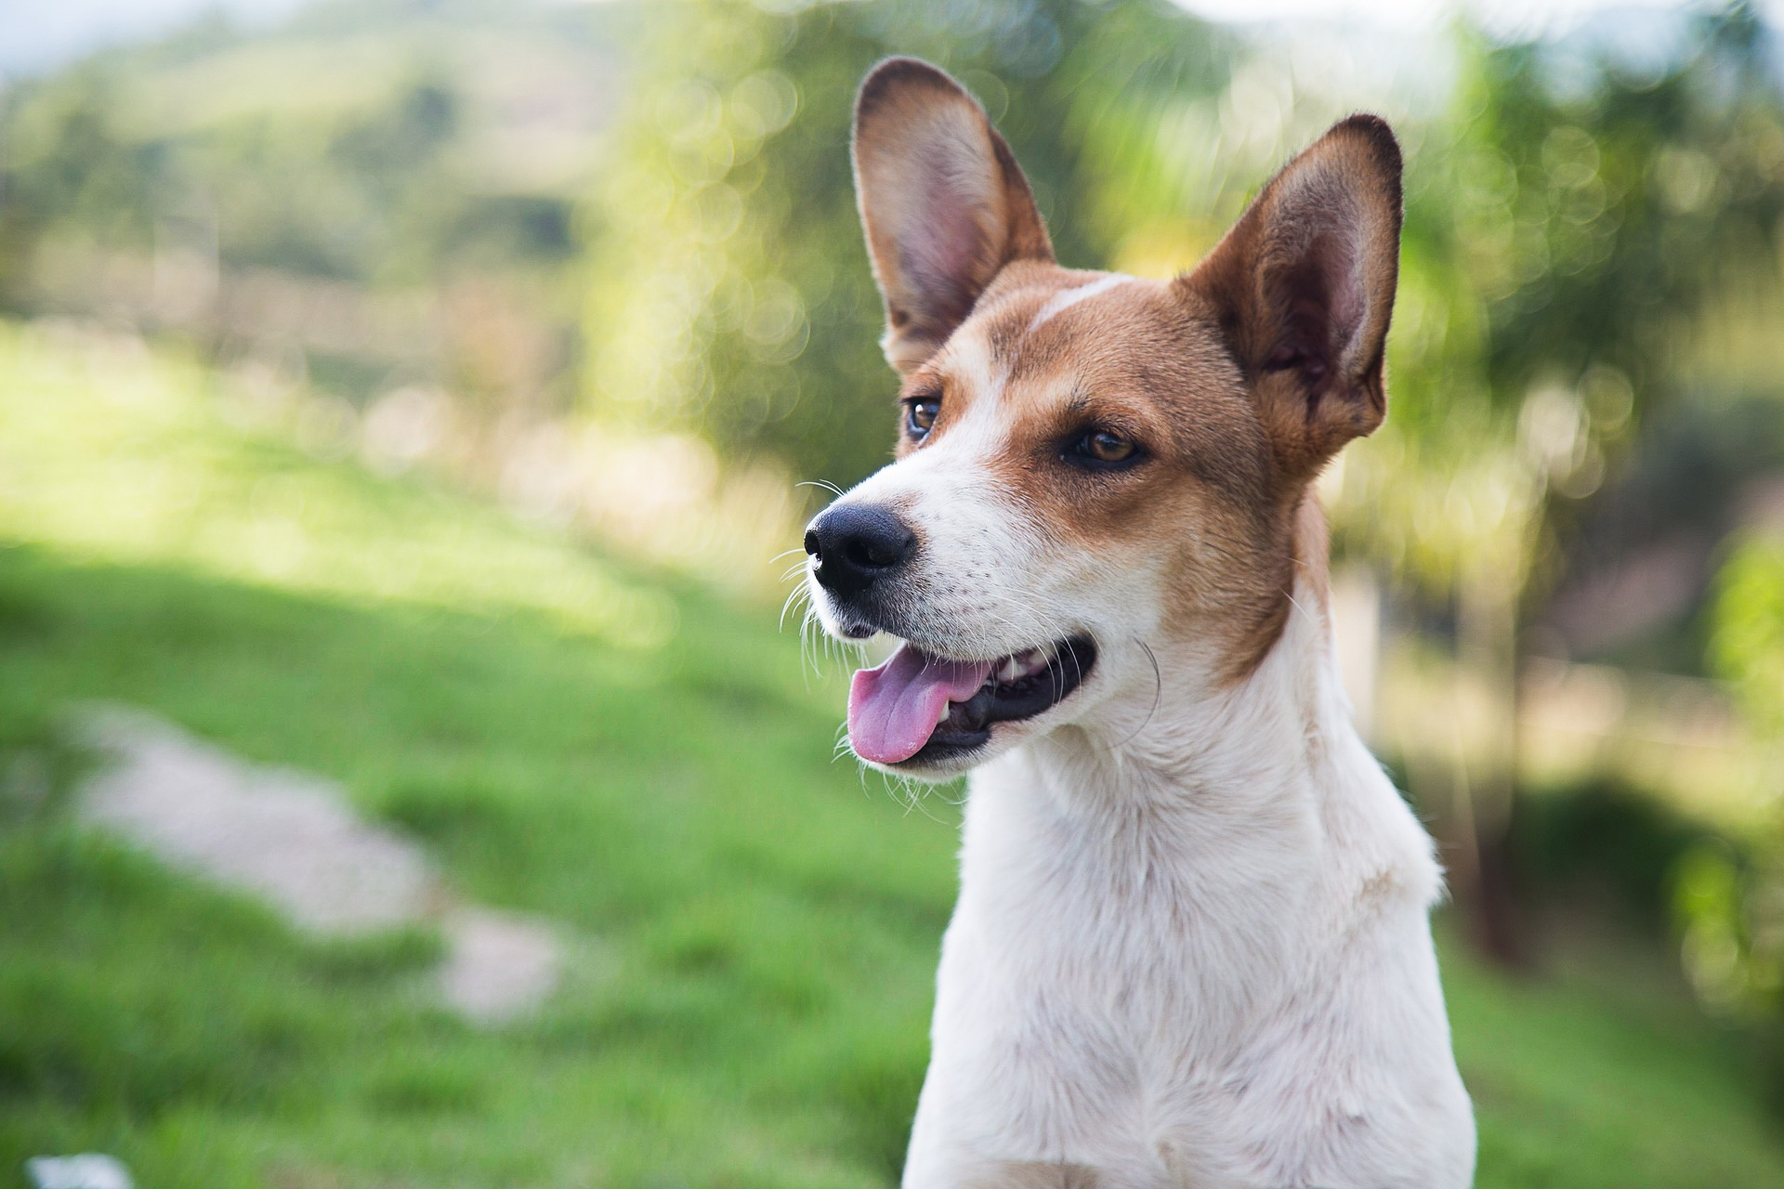
This two-way table summarizes data from a survey of 200 people who reported their home environment (urban or rural) and pet preference (dog or cat).
 | urban | rural | total
cat | 54 | 42 | 96
dog | 80 | 24 | 104
total | 134 | 66 | 200
What do you notice? What do you wonder?

2 Rolling into Tables

Student Task Statement
Decide which person will be partner A and which will be partner B.
The result of partner A’s roll is represented by the values on the left side of the table. The result of partner B’s roll is represented by the values on the top of the table.
Roll your number cube. Record the result of the roll. For example, if partner A rolls a 3 and partner B rolls a 5, then record 3,5. Repeat this process until your teacher tells you to stop.
Use the table to summarize the results. For example, if 6,6 appears on your list a total of five times, write a 5 in the bottom right cell of the table.
 | 1 | 2 | 3 | 4 | 5 | 6
1
2
3
4
5
6
- Do the values in the table match your expectation? Explain your reasoning.
- Based on the table, how many times did partner A roll a 5?
- How many times did you both roll the same number?
- What percentage of the rolls resulted in the same number from both partners?
- What percentage of the rolls resulted in partner A rolling a 3 and partner B rolling a 6?
- Based on the table, estimate the probability that partner A will roll a 2 and partner B will roll a 4. Explain your reasoning.

3 Traveling Methods

Student Task Statement
- A company has an office in Austin, Texas, and an office in Copenhagen, Denmark. The company wants to know how employees get to work, so they take a survey of all the employees and summarize the results in a table.
 | - walk | - car | - public transit | - bike | - total
- Austin | - 63 | - 376 | - 125 | - 63 | - 627
- Copenhagen | - 48 | - 67 | - 95 | - 267 | - 477
- total | - 111 | - 443 | - 220 | - 330 | - 1,104
  - If an employee is selected at random, what is the probability that they work in Austin and drive a car to work?
  - If an employee is selected at random, what is the probability that they work in Copenhagen and ride a bike to work?
  - If an employee is selected at random, what is the probability that they take public transit to work?
  - If an employee from Copenhagen is selected at random, what is the probability that they ride a bike to work?
  - If an employee who takes public transit to work is selected at random, what is the probability they work in Austin?
  - How are the last two questions different from the first three?
- A school district is interested in how students get to school, so they survey their high school students to see how they get to school and separate the numbers by grade level. The results of the survey are summarized in the table.
 | - car | - bus | - other method | - total
- grade 9 | - 1,141 | - 3,196 | - 228 | - 4,565
- grade 10 | - 1,126 | - 1,770 | - 322 | - 3,218
- grade 11 | - 1,732 | - 799 | - 133 | - 2,664
- grade 12 | - 1,676 | - 447 | - 111 | - 2,234
- total | - 5,675 | - 6,212 | - 794 | - 12,681
  - If a high school student is selected at random, what is the probability they are in grade 9 and ride the bus to school?
  - If a high school student is selected at random, what is the probability that they are in grade 12?
  - If a high school student is selected at random, what is the probability that they take a car to school?
  - If a grade 10 student is selected at random, what is the probability that they ride a bus to school?
  - If a grade 12 student is selected at random, what is the probability that they ride a bus to school?
  - If a student who rides the bus to school is selected at random, what is the probability that they are in grade 9?
© CC BY 2019 by Illustrative Mathematics®

