Unit 5 Lesson 5 Cumulative Practice Problems
- The solution to a system of equations is $(6,\text{-}3)$. Choose two equations that might make up the system.
  - $y=\text{-}3x+6$
  - $y=2x−9$
  - $y=\text{-}5x+27$
  - $y=2x−15$
  - $y=\text{-}4x+27$
- (From Unit 4, Lesson 13.)
- A car is traveling on a small highway and is either going 55 miles per hour or 35 miles per hour, depending on the speed limits, until it reaches its destination 200 miles away. Letting $x$ represent the amount of time in hours that the car is going 55 miles per hour, and $y$ being the time in hours that the car is going 35 miles per hour, an equation describing the relationship is: $55x+35y=200$
  - If the car spends 2.5 hours going 35 miles per hour on the trip, how long does it spend going 55 miles per hour?
  - If the car spends 3 hours going 55 miles per hour on the trip, how long does it spend going 35 miles per hour?
  - If the car spends no time going 35 miles per hour, how long would the trip take? Explain your reasoning.
- (From Unit 5, Lesson 3.)
- The graph represents an object that is shot upwards from a tower and then falls to the ground. The independent variable is time in seconds and the dependent variable is the object’s height above the ground in meters.
- 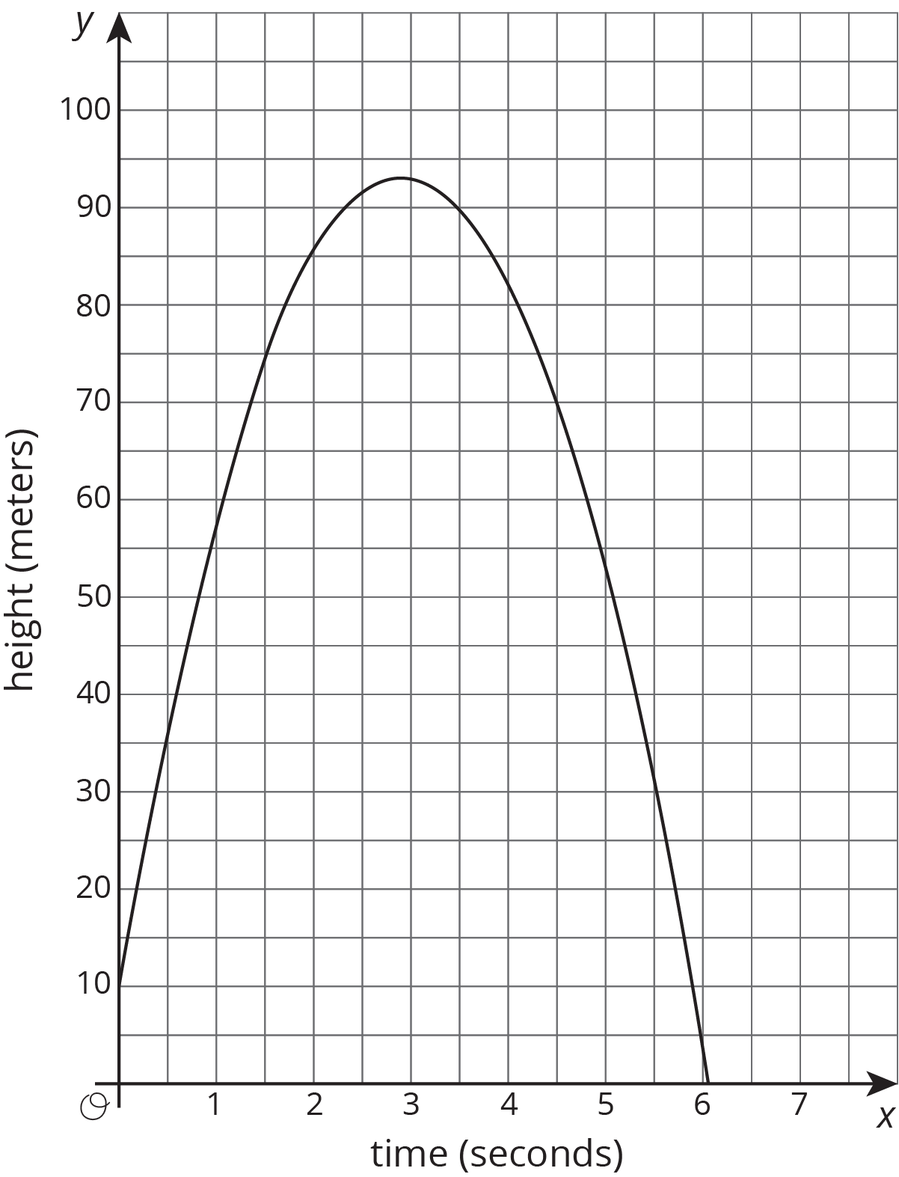
  - How tall is the tower from which the object was shot?
  - When did the object hit the ground?
  - Estimate the greatest height the object reached and the time it took to reach that height. Indicate this situation on the graph.
© CC BY Open Up Resources. Adaptations CC BY IM.

