Lesson 4: Explore Place Value Relationships
- Let’s explore place value relationships.

Warm-up: Notice and Wonder: Maintain Your Balance
What do you notice? What do you wonder?
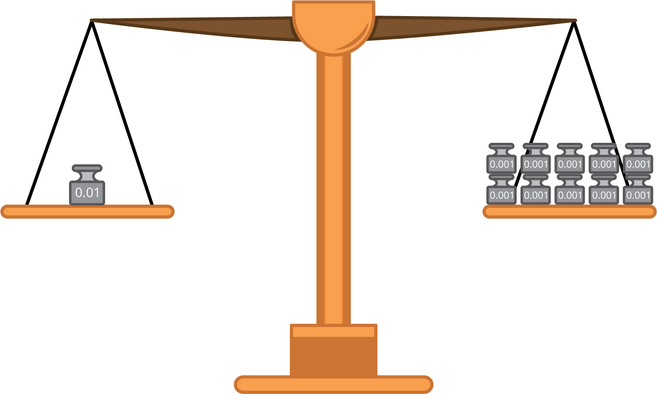

4.1: Balance the Weight
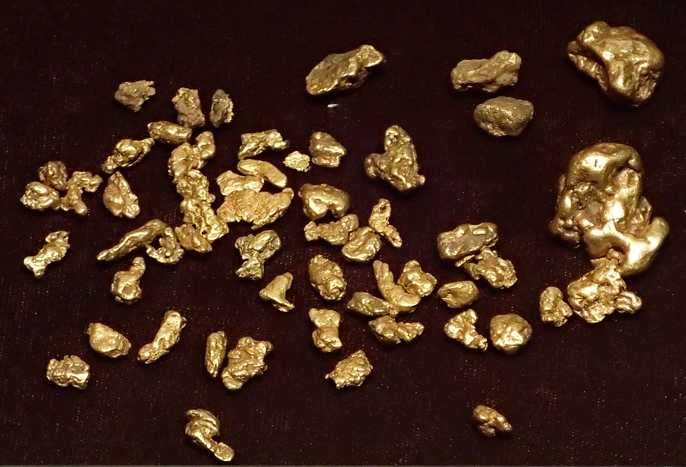
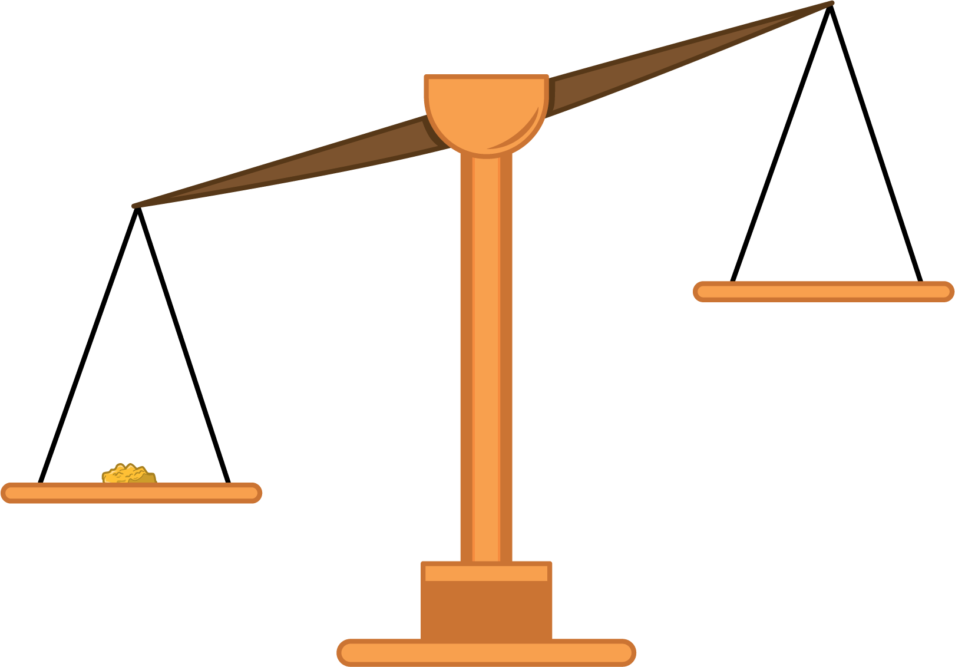
For each problem, you have a balance and weights of 0.1 ounce, 0.01 ounce, and 0.001 ounce.
- A gold nugget weighs 0.2 ounces.
  - What is one set of weights you could use to balance the nugget? Explain or show your reasoning.
  - What is another set of weights you could use to balance the nugget? Explain or show your reasoning.
  - How many 0.01 ounce weights would you need to balance the nugget? What about 0.001 ounce weights?
- Another nugget weighs 0.385 ounce.
  - What is one set of weights you could use to balance the nugget? Explain or show your reasoning.
  - What is the smallest number of weights you can use to balance the nugget? Explain or show your reasoning.
  - What is the largest number of weights you can use to balance the nugget? Explain or show your reasoning.
- Write a decimal number for the weight of the gold nuggets that balanced with:
  - 266 of the 0.001 ounce weights
  - 150 of the 0.01 ounce weights
  - 27 of the 0.1 ounce weights

4.2: Weights and Place Values
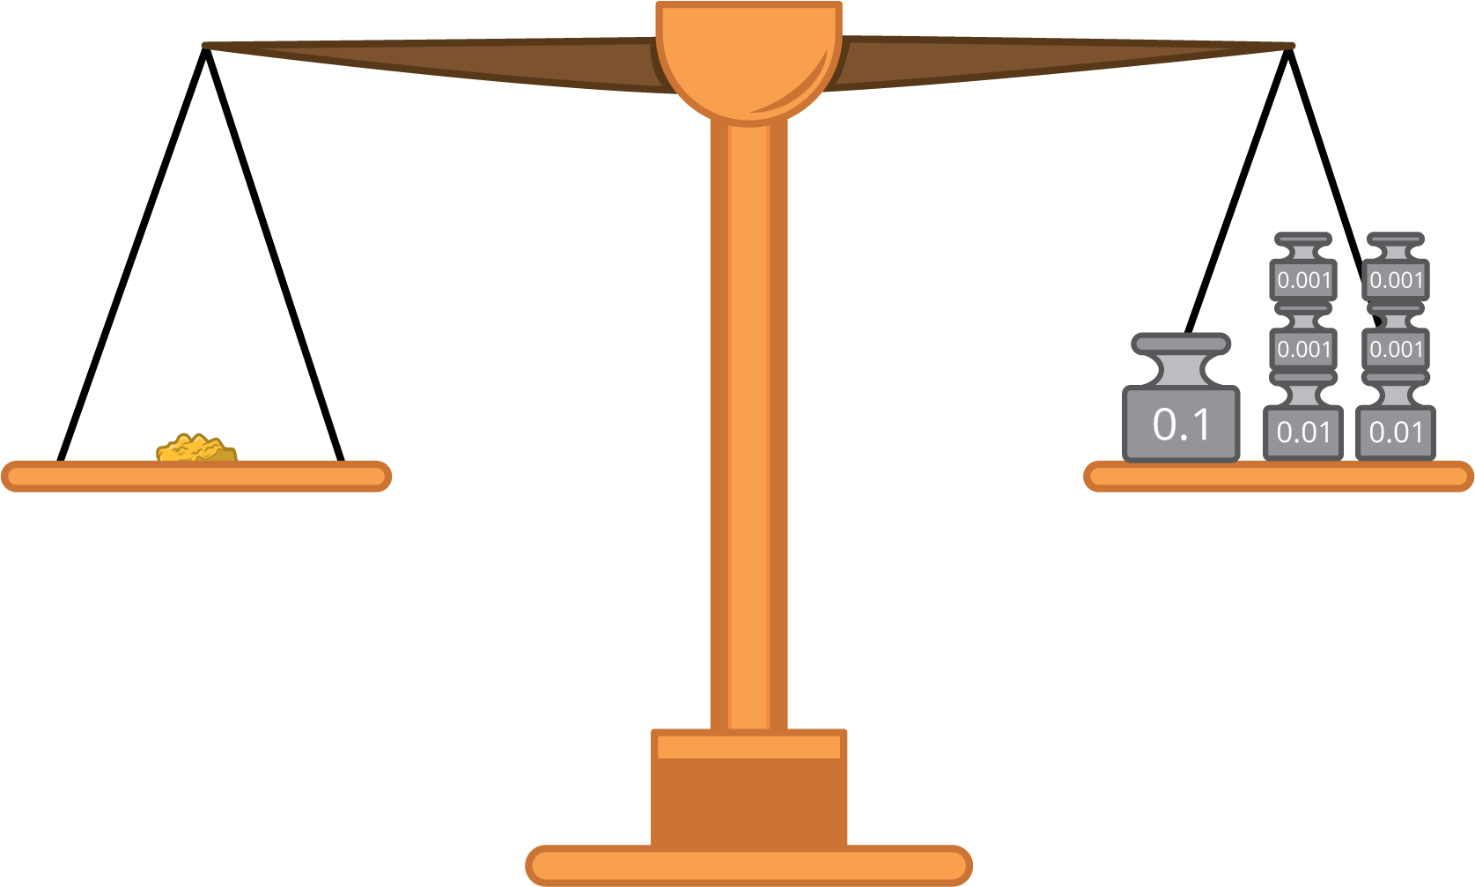
- Weights are used to balance some gold nuggets. Write the weight of each gold nugget in expanded form.
  - three 0.1 ounce weights, five 0.01 ounce weights, and eight 0.001 ounce weights
  - six 0.1 ounce weights and two 0.001 ounce weights
  - two 0.01 ounce weights and six 0.1 ounce weights
- Here are the weights of some gold nuggets in word form. Write the weights in expanded form.
  - two hundred eighty three thousandths of an ounce
  - four hundred nine thousandths of an ounce
- A gold nugget weighs 0.527 ounces.
  - What is the value of each of the digits in the decimal 0.527?
  - How does the expanded form of 0.527 show the value of each digit in the decimal?

4.3: Comparing Place Values with Weights
- How many 0.01 ounce weights will balance one 0.1 ounce weight? Explain or show your reasoning.
- How many 0.001 ounce weights will balance a 0.1 ounce weight? Explain or show your reasoning.
- The table shows the weights of 3 of the gold nuggets Diego and his friends found panning for gold.
- Fill in the blanks. Explain or show your reasoning.
- gold | - weight  (grams)
- nugget A | - 0.6
- nugget B | - 0.06
- nugget C | - 0.006
  - Nugget A weighs $\underset{_}{}$ times as much as Nugget B.
  - Nugget A weighs $\underset{_}{}$ times as much as Nugget C.
  - Nugget C weighs $\underset{_}{}$ times as much as Nugget B.
  - Nugget C weighs $\underset{_}{}$ times as much as Nugget A.
© CC BY 2021 Illustrative Mathematics®

