Lesson 2: Represent Data and Solve Problems
- Let’s create graphs and answer questions.

Warm-up: How Many Do You See: Dots in Groups
How many do you see? How do you see them?
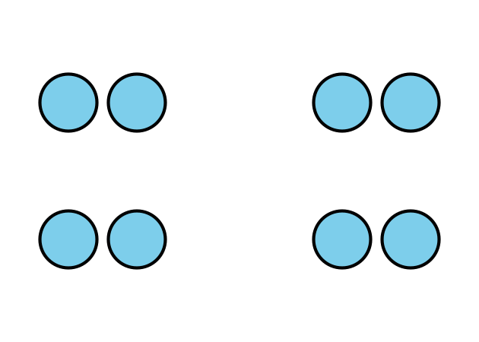

2.1: How We Get Home
- Follow your teacher’s instructions to organize and represent the class data in a picture graph.
- Represent the same data that shows how our class gets home on a bar graph.

2.2: Questions About a Bar Graph
- Decide if each statement is true or false about how our class gets home. Explain your reasoning to your partner.
  - More students walk than go home any other way.
  - More students ride home on a bus than in a car.
  - Fewer students walk home than ride their bikes.
  - More students walk or ride their bikes than ride in a van.
- Fill in the blanks as directed by your teacher, then answer each question.
  - “How many more students 0000000000_ than 0000000000_?”
  - “How many more students 0000000000_ or
0000000000_ than 0000000000_?”
© CC BY 2021 Illustrative Mathematics®

