Unit 2 Lesson 17: Paper Clip Games

WU Notice and Wonder: Lots of Paper Clips (Warm up)

Student Task Statement
What do you notice? What do you wonder?
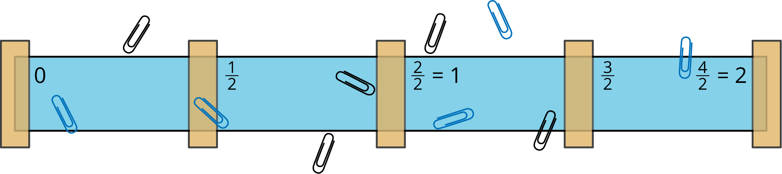

1 Paper Clip Tossing Game

Student Task Statement
Let’s prepare a game board and figure out how to toss paper clips and record the results!
- Make your game board:
  - Tape the paper strip to your workspace. Place the tape at these benchmarks: 0, $\frac{1}{2}$, 1, $\frac{3}{2}$, and 2 .
  - Label the benchmark fractions 0, $\frac{1}{2}$, 1, $\frac{3}{2}$, and 2 on the paper strip.
- Play the game:
  - Take turns tossing the paper clips onto the game board.
  - Label the fraction where each paper clip lands.
Be prepared to share your strategies for tossing the paper clips and for finding out the fractions for their locations.

2 A New Game with New Rules

Student Task Statement
Invent your own game.
- Make a list with the rules of your game.
- Play your game, paying close attention to the rules.
- Revise and clarify your game rules, if necessary.

3 Field Test

Student Task Statement
Let’s try out these games!
- Before playing the game, exchange your game rules with another team. Carefully read the rules. Take turns asking clarifying questions, if you have any.
- Play each other’s games.
- After playing the game, give feedback to each other about the rules.
  - What is one thing you liked about the other team's game?
  - What is one thing you might change?
© CC BY 2021 Illustrative Mathematics®

