Unit 5 Lesson 18: What a Point in a Scatter Plot Means

1 The Giant Panda (Warm up)

Student Task Statement
A giant panda lives in a zoo. What does the point on the graph tell you about the panda?
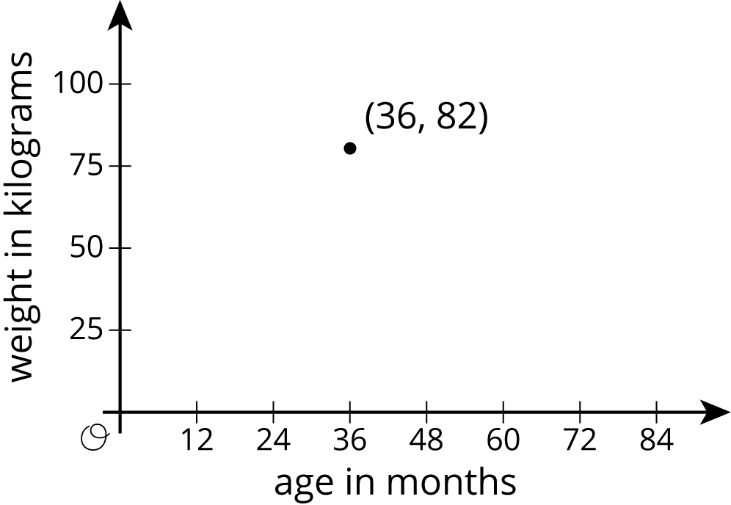

2 Weight and Fuel Efficiency

Student Task Statement
The table and scatter plot show weights and fuel efficiencies of 18 cars.
car | weight  (kg) | fuel efficiency
A | 1,549 | 25
B | 1,610 | 20
C | 1,737 | 21
D | 1,777 | 20
E | 1,486 | 23
F | 1,962 | 16
G | 2,384 | 16
H | 1,957 | 19
I | 2,212 | 16
J | 1,115 | 29
K | 2,068 | 18
L | 1,663 | 19
M | 2,216 | 18
N | 1,432 | 25
O | 1,987 | 18
P | 1,580 | 26
Q | 1,234 | 30
R | 1,656 | 23
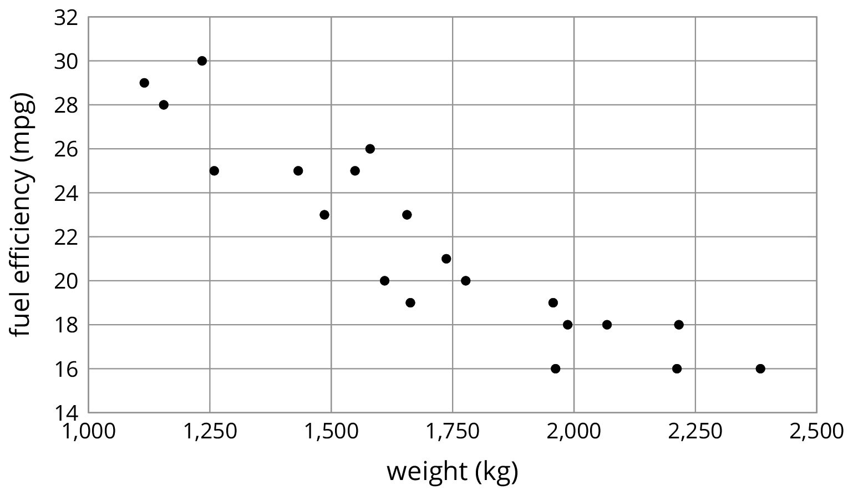
- Which point in the scatter plot represents Car L’s measurements?
- What is the fuel efficiency of the car with the greatest weight?
- What is the weight of the car with the greatest fuel efficiency?
- Car S weighs 1,912 kilograms and gets 16 miles per gallon. On the scatter plot, plot a point that represents Car S’s measurements.
- Cars N and O, shown in the scatter plot, are made by the same company. Compare their weights and fuel efficiencies. Does anything surprise you about these cars?
- A different company makes Cars F and G. Compare their weights and fuel efficiencies. Does anything surprise you about these cars?

3 Coat Sales

Student Task Statement
A clothing store keeps track of the average monthly temperature in degrees Celsius and coat sales in dollars.
temperature (degrees Celsius) | coat sales (dollars)
-5 | 1,550
-3 | 1,340
3 | 1,060
8 | 1,070
15 | 680
21 | 490
23 | 410
21 | 510
17 | 600
11 | 740
6 | 940
-2 | 1,390
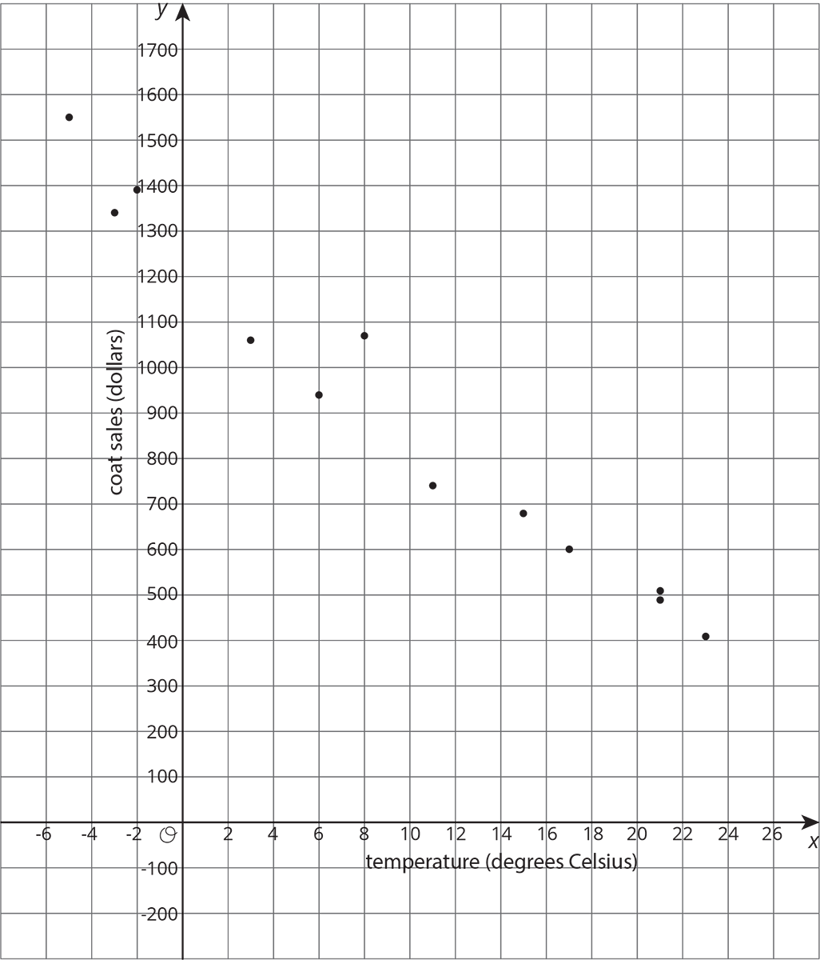
- What does the point $(15,680)$ represent?
- For the month with the lowest average temperature, estimate the total amount made from coat sales. Explain how you used the table to find this information.
- For the month with the smallest coat sales, estimate the average monthly temperature. Explain how you used the scatter plot to find this information.
- If there were a point at $(0,A)$ what would it represent? Use the scatter plot to estimate a value for $A$.
- What would a point at $(B,0)$ represent? Use the scatter plot to estimate a value for $B$.
- Would it make sense to use this trend to estimate the value of sales when the average monthly temperature is 60 degrees Celsius? Explain your reasoning.
© CC BY Open Up Resources. Adaptations CC BY IM.

