Lesson 3 Practice Problems
- Segment $AB$ measures 3 cm. Point $O$ is the center of dilation. How long is the image of $AB$ after a dilation with . . .
  - Scale factor 5?
  - Scale factor 3.7?
  - Scale factor $\frac{1}{5}$?
  - Scale factor $s$?
- Here are points $A$ and $B$. Plot the points for each dilation described.
  - $C$ is the image of $B$ using $A$ as the center of dilation and a scale factor of 2.
  - $D$ is the image of $A$ using $B$ as the center of dilation and a scale factor of 2.
  - $E$ is the image of $B$ using $A$ as the center of dilation and a scale factor of $\frac{1}{2}$.
  - $F$ is the image of $A$ using $B$ as the center of dilation and a scale factor of $\frac{1}{2}$.
- Make a perspective drawing. Include in your work the center of dilation, the shape you dilate, and the scale factor you use.
- Triangle $ABC$ is a scaled copy of triangle $DEF$. Side $AB$ measures 12 cm and is the longest side of $ABC$. Side $DE$ measures 8 cm and is the longest side of $DEF$.
  - Triangle $ABC$ is a scaled copy of triangle $DEF$ with what scale factor?
  - Triangle $DEF$ is a scaled copy of triangle $ABC$ with what scale factor?
- (From Unit 2, Lesson 1.)
- The diagram shows two intersecting lines.
- Find the missing angle measures.
- 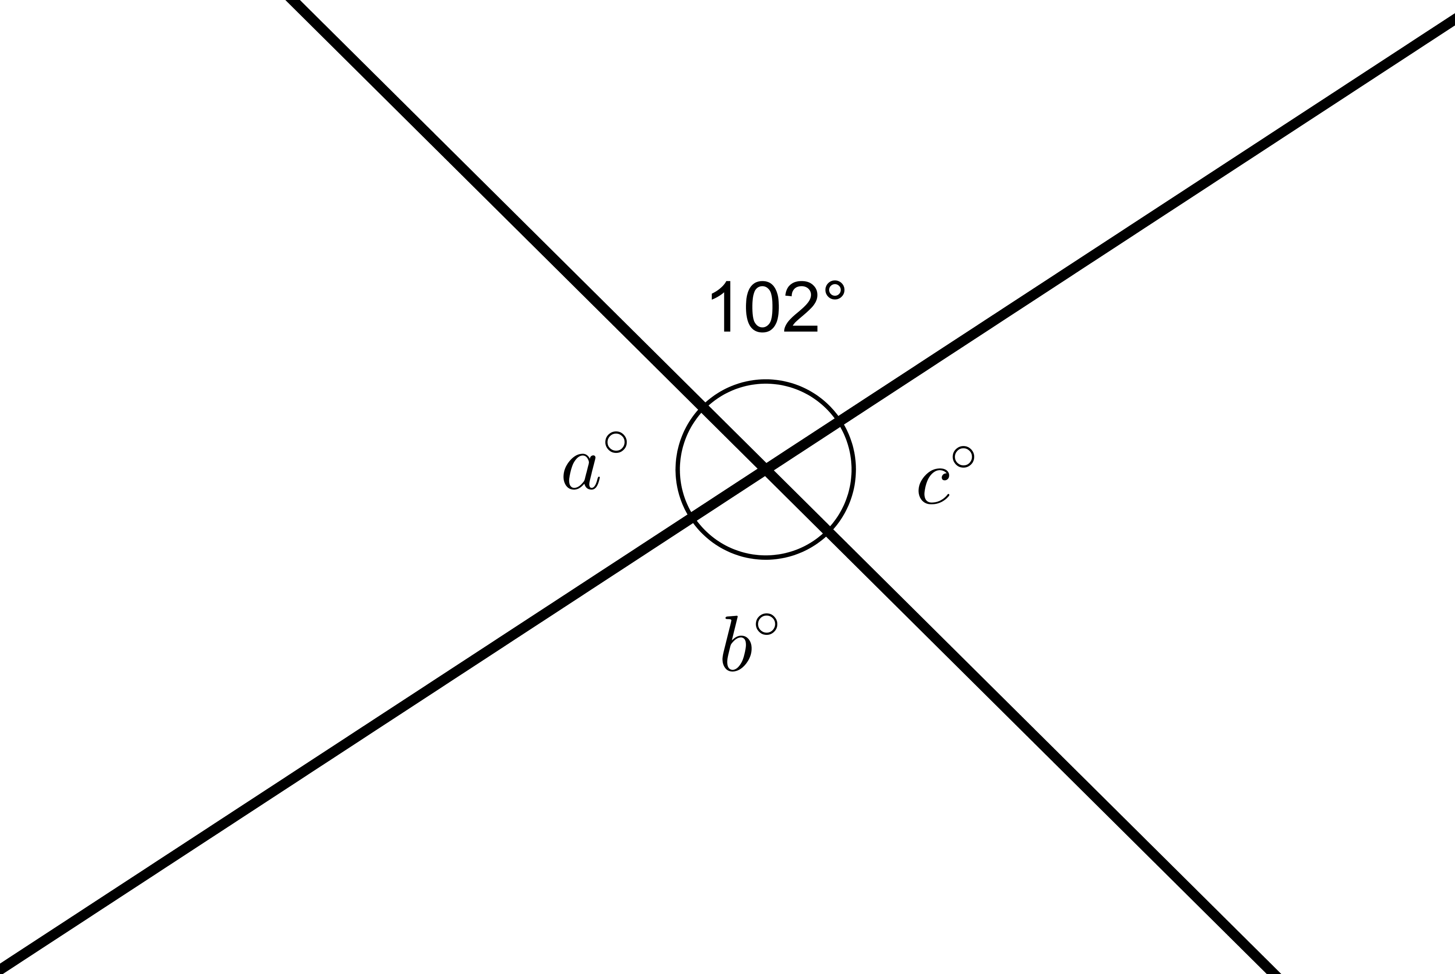
- (From Unit 1, Lesson 14.)

  - Show that the two triangles are congruent.
  - Find the side lengths of $DEF$ and the angle measures of $ABC$.
- 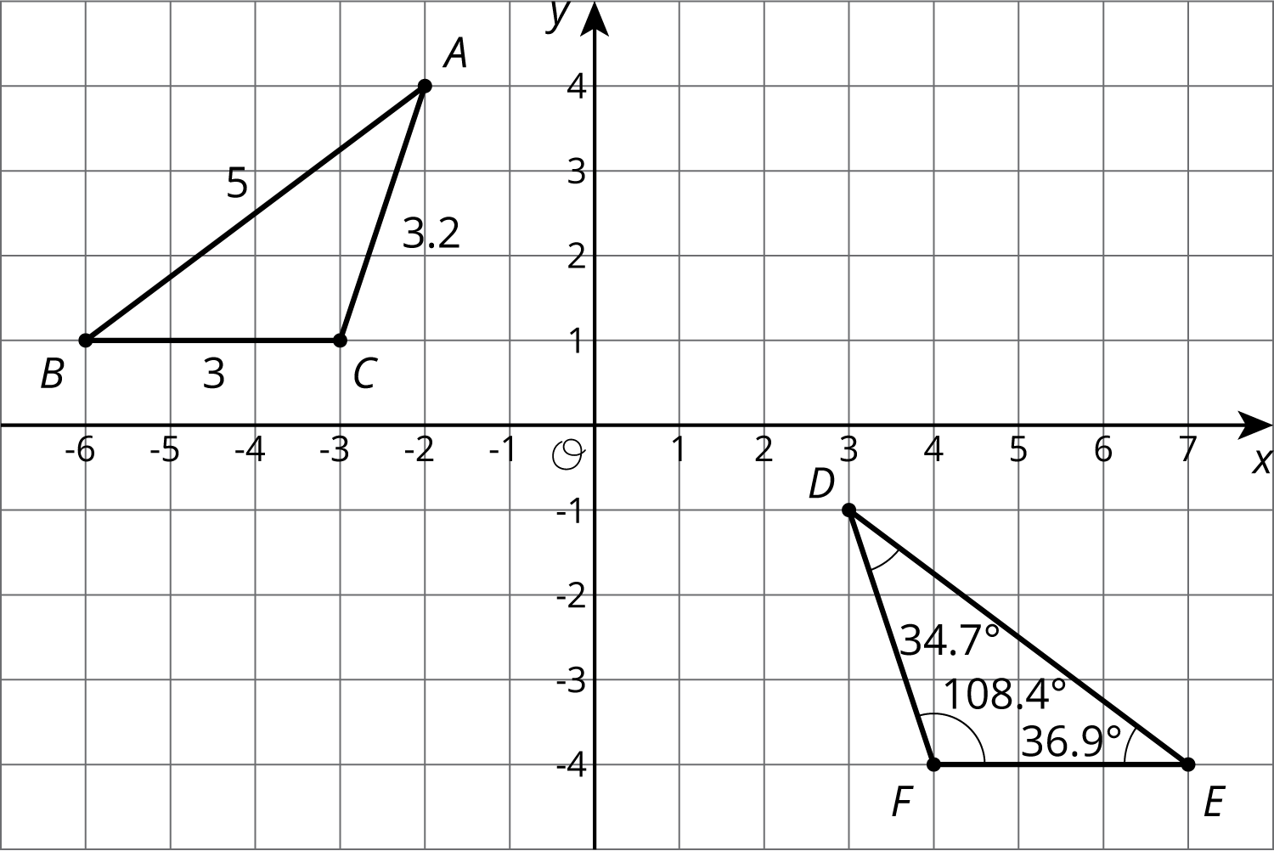
- (From Unit 1, Lesson 12.)
© CC BY Open Up Resources. Adaptations CC BY IM.

