Lesson 1: What is One Thousandth?
- Let’s make sense of thousandths.

Warm-up: Estimation Exploration: One Tiny Piece
What fraction of the whole picture is a single square tile?
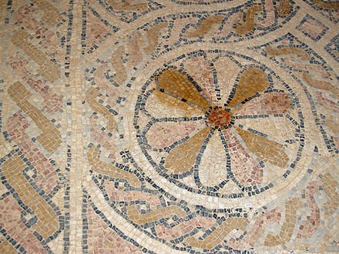
Record an estimate that is:
too low | about right | too high

1.1: What Do You Know About Thousandths?
- What do you know about 1 tenth?
- What do you know about 1 hundredth?
- What do you know about 1 thousandth?

1.2: Represent Numbers on a Hundredths Grid
- The grid represents 1. What does the shaded region represent?
- Be prepared to explain your reasoning.
- 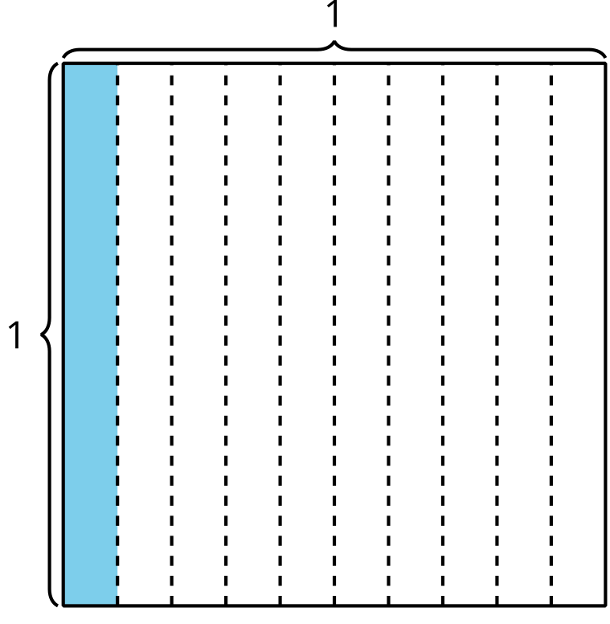
- The grid represents 1. What does the shaded region represent?
- Be prepared to explain your reasoning.
- 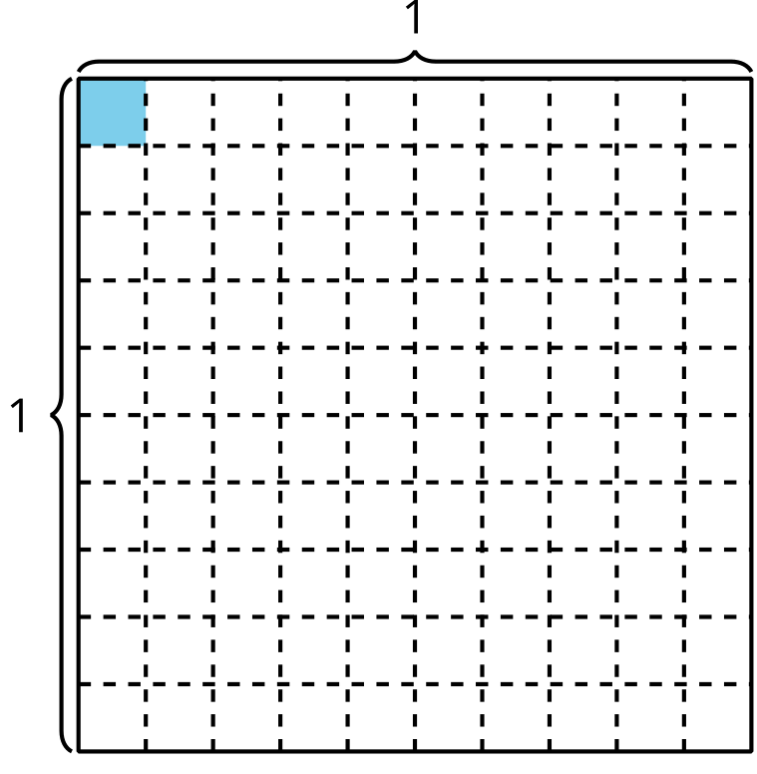
- How many of the small rectangular pieces (one of them is shaded) are there in the unit square?
- Explain or show your thinking.
- 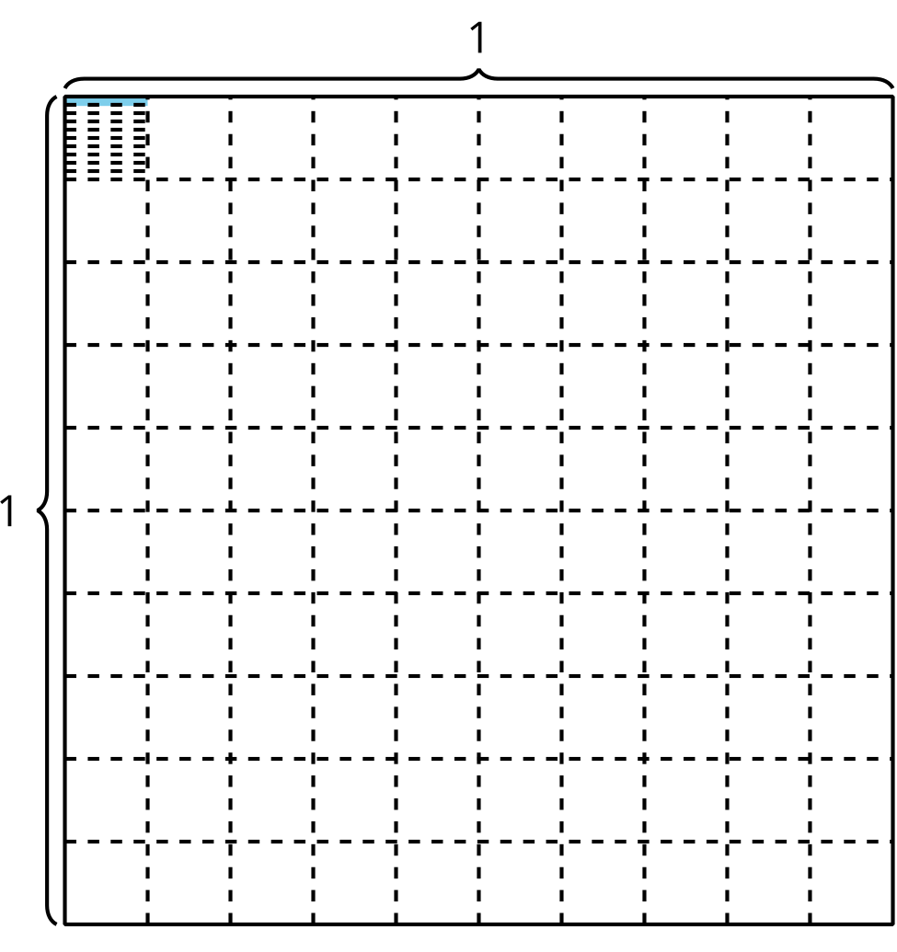
- Fraction | - Decimal
- $\frac{1}{10}$ | - 0.1
- $\frac{1}{100}$ | - 0.01
- $\frac{1}{1,000}$ | - ?
- How do you think we write the number one thousandth as a decimal? Explain your reasoning.
© CC BY 2021 Illustrative Mathematics®

