Unit 3 Lesson 8: Apply Fraction Multiplication

WU Number Talk: Fraction Multiplication (Warm up)

Student Task Statement
Find the value of each expression mentally.
- $\frac{1}{3}×\frac{3}{5}$
- $\frac{2}{3}×\frac{3}{5}$
- $\frac{5}{3}×\frac{3}{5}$
- $\frac{2}{3}×\frac{13}{5}$

1 Flags

Student Task Statement
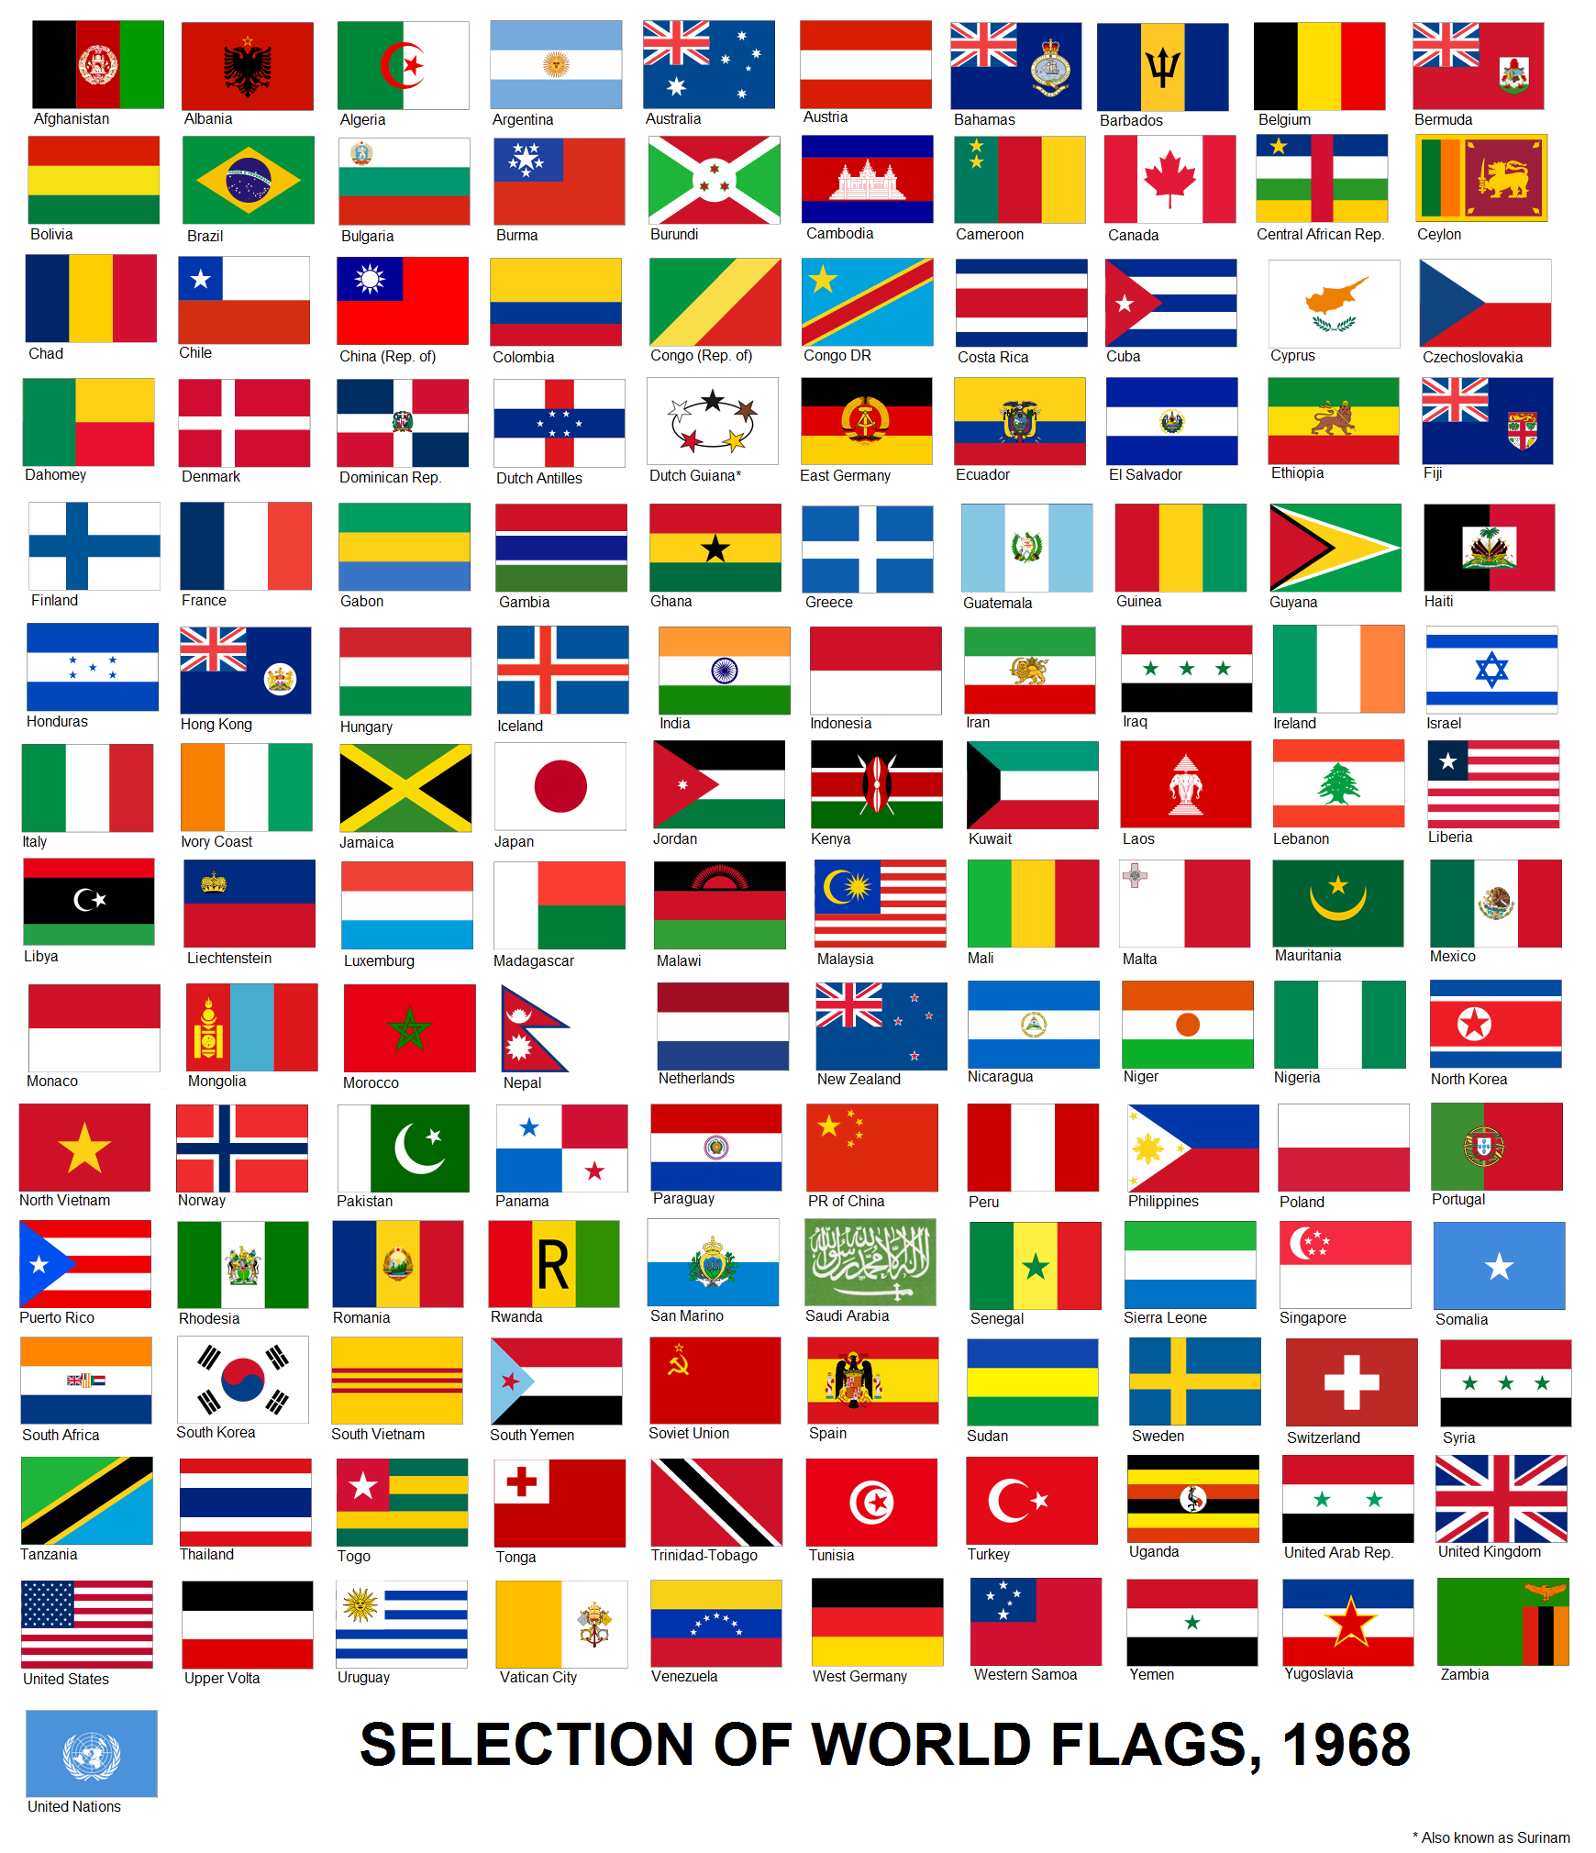
Jada has a small replica of a flag of Thailand.
It is 5 inches wide and $7\frac{1}{2}$ inches long.
- What is the area of the flag? Explain or show your reasoning.
- Each red stripe is $\frac{5}{6}$ inches wide. What is the area of each red stripe? Explain or show your reasoning.
- The blue stripe is $\frac{10}{6}$ inches wide. What is the area of the blue stripe? Explain or show your reasoning.

2 More Flags

Student Task Statement
Han has a replica of the flag of Colombia.
It is $3\frac{1}{2}$ inches wide and $5\frac{1}{4}$ inches long. The yellow stripe is $\frac{1}{2}$ of the width of the flag and the blue and red stripes are each $\frac{1}{4}$ of the width.
- $\frac{1}{4}×3\frac{1}{2}=\frac{7}{8}$. The answer is $\frac{7}{8}$ inch. What is the question?
- $\frac{1}{2}×3\frac{1}{2}=\frac{7}{4}$ and $\frac{7}{4}×\frac{21}{4}=\frac{147}{16}$. The answer is $\frac{147}{16}$ square inches. What is the question?
© CC BY 2021 Illustrative Mathematics®

