Lesson 8: Compose Tens and Hundreds to Add

Standards Alignments
Addressing | 2.NBT.B.7, 2.NBT.B.9

Teacher-facing Learning Goals
- Add a two-digit number to a three-digit number using place value strategies that include composing units.

Student-facing Learning Goals
- Let’s compose tens and hundreds to add.

Lesson Purpose
The purpose of this lesson is for students to add within 1,000 using place value-based strategies by composing both a ten and a hundred.
In previous lessons, students related composing a ten and a hundred when adding within 1,000. They found sums that required composing one larger unit when adding by place. Throughout this lesson, the addends in each expression encourage students to consider adding by place. Both activities invite students to make sense of methods based on adding by place and to use the method that makes the most sense to them. Monitor for the different methods students use and how they use their understanding of place value to add and make sense of others' work (MP3, MP7).

Access for:

Students with Disabilities
- Action and Expression (Activity 1)

Instructional Routines
How Many Do You See? (Warm-up), MLR8 Discussion Supports (Activity 1)

Materials to Gather
- Base-ten blocks: Activity 1, Activity 2

Lesson Timeline
Warm-up | 10 min
Activity 1 | 20 min
Activity 2 | 15 min
Lesson Synthesis | 10 min
Cool-down | 5 min

Teacher Reflection Question
Today students composed a ten and a hundred when adding a two-digit number and a three-digit number for the first time. Where did you observe students generalizing their understanding of place value and composing larger units as they found the sums? How will you support students who prefer other methods to make sense of composing units when adding by place as they continue this work in upcoming lessons?

Cool-down
(to be completed at the end of the lesson) 5min
Make Tens and Hundreds

Standards Alignments
Addressing | 2.NBT.B.7

Student-facing Task Statement
Find the value of $278+65$.
Show your thinking. Use base-ten blocks if it helps you.

Student Responses
343. Sample responses:

- 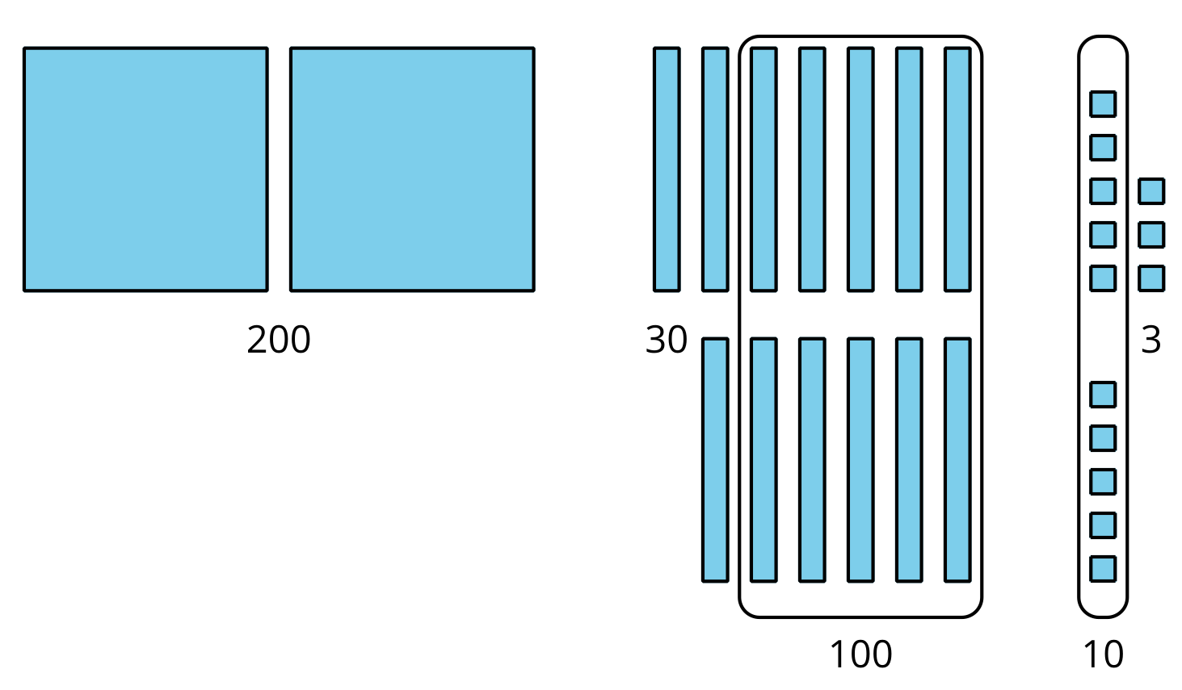
- $200+100+30+10+3$
- $300+40+3=343$

