Unit 2 Lesson 14: Fraction Comparison Problems

WU Number Talk: Multiples of Ten (Warm up)

Student Task Statement
Find the value of each expression mentally.
- $119+119$
- $139+139$
- $159+159$
- $199+199$

1 Mystery Fractions

Student Task Statement
Six friends are each given a list of 5 fractions. They each chose one fraction quietly and wrote clues about their choice. Use their clues to identify the fractions they chose.
Andre: $\frac{8}{12} \frac{3}{6} \frac{3}{4} \frac{3}{2} \frac{2}{12}$
- less than 1
- greater than $\frac{1}{3}$
- less than $\frac{2}{3}$

Tyler: $\frac{2}{6} \frac{2}{2} \frac{2}{4} \frac{2}{3} \frac{2}{5}$
- greater than $\frac{1}{3}$
- less than 1
- less than $\frac{1}{2}$

Clare: $\frac{4}{3} \frac{4}{2} \frac{3}{4} \frac{1}{4} \frac{2}{10}$
- greater than $\frac{2}{8}$
- less than $\frac{11}{6}$
- greater than 1

Diego: $\frac{2}{8} \frac{6}{12} \frac{6}{8} \frac{12}{10} \frac{11}{12}$
- greater than $\frac{1}{2}$
- less than 1
- greater than $\frac{3}{4}$

Elena: $\frac{2}{12} \frac{50}{100} \frac{4}{10} \frac{3}{5} \frac{7}{5}$
- greater than $\frac{2}{10}$
- less than 1
- greater than $\frac{3}{6}$

Noah: $\frac{18}{10} \frac{7}{8} \frac{2}{5} \frac{18}{5} \frac{150}{100}$
- greater than $\frac{1}{2}$
- less than $\frac{25}{10}$
- greater than $\frac{8}{5}$

2 Distances on Foot

Student Task Statement
In China and some East Asian countries, the unit “li” is used for measuring distance.
Here are the walking distances between the home of a student in China and the places he visits regularly.
- school: $\frac{7}{5}$ li
- library: $\frac{23}{10}$ li
- market: $\frac{7}{4}$ li
- badminton club: $\frac{23}{12}$ li
- Which is a shorter distance from the student’s home:
  - His school or the library?
  - The market or the badminton club?
  - The library or the market?
- A student in America walks $\frac{4}{5}$ kilometer (km) to school. These number lines show how 1 kilometer compares to 1 li.
- 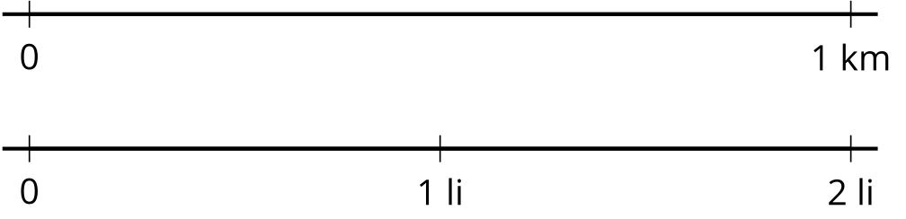
- Which student walks a longer distance to school? Use the number lines to show your reasoning.
- Explain why we can’t just compare the fractions $\frac{4}{5}$ and $\frac{7}{5}$ to see which student walks a longer distance.
© CC BY 2021 Illustrative Mathematics®

