Lesson 21: Zeros in the Standard Algorithm
- Let’s subtract from numbers with several zeros.

Warm-up: Which One Doesn’t Belong: Numbers with 0, 2, and 5
Which one doesn’t belong?
- 2,050
- 2,055
- 205.2
- 20,005

21.1: What If There is Nothing to Decompose?
Here are some numbers you saw earlier. Each number has at least one 0. From each number, 1,436 is being subtracted.
- Make sense of the problems and explain to a partner.
- a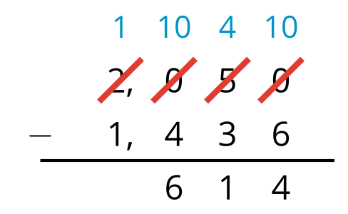
- b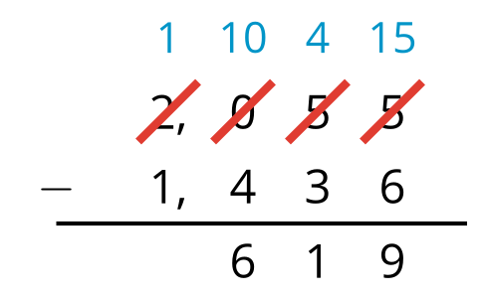
- Use the approach in the first problem to find these two differences:
- a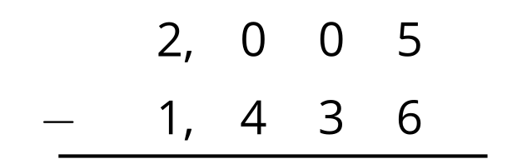
- b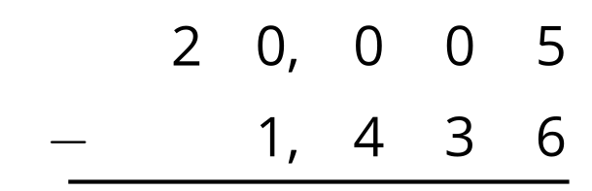
- Find the value of each difference. Be prepared to explain your reasoning. If you get stuck, try subtracting using the expanded form.
- a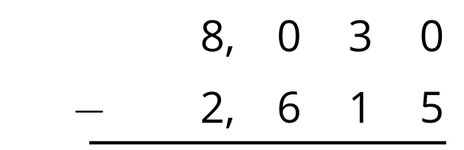
- b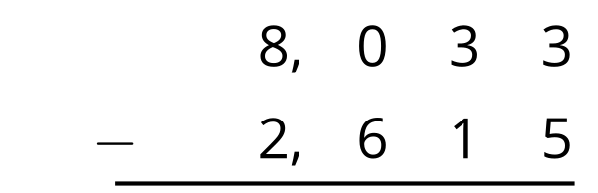
- c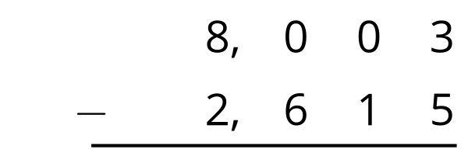
- d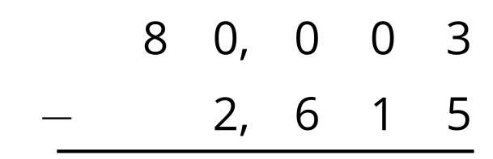

21.2: What is Your Age?
Jada recorded the birth year of some of her maternal grandparents for a family history project.
family member | birth year
grandmother | 1952
grandfather | 1948
great-grandmother | 1930
great-grandfather | 1926
As of this year, what is the age of each family member? Show your reasoning. Use the standard algorithm at least once.
© CC BY 2021 Illustrative Mathematics®

