Lesson 10: Ways to Find Angle Measurements
- Let’s find angle measurements in figures with line symmetry.

Warm-up: How Many Do You See: Symmetry in a Star
How many lines of symmetry do you see? How do you see them?

10.1: Before and After, Angle Edition
Noah, Clare, Andre, and Elena each have a sheet of paper with one line of symmetry. When they folded their paper along the line of symmetry, they all produced the same shape. The dashed line represents the folding line.
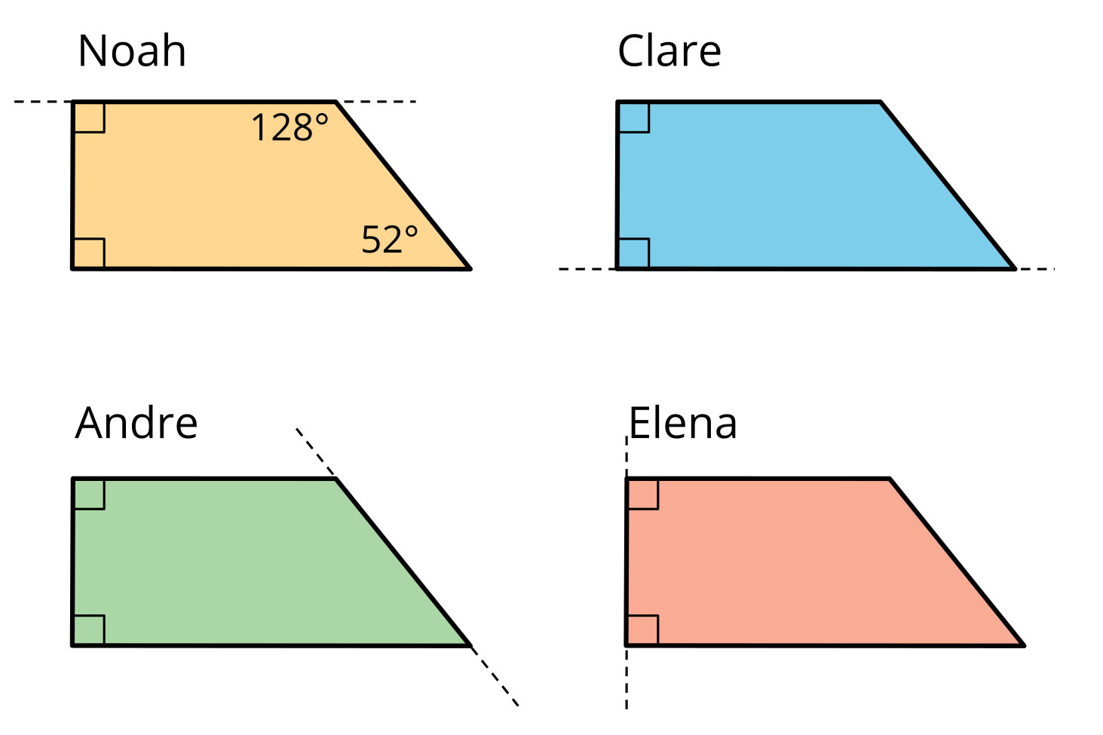
- Draw the shape of the unfolded paper that each student received. Be as precise as possible.
- Without measuring, find the measurement of all angles within the shape (of the unfolded paper) that you drew.

10.2: Angular Fish
Here is a diagram of an origami fish, which has one line of symmetry.
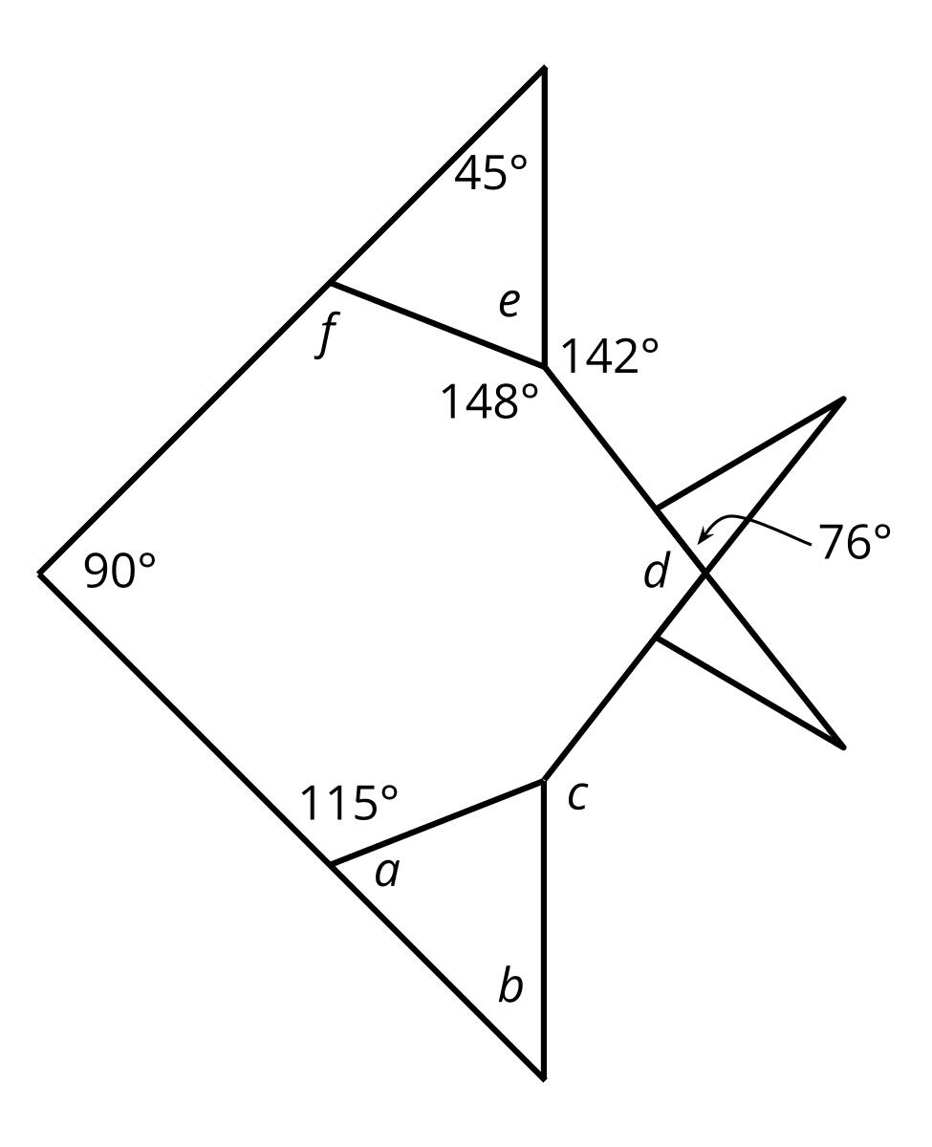
- Draw the line of symmetry.
- Without measuring, find the measurement of angles labeled $a$–$f$. Be prepared to explain your reasoning.
© CC BY 2021 Illustrative Mathematics®

