Lesson 15: Diagrams with All Kinds of Compare Problems

Warm-up: Number Talk: 10 and Some More
Find the value of each sum mentally.
- $4+8+2$
- $4+5+3+2$
- $9+3+1$
- $9+5$

15.1: Shell Collections
Diego has 55 shells. Lin has 20 fewer shells than Diego.
- Use the story problem to complete the diagram.
- 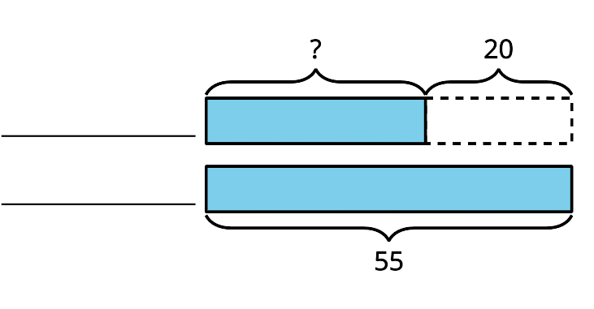
- Write an equation to show how you could find the unknown number of shells. Use a question mark to represent the unknown.

15.2: Card Sort: At the Beach
- Read a card with a story problem.
- Find cards that match the story problem.
- Explain why the cards match.
© CC BY 2021 Illustrative Mathematics®

