Unit 5 Lesson 22: Observing More Patterns in Scatter Plots

1 Notice and Wonder: Clustering (Warm up)

Student Task Statement
What do you Notice? What do you Wonder?
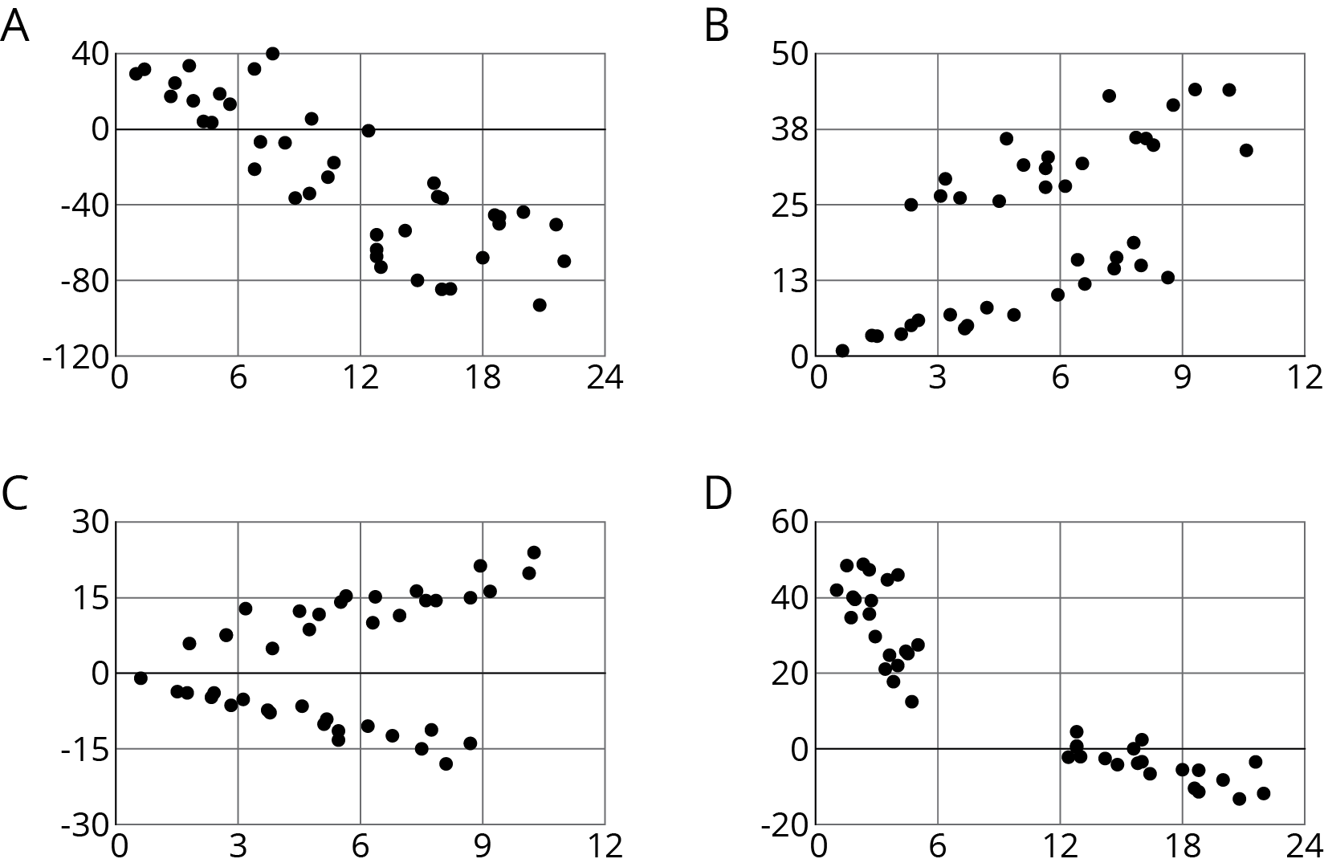

2 Scatter Plot City

Student Task Statement
Your teacher will give you a set of cards. Each card shows a scatter plot.
- Sort the cards into categories and describe each category.
- Explain the reasoning behind your categories to your partner. Listen to your partner’s reasoning for their categories.
- Sort the cards into two categories: positive associations and negative associations. Compare your sorting with your partner’s and discuss any disagreements.
- Sort the cards into two categories: linear associations and non-linear associations. Compare your sorting with your partner’s and discuss any disagreements.

3 Animal Brains

Student Task Statement
Is there an association between the weight of an animal’s body and the weight of the animal’s brain?
Use the data in the table to make a scatter plot. Are there any outliers?
animal | body weight (kg) | brain weight (g)
cow | 465 | 423
grey wolf | 36 | 120
goat | 28 | 115
donkey | 187 | 419
horse | 521 | 655
potar monkey | 10 | 115
cat | 3 | 26
giraffe | 529 | 680
gorilla | 207 | 406
human | 62 | 1,320
rhesus monkey | 7 | 179
kangaroo | 35 | 56
sheep | 56 | 175
jaguar | 100 | 157
chimpanzee | 52 | 440
pig | 192 | 180
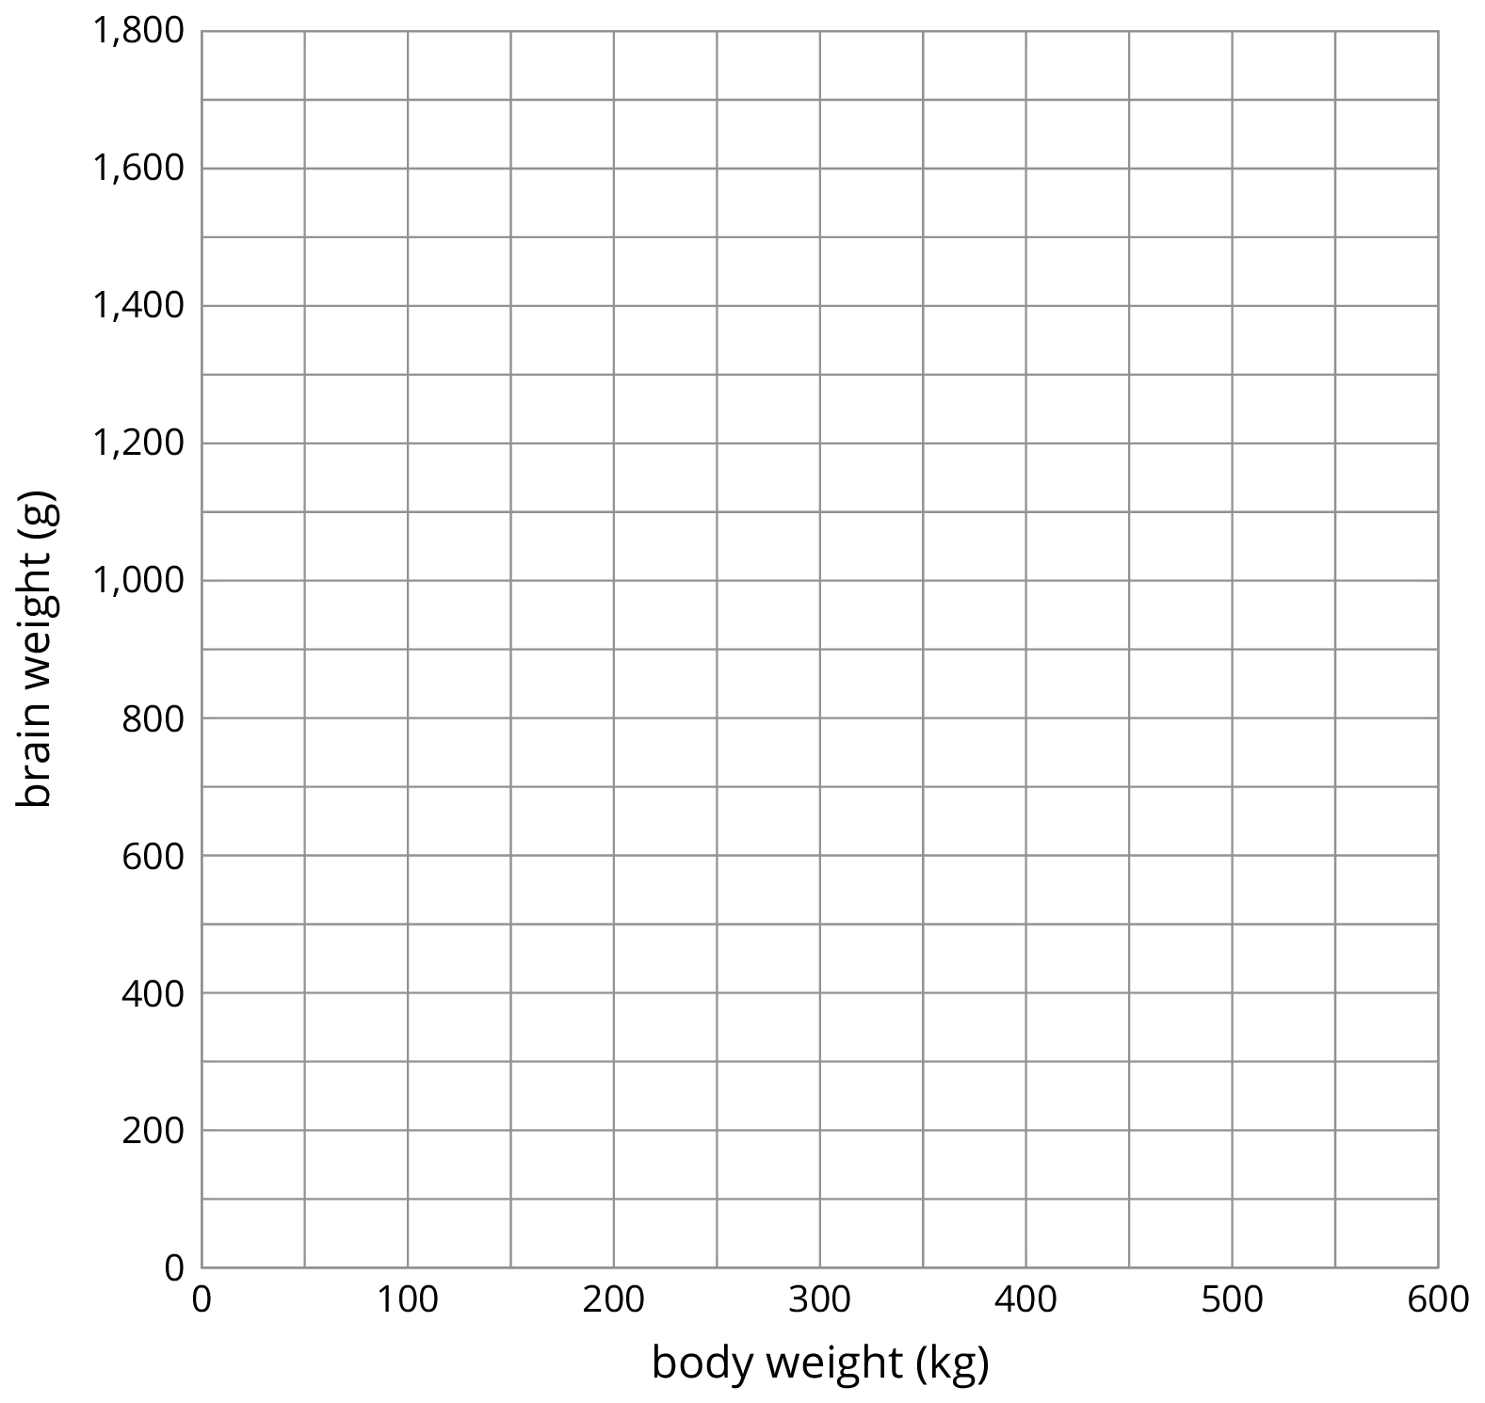
- After removing the outliers, does there appear to be an association between body weight and brain weight? Describe the association in a sentence.
- Using a piece of pasta and a straightedge, fit a line to your scatter plot, and estimate its slope. What does this slope mean in the context of brain and body weight?
- Does the fitted line help you identify more outliers?
© CC BY Open Up Resources. Adaptations CC BY IM.

