Lesson 2: Thousandths on Grids and in Words
- Let’s represent numbers as decimals, fractions, words, and on hundredths grids.

Warm-up: Estimation Exploration: What Part of the Square is Shaded?
How much of the square is shaded?
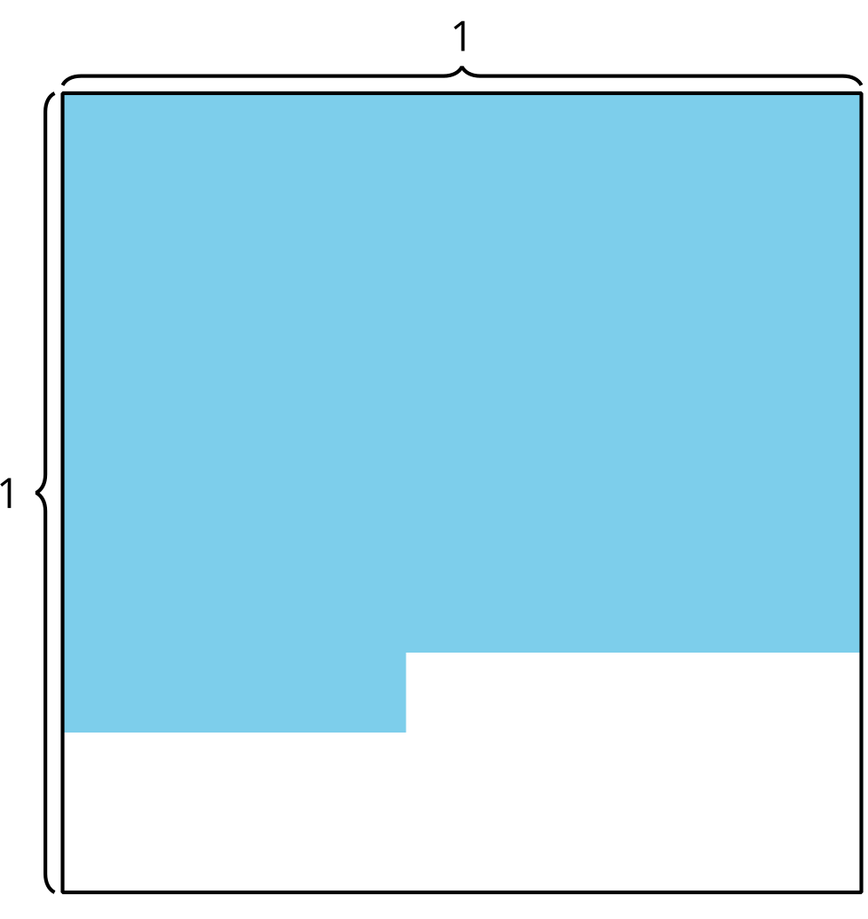
Record an estimate that is:
too low | about right | too high

2.1: Represent Thousandths on a Grid
- Shade each grid to represent the given number.
- a. $\frac{2}{10}$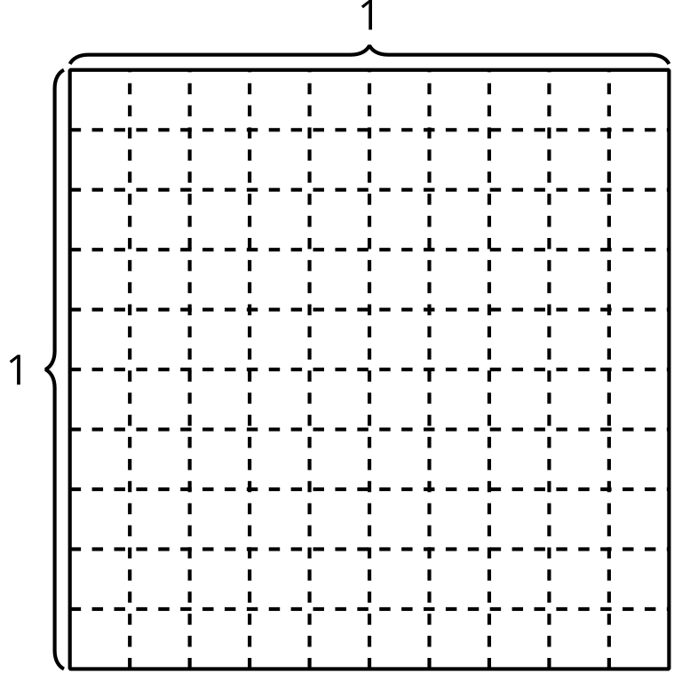
- b. $0.2$
- c. $\frac{15}{100}$
- d. $0.34$
- For each diagram, write a decimal number to represent how much is shaded. Explain or show your reasoning.
- a. 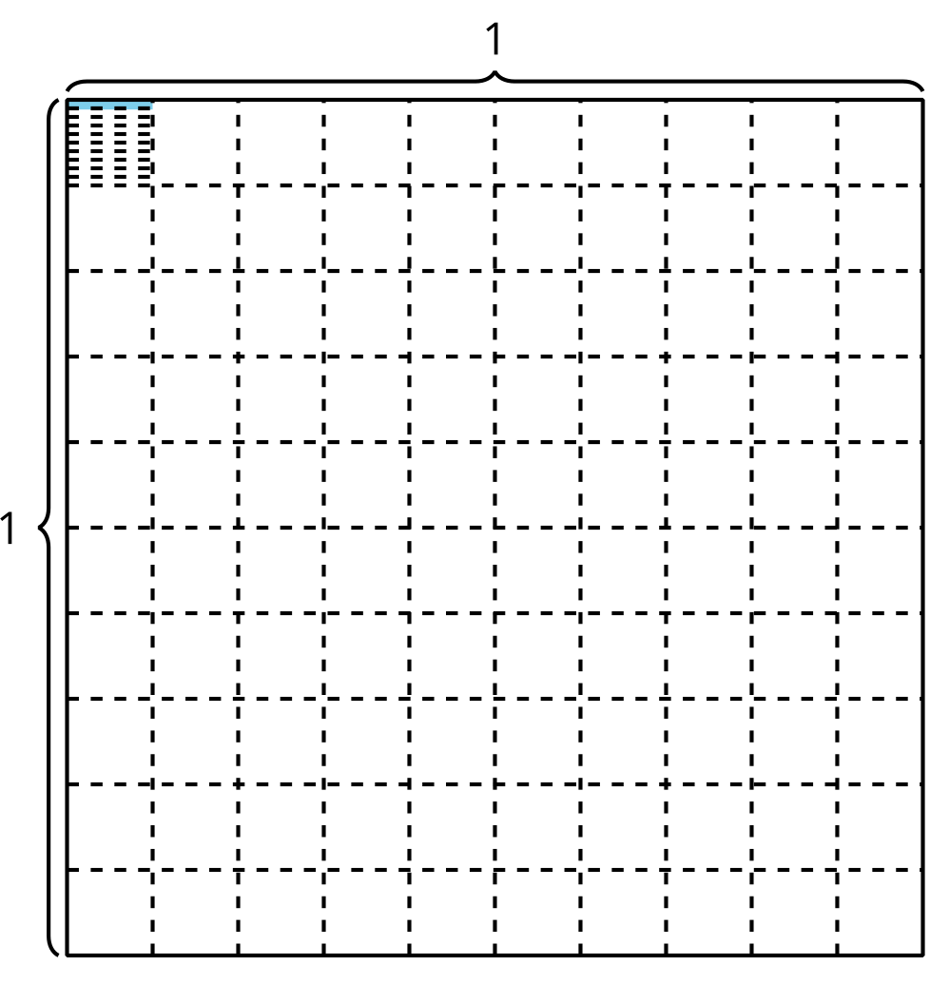
- b.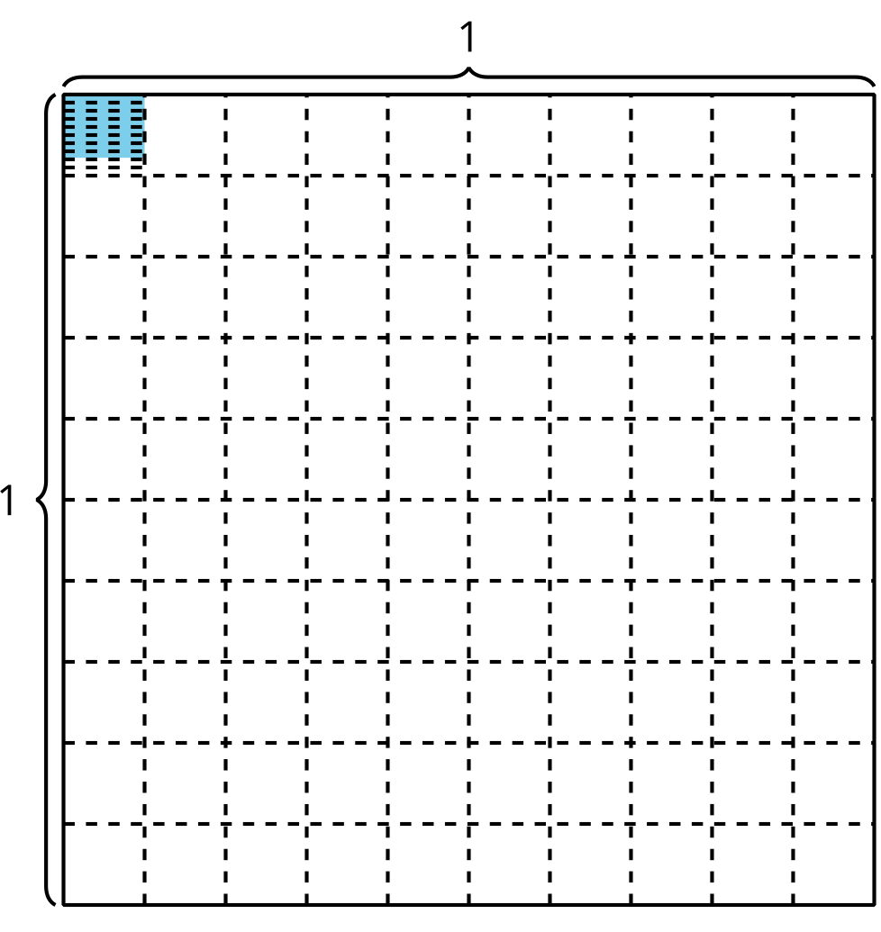
- c.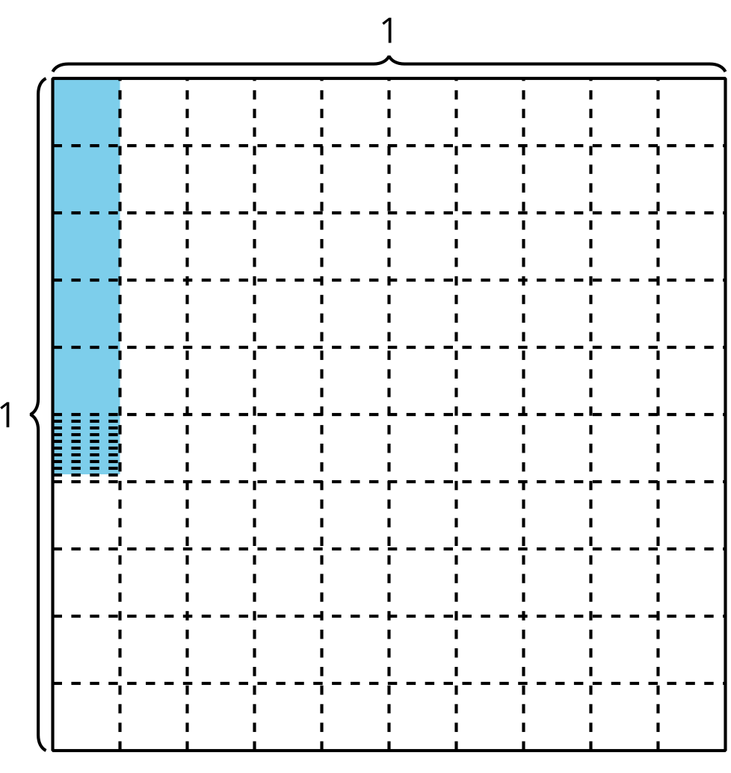
- d. 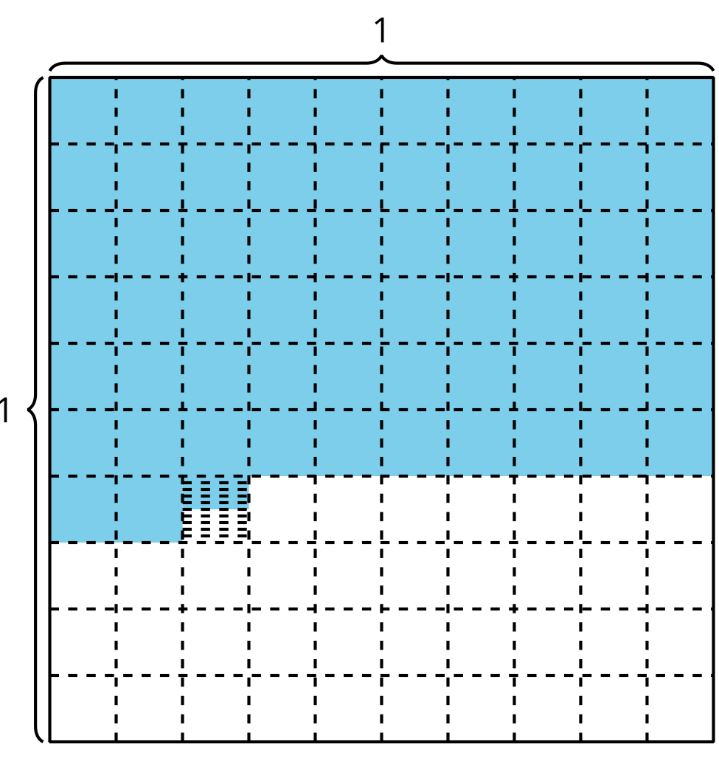
- Shade 0.328 in the diagram. Explain or show your reasoning.

2.2: Say What?
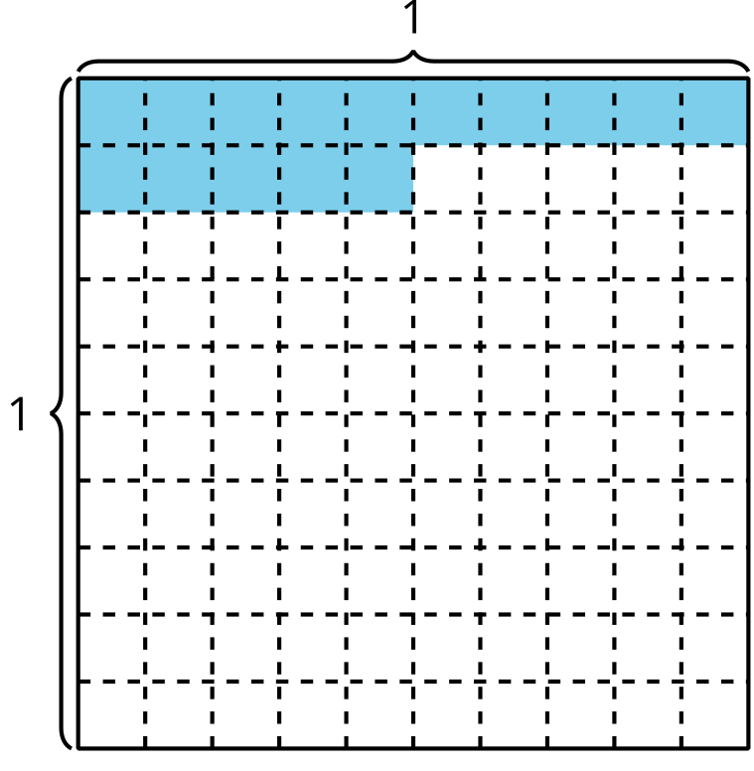
Several students look at the diagram and describe the shaded region in different ways. Who do you agree with? Why?
- Jada says it’s “15 hundredths.”
- Priya says it’s “150 thousandths.”
- Tyler says it’s “15 thousandths.”
- Diego says it’s “1 tenth and 5 hundredths.”
- Mai says it’s “1 tenth and half of a tenth.”
© CC BY 2021 Illustrative Mathematics®

