Unit 1 Lesson 16: Solve All Kinds of Compare Problems

WU True or False: Multiples of 10 (Warm up)

Student Task Statement
Decide if each statement is true or false. Be prepared to explain your reasoning.
- $18+5=18+2+3$
- $28+5=30+3$
- $38+4=40+3$

1 A Trip to the Library

Student Task Statement
- Priya and Andre returned books to the library. Priya returned 29 books. Andre returned 8 more books than Priya.
  - Who returned more books?
  - Use the story problem to complete the diagram.
  - How many books did Andre return?
- Andre read 45 pages of his book last night. Priya read 20 fewer pages of her book than Andre.
  - Who read more pages?
  - Use the story problem to complete the diagram.
  - 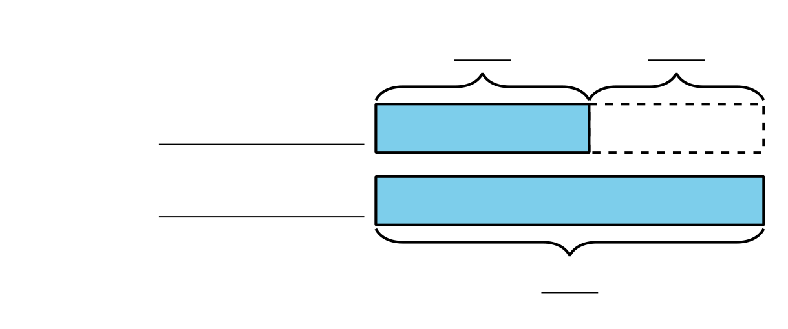
  - How many pages did Priya read?

2 Solve Compare Problems

Student Task Statement
- Jada read 10 fewer pages than Noah. Noah read 27 pages. How many pages did Jada read?
- Noah spent 25 minutes reading. Jada spent 30 more minutes reading than Noah. How many minutes did Jada spend reading?
- Jada read 47 pages of the book. Noah read 20 pages of the book. How many fewer pages did Noah read?
- Noah stacked 14 more books than Jada. Jada stacked 28 books. How many books did Noah stack?
© CC BY 2021 Illustrative Mathematics®

